Assessment – Pre-Trip Plan

Community: | El Cacao
Country: | Nicaragua
Chapter: | University of Maryland
Submittal Date: | November 6, 2017
Authors: | Heather Groves, Timothy Blount, Jimmy Baldwin, Antonio Karides, Richard Vook, Nipun Kottage
Scope of Assessment (100 words) | This 521 pre-trip assessment plan constitutes the official request for approval for the University of Maryland chapter of EWB-USA to travel to El Cacao, Nicaragua on an assessment trip for the El Cacao community water project from January 8th, 2018 to January 18th, 2018.  The goal of this project is to provide the El Cacao community with a reliable source of water for cleaning, drinking and cooking. EWB-UMD and the community of El Cacao will work together to determine the scope of need for the community with future plans to implement a sustainable water source which will meet the needs of the community.

Table of Contents
Pre-Assessment Report Part 1- Administrative Information 3
Contact Information 3
Travel History 4
Travel Team 4
Health and Safety 5
Planning, Monitoring, Evaluation and Learning 5
Project Location 5
Project Impact 5
Pre-Assessment Report-Technical Information 6
Objectives of Site Assessment Trip 6
Data Collection and Analysis 7
Community Land Survey 7
Water Sample Testing 11
Wells 11
Catchment Ponds 11
Spring Boxes / Seepage System 12
Tanks and Pumps 12
Carbon and Sand Purification 13
Rainwater Catchment 13
Filters and UV Purification 13
Chlorine purification 13
Soil Sample Testing 21
Baseline Study and Needs Assessment 27
Design Alternatives Considerations 29
Schedule of Tasks 29
Go/No Go Decision 29
List of Attachments 30
References 31
Appendix A: 32

Pre-Assessment Report Part 1- Administrative Information

Contact Information

Project Title | Name | Email | Phone | Organization
Project Lead | Heather Groves | ewb.nicaragua.pl@gmail.com | 4105708211
President | Jeff O’Neal | presidentewbumcp@gmail.com | 4435202121
Responsible  Engineer in  Charge | Ivan Zapata
Traveling Mentor | Ivan Zapata
Additional Mentor | Thurka Sangaramoorthy | tsangara@umd.edu
Faculty Advisor | Thurka Sangaramoorthy | tsangara@umd.edu
Health and  Safety Officer | James Baldwin | baldwinj929@gmail.com | 2403800514
Assistant Health  and Safety  Officer | Bryan Croce
Education Lead | Nina Horne | nhorne@terpmail.umd.edu | 4437602405
Planning,  Monitoring,  Evaluation and  Learning (PMEL)  Lead | Bryan Croce | bryandcroce@gmail.com | 4356476385
NGO Contact | Carmin
Community  Contact | Claudia

Travel History
This project is the first in the newly approved El Cacao, Nicaragua program. There is no prior travel history. This assessment trip will be the first trip for the program.

Travel Team

Project Title | Name | Email | Phone | Organization
Project Lead | Heather Groves | heatherdgroves@gmail.com | 4105708211
Responsible  Engineer in  Charge | Ivan Zapata
Traveling Mentor | Thurka Sangarmoorthy
Team member | Nipun Kottage | nkottage@gmail.com | 2407783801
Team member | James Baldwin | baldwinj929@gmail.com | 2403800514
Team member | Bryan Croce | bryandcroce@gmail.com | 4356476385
Team member | Nina Horne | nhorne@terpmail.umd.edu | 4437602405
Team member | Taqui Mahmood | mahmood1@terpmail.umd.edu | 3013122922

Health and Safety
The assessment team will follow the procedures outlined in the Health and Safety Plan (HASP) prepared specifically for this trip. The HASP will be submitted as a standalone document for review with the Trip Details (3 weeks prior to travel).

Planning, Monitoring, Evaluation and Learning
  - If this will be the first assessment trip for the program, is the Draft 901 – Program Plan and Baseline Study included with this report? ___Yes _X__No ___Not the First Assessment trip
Draft 901 will be submitted as a standalone document for review with the Trip Details (3-weeks prior to travel).
This is not the first assessment trip and the travel team has reviewed the 901B – Program Impact Monitoring Report template and has assigned travel team members to complete this report during the upcoming trip. We acknowledge that the completed 901B is required with the eventual submittal of the 522 – Post-Assessment Trip Report. ___Yes ___No x N/A

Project Location
Latitude: 11.74475218
Longitude: -86.14016834

Project Impact
Number of Persons directly affected: 465
Number of Persons indirectly affected: 300

Pre-Assessment Report-Technical Information

Objectives of Site Assessment Trip
The objectives of the January 2017 assessment trip will be to complete all necessary tasks so that the team will be prepared to start implementation plans without a secondary assessment.
  - Determine Program Feasibility
    - Verify the community’s willingness to work with EWB-UMD and its openness to project design ideas.
    - Understand the perspectives and needs of the community.
    - Assess the safety of the location of the program.
    - Validate the willingness of the local NGO, Asociacion Tierra Y Vida, to offer their resources to look for, meet and work with stakeholders for this project, organize and lead any task that community members will need to do to ensure project success and assist in the transport materials to the project site.
    - Determine the NGO’s willingness to work in conjunction with EWB-UMD while allowing this chapter to handle distribution of the funds and take lead on the project.
    - Validate the willingness of the local CBO, CAPS San Romero de America, to serve as communication bridge between EWB-USA team and CAPS, offer logistic support to CAPS and EWB-USA members and organize the community members to attend meetings, achieve assigned goals and do project related activities/duties.
  - Determine Project Feasibility
    - Determine ease of collecting all data to allow for the analysis and design of the project
    - Identify the location of material sourcing in the country and determine the easiness of transporting resources across borders in the event they are not available.

  - First project objectives
    - The first proposed project involves providing greater access to water for the community, which currently only has 23/90 homes with access to water.
    - The initial approach to this project will be to conduct a survey of the community. The physical area will be surveyed so that we have all the necessary information when we start planning for implementation.
    - Interviews and participant observation will be conducted in order to assess community perspectives of need and their interests in working with EWB-UMD.
    - If we are able to meet all of the trip objectives, the team will compile a list of possible water solutions for the community to ascertain what would work best.
  - Work with the community to start the setup of an operation and maintenance system for the project after completion.
  - Finalize and sign the Project Partnership Agreement with the community and local partners.
    - Before traveling, the team will have sent a draft of the Project Partnership Agreement to the community for review and comments. A current rough draft is included in Appendix A. During the first assessment trip, the team will discuss the Project Partnership Agreement with the community and the NGO. Upon agreement to the conditions listed in the document, the leaders of the three parties will then sign the document.
    - Provide the community with an understanding that EWB-UMD is a group of volunteers who still have to fundraise for the project and will likely take a year or more to start any construction.

Data Collection and Analysis

Community Land Survey
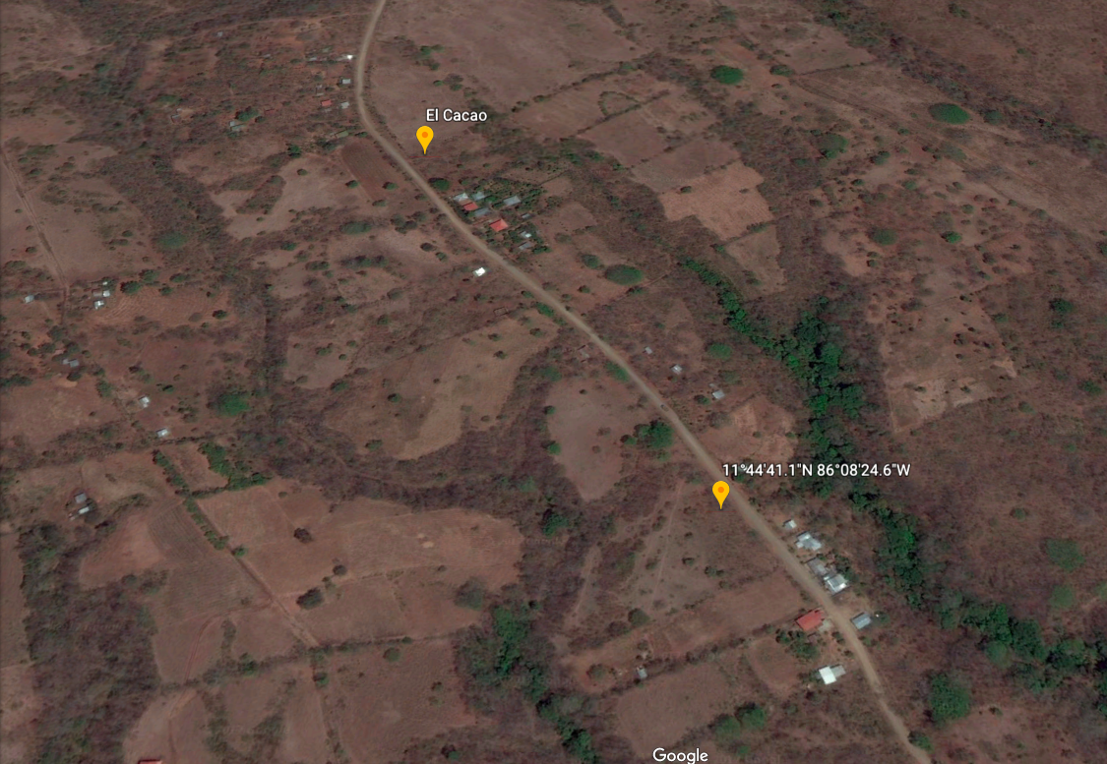
Figure 1: Satellite imaging of the current El Cacao community
Abstract:
The EWB UMD Nicaragua Travel Team plans to conduct a topographical survey using TopCon equipment to map elevation data within the entire city of El Cacao, Nicaragua. The specific points that are of importance are listed below in list format but are representative of key natural and built environmental structures that are deemed important for future analysis. In order to best address possible challenges encountered by the travel team, backup-plans and follow up procedures are listed below in order to ensure a successful first trip to Nicaragua. The end goal is to obtain and retrieve the elevation data and export the data into a Geospatial Information Systems (GIS) format through a designated software (e.g.) AutoCAD. The GIS information analysis will be used in regards to future design for a potential water distribution system.

Methods:
` Depending on the circumstances that arise during the travel team’s first trip to El Cacao, several surveying methods may need to be employed to develop a thorough, yet efficient, graphical representation of El Cacao’s terrain. If the team is tasked with building a new water distribution system for the community, a precise and extensive land survey will be required in order to have a manipulable electronic topographical representation of the area. However, as the first trip is centered on initial information gathering, a complete electronic land survey may not be necessary to develop an adequate depiction of the topography. Depending on what will be implemented in the future, for example, if no further water distribution systems are required, and land survey may not be necessary. Instead, there are other methods for determining topography that are more efficient than surveying. The following is a list of the various methods that may be implemented by the Engineers without Borders, UMD, Nicaragua travel team to determine the topography of the area.
- Topographic Survey: a highly extensive and precise land survey using topcon equipment to transpose the recorded topography into a GIS representation of El CaCao.
- Construction Survey: using construction-oriented techniques to stake out the area, these include horizontal and vertical grading, slope staking, and a final as-built survey upon project completion
- Site Planning Survey: using boundary and topographic survey as a base to design future improvements to a system.
- GPS tracking: using smart phone and GPS technology to record the elevation of the most important parts of the community. Applications such as GPS Tracks are excellent for this procedure. (this method should be used when less detailed surveying data is adequate for the trip).
- Paper Surveying: (this method should only be used if all equipment to perform the previous methods is inaccessible) In the worst case scenario, a protractor, bubble level, and measuring tape can be used to record the distance and elevation of important points in the area. Using trigonometry, these values can be converted into survey coordinates.
- Additionally, take note of Water hydrology, rainfall depths, watershed elevations throughout the area.

Points to Survey:
The EWB UMD Nicaragua Travel Team plans to map out every feature of the
town of El Cacao, Nicaragua through the use of a Topcon surveying system, a GPS tracking application, or hand calculations, depending on our need and the availability of equipment. To this end, we plan to specifically chart the locations and sizes of, at a minimum, the features contained in the following list, as well as record other vital information such as treeline dimensions and the water table elevation in the immediate relevant area.
- Manhole covers/ any access point to pre-existing underground systems
- Invert and crown of pipes between manhole covers
- Unearthed pipes and other exposed subterranean infrastructure
- Pre-existing water distribution systems (valves, wells, bends/fittings)
- Natural high and low points, all changes in elevation (install air release valve at high point)
- Natural sources of water (lakes, rivers, underground spring, cross-sections etc.)
- Homes/Small Structures(houses, sheds, small shops)
- Large Structures (school, community center, etc.)
- Fences/Manmade barriers
- Power Distribution Systems (Poles, power lines, stationary generators)
- All Concrete Structures
- Natural barriers that could interfere with our eventual mission (ravines, etc.)
- Roads/paths
- Latrines/Other waste disposal areas

Possible Challenges:
The EWB UMD Nicaragua Travel Team may encounter a variety of more complex situations while surveying El Cacao that may require a different approach. Below are listed several issues that may arise during the travel trip and solutions to them:
1. Issue: Surveying on mountainous terrain (area with significant elevation changes)
The “advanced angle measurement system” of topcon enables accurate measurements on even mountainous terrain when properly leveled
2. Issue: Thick tree cover makes it difficult to get a clear shot over distances
The Topcon can still locate the prism through bushes, tree branches, and leaves if slightly intrusive; however, when possible, select survey points that do not interfere with trees. If trees cannot be avoided or you need to find elevation at the point of a tree. Establish a point at a known elevation, centered in front of the tree, set the topcon up there and shoot the other side of the tree in the opposite direction to get the elevation “through the tree” with the offset
3. Issue: Surveying points in between building complexes
To shoot the building itself: hold the rod as close to the building as possible and shoot the distance, can offset on Topcon distance if necessary. If possible, line topcon up so it avoids buildings, and goes around or between them, if not possible: shoot topcon to the closest corner of the building, holding the rod as close to the building as possible (or measuring the offset) and shoot along the edge of the building.
4. Issue: Lack of known elevation points in Nicaragua
Set initial point as 1000, 1000, 1000, since it will not be exported to an international datum.
5. Issue: Surveying roads or high traffic areas
When working in traffic, personal protective equipment must be worn. This includes goggles, proper footwear, high-visibility vests, and working only during daylight hours when there is no flagger. If possible, warning signs should be set up prior to the survey work. Follow safety rules:
    - Always face traffic when working on the traveled way of a divided road or on shoulders of highways
    - Do not make sudden movements
    - Avoid interrupting traffic as much as possible
    - Minimize the crossing of traffic lanes
    - Use a barrier to shield you from traffic
    - Do not allow equipment to impede traffic in other lanes
6. Issue: Surveying on private property
We will need to approach homeowners and ask them to survey their land. If they refuse, we can inform them the impact of surveying their land. As a last resort, we can identify the property line, and take survey points along the property’s edges. Furthermore, we could shoot points and offset them by a certain distance to represent the house.
7. Issue: Top-Con malfunctions and Damaged Equipment
We will need to bring a second prism, to ensure there is a backup if the first one breaks. We will not be able to use the Topcon if both prisms break and would have to rely on the hand calculated system, and look through the viewer to find the top of the rod. If top-con malfunctions, use hand calculated system.

Equipment:
The EWB UMD Nicaragua Travel Team will need to bring a variety of equipment to effectively survey El Cacao. This equipment is listed below and includes the materials necessary to use the TopCon system or the GPS alternative backup:
- Topcon/tripod stand
- Scope and level
- Prism (x2)
- Rod
- Walkie-talkies
- Long Tape measure (metric)
- Flexible tape measure (metric)
- Data Collector (If operational)
- Waterproof and Tear-Resistant notebooks
- Reflective Vest
- Personal Protective Equipment
- GPS (alternative backup)
- Smartphone with GPSTracker app installed (alternative backup)

Water Sample Testing
- Conducting using several samples along the flow path of the water source and at each distribution tank.
- Analyzed using recommended EWB methods (Hach PathoScreen test kits in addition to WaterSafe test strips to identify microbial contamination, and turbidity measurements).

Wells
The community already has two communal wells that need to be assessed for performance, as well as a third decommissioned well. The community application denotes that only 20/93 families are supplied by these wells, so regardless of this well’s ability, another source of water is necessary. To test the current well for ability, the team should measure flow rate and possibly do an aquifer test. To measure flow rate, the team should allow the well to run for a designated amount of time, and then record the volume. An aquifer test, according to Glenn M. Duffield, President of HydroSOLVE, Inc., measures the permeability of the aquifer, which could help determine the effectiveness of the current well. A slug test, which is a type of aquifer test, is an inexpensive way to determine the hydraulic potential of the well, but requires specific tools and software to do most accurately.
Since we do not have sufficient information regarding data on the current communal wells in the El Cacao community, the travel team will have to determine if the current ones are suitable to provide enough water for the remaining 73 families. To determine if the desired amount and quality of the water is available, the following should be considered, according to “Water Well Design and Construction” by Thomas Harter of University California Davis:
- Prior knowledge of groundwater
- Land surface topography and geophysical measurements
- Local vegetation geology
- Groundwater chemistry
- Thickness/Depth/Permeability of aquifers from existing wells
- Groundwater levels
- Satellite/Aerial Photographs

Catchment Ponds
According to “How To Calculate Catchment For A Pond” by Phil Williams, Ponds are used to collect water in the form of surface runoff and rainwater from the area that around them known as a catchment. Catchments can be determined using a contour map or surveying to find the areas uphill from a low point. To determine the particular amount of runoff flowing into the pond, the hydrologic soil type and the rainfall of the area must be known. According to Purdue Engineering, soil type falls into four different categories, known as groups A through D. These are listed below and should be tested for:
- Sand, loamy sand or sand loam types of soils
- silt loam or loam
- sandy clay loam
- clay loam, silty clay loam, sandy clay, silty clay or clay
The sandier groups have a much lower runoff potential than the more clay soils, which is less beneficial for a catchment pond. The specific runoff amount can be calculated though is not pertinent during surveying process.

Spring Boxes / Seepage System
For the implementation of spring boxes or seepage systems a proper spring source needs to be identified. Typically, springs arise where groundwater is close enough to the surface that some water will spill onto the surface. The site of a spring should be easily noticed by water spilling out of the ground in a concentrated location. By comparison, a seepage spring looks like a continuously wet spot in the ground or hillside. Water can be gathered from these using a perforated pipe attached to a spring box but the water source must be continuously supplied.
The first step of cataloguing a spring is to record its location on the site analysis. Springs should be well concentrated sources of water that can be noted as a point on the site plan. However, if the area of the spring is significantly large in the case of seepage, the surface area of the spring or seepage should be recorded. Additionally, the flow rate of the spring across the day, week, season, and year should be recorded.
For both systems, the source of the spring should be identified by removing the loose soil around the spring until an impervious surface can be found. The type of soil on the surface as well as the type of impervious surface below should be noted. This helps with the design of spring boxes because they need to be constructed on firm, impermeable soil to prevent underscoring.
In addition to soil characteristics, the water properties should be recorded for different times of day, week, and year. Information on water testing can be found in Water Sample Testing.

Tanks and Pumps
The survey must determine a viable location to build the water tank. The tank must be placed in a flat location that is easy for community members to access or allow the creation of an efficient distribution system through piping. A map of of the community would be helpful to determine where to place the tank. The survey group should look to specifically map population centers and topography in the community. Additionally, the survey should determine how much electricity could feasibly be devoted to pumping water into and out of the storage tank, be this from the existing electric grid, or finding an area where solar panels could be placed where they would not be damaged, and could gather enough power to run the pump.
The survey group, after looking at potential placement for tanks should be try to find how deep the tank can be. This will affect what type of pump must be used in order to retrieve water from the tank.

Carbon and Sand Purification
Activated carbon can filter out chlorine, chloramine, tannins, phenol, some drugs, hydrogen sulfide and some volatile compounds, and small amounts of metals, can diminish unpleasant odors, and can improve water clarity. It cannot filter out ammonia, nitrates, nitrites, fluoride, sodium, large amounts of metals or hydrocarbons, or microorganisms. The presence of all these things should be measured.
For sand, we should identify the nearest sand supply to El Cacao, the type of soil and sand on the site. We need between .35mm and .15mm effective size with a uniformity coefficient of less than 2. We should figure out if there is a site available for a slow sand filtration system, at least 30” deeper in the ground is better for every fine coarse sand.

Rainwater Catchment
Rainwater catchment systems can be made by extending the roof gutter system so that the roof water flows into a tank. First, the survey should identify how many buildings already have rainwater catchment systems. Make sure to note what kind of building it is and its location in the community. If there are pre-existing systems, the survey should take note of what materials were used in making those systems. Also, the survey should ask the owner of the catchment system how often he or she uses it and what reasons do they use it for.
During the time of the survey, Nicaragua will enter its dry season. Thus, there will most likely be no water in the system. If there is water in the system, take water samples from the roof, gutters, and tank. Also, record the average roof surface area, shape (angle in which roof is inclined), state (rusty, dirty, clean, etc.), and material.

Filters and UV Purification
In order to choose an appropriate filter, the surveying team would need to see what filter replacements are available in the local hardware stores. It is also important to check the temperature of the water because filters are only able to function properly under a certain temperature. The pre-existing wells should also be assessed in terms of if filters need to or can be installed. In terms of what filter needs to be chosen, we will have to analyze the water collection data.
For UV purification the team needs to see what the availability of the UV lamps are the hardware stores because the UV lamp will need to be changed periodically.The turbidity needs to be assessed as well because UV filters can only be used to purify clear water. If dissolved solids are present, the UV purification should not be used because this method cannot remove dissolved solids from water.

Chlorine purification
- Chlorine purification would kill bacteria or other organic contaminants in the water. -
- However, it should be noted that chlorine purification has had problems in the past because people don’t like the taste. If this is implemented we may want to consider filtration after to remove the chlorine and improve the taste. (CDC, https://www.cdc.gov/healthywater/drinking/public/chlorine-disinfection.html)
- Chlorine levels up to 4 milligrams per liter (mg/L or 4 parts per million (ppm) are considered safe in drinking water. At this level, no harmful health effects are likely to occur. (CDC, https://www.cdc.gov/healthywater/drinking/public/chlorine-disinfection.html)
- Some things that need to be researched further: proximity to a hardware store/place that chlorine can be obtained, if the community can afford continued purchase of tablets or chlorine diffusers, and if the people are receptive to the idea of chlorinated water or if this will not be a wanted solution.
- In addition, chlorine will not remove toxins or chemicals.

General Sampling Instructions for water testing
- Representative samples
  - ie. samples with similar color, smell, particulate matter content to majority of water source
  - Samples should be taken from existing public well at multiple points along distribution system, and from any open storage tanks
  - Samples should be taken from at least one private well
  - Samples should be taken from any viable streams, springs, or seeps encountered
- Triple rinse all equipment
  - Two rinses with distilled water, one rinse with water from next sample to undergo test
- Calibrate all meters before running tests
- Neutralize and dispose of all wastes from field lab properly
  - Sample and reagent containers must be thoroughly cleaned or disposed of to prevent reuse
- Laboratory testing
  - If samples are sent to an in country lab for analysis, keep track of handling procedures regarding holding times, preservatives, ice, and headspace in the lab of interest
  - Schedule testing ahead of time
  - Maintain contact in case of need for follow up testing
- Quality Assurance
  - Trip blank - distilled water in sealed container, kept with other samples and tested
    - To ensure samples maintain quality throughout transport
  - Field blank - fill container with distilled water in the field, opening the sample bottle in the same conditions that other samples are under, test
    - To test for in-field contamination of samples
  - Equipment blank - fill sample bottle with rinse while washing equipment, test
    - To test for cross contamination via dirty equipment
  - Field duplicate - take a second sample from the same location, test
    - To test for precision of sampling and testing
    - Results should coincide with sample duplicated

Parameters to test for

- Essential Parameters
  - Turbidity - important to test for due to implications for treatment techniques, can also affect aesthetic appeal of water
    - Chlorination and UV disinfection are dependent on low turbidity readings
    - USEPA standard - below 5 NTU
  - Total Dissolved Solids- does not have direct human health implications but can identify a need for further filtration, can also affect taste of water at high concentrations
    - TDS will be tested for indirectly via Specific Conductivity
    - USEPA standard - below 500 mg/L
  - Specific Conductivity - This test is testing for the amount of dissolved mineral ions present in the water. With this test, we can determine the water's electrical conductivity. If the conductivity is high, then the water becomes saline.
  - Bacteria - Tests for presence of coliforms to detect possible human health threats, can also indicate contamination by fecal matter
    - USEPA standard: public health goal = 0
- Geogenic Hazards
  - Arsenic - highly toxic to humans, may be an issue in Nicaragua due to volcanic contamination of groundwater
    - USEPA standard- below 0.010 mg/L
  - Fluoride - Large amounts of Fluoride can act as a neurotoxin and cause aggression, lower IQ, and a mental fog.
    - USEPA standard-below 4 mg/L
- Supplemental characteristics
  - pH - Measures the acidity/ alkalinity of water.
    - USEPA standard - between 6.5 and 8.5
  - Temperature - useful for quality assurance of sampling
  - Color - Discoloration may be indicative of dissolved organic matter or inorganic metals
    - In either case, discoloration identifies a potential need for treatment
    - Color is also a big component of aesthetic appeal of water
  - Hardness - Hardness is not generally a health concern, but (Hardness) Hard Water can have an unpleasant taste, can form a hard scale on pipes and equipment as the metal ions (calcium and magnesium) precipitate out as the temperature rises. Hardness can be measured in the field using test strips or a drop count titration.
USGS general guidelines for classification of waters are:
    - 0 to 60 mg/L (milligrams per liter) as calcium carbonate is classified as soft
    - 61 to 120 mg/L as moderately hard
    - 121 to 180 mg/L as hard
    - More than 180 mg/L as very hard.
  - Iron - While discoloration has no negative health effects, it can be deterrent for users who would then find an alternate source of water that might be contaminated.
    - High iron levels in water can lead to discoloration.
    - Can also lead to buildups and pipe blockages.
    - Iron levels of 0.3mg/L or higher can stain clothing and plumbing
- Hazards from Human Activity
  - Nitrites/Nitrates- High Nitrate levels can pose a health risk to users. In addition, Nitrate can be an indicator of other contamination from septic systems or agriculture. Also, they might indicate the presence of nitrifying and denitrifying bacteria within the water source or the system itself.
    - USEPA standard - 10mg/L as NO₃⁻, 1 mg/L as NO₂⁻
  - Ammonia - High levels of Ammonia are indicators of faecal matter contamination
    - odor effects at a concentration of 1.5 mg/L and taste effects at 35 mg/L
  - Phosphates - High levels of Phosphates in water can lead to serious environmental impacts since they cause the water level to decrease over time
    - Human wastewater can run off into the water body which results in the eutrophication of water. This leads to an algal bloom that chokes the waterway and causes decay in the aquatic life.
    - USEPA standard - 0.1 mg/L for streams which do not empty into reservoirs, 0.05 mg/L for streams discharging into reservoirs, 0.025 mg/L for reservoirs.
  - Chlorine demand and residual - testing for the amount of chlorine that must be applied to properly treat drinking water
    - Chlorine demand refers to the amount of chlorine that reacts with inert matter in the water
    - Chlorine residual is the amount of chlorine free for disinfection
    - Free chlorine is effective at a concentration of 0.3-0.5 mg/l at a minimum to maintain disinfection and starts having taste issues around 2.0 mg/L.
    - USEPA standard - less than 4 mg/L free chlorine

Test Procedures
- Turbidity
  - Secchi disk method
    - Fill transparency tube with water from source until secchi disk is obscured
    - Release water until secchi disk can be seen
    - Record height of water column
- Specific Conductivity
  - Field meter (μS·cm⁻¹)
    - Calibrate the meter with a conductivity standard solution like KCl or NaCl with a known TDS/conductivity value and immerse probe in solution. Gently swirl until value stabilizes.
    - Rinse the probe with deionized or distilled water then wipe with tissue.
    - Insert probe into sample and gently swirl until value stabilizes.
- Bacteria
  - HACH PathoScreen (P/A test)
    - Prepare sample bottles
      - Add 10-12 drops of bleach solution to the bottle cap
      - Swirl and invert bottle, coating walls and inner surface of cap with solution, allow to sit for 2min
      - Rinse sample bottles several times with sample water
    - Collect sample - fill the prepared bottle to she shoulder with sample water (approx. 20mL)
      - Prepare a control sample with bottled water as well
    - Add medium
      - Swab PathoScreen Medium powder with alcohol
      - Empty contents of powder pillow into sample bottle
      - Cap bottle and invert sample to mix with medium
    - Incubate
      - Store samples at constant temperature (77-95F) for 24-48 hours
    - After elapsed time, store negative samples for additional 24 hours
      - Interpret results
      - Color change from yellow to black or the formation of a black precipitate indicates a positive result
      - No color change indicates a negative result
  - Plate count test
    - Petrifilm test
      - Lay the films on a flat surface, with the flaps opening towards you.
      - Fill a 1mL pipette with the water to be tested.
      - Lift the flap on the first film, and use a pipette to gently spread the solution on the film. Ensure that the pipette does not scratch the film surface, and that the water does not overflow the film's circular area.
      - Gently replace the clear sheet on the surface of the film. Make sure there are not significant air bubbles between the clear sheet and the film's surface.
      - Use a permanent marker to write the sample name on each film.
      - Repeat steps 2 - 5 for as many films as needed.
    - Incubate
      - Store samples at constant temperature of 37 +/- 1 Celsius for 48 hours
    - Interpret results
      - Compare the bacteria count with the Petrifilm manual and record data
- Arsenic
  - Colorimetric method
    - Fill bottle with water sample
    - Add one scoop of arsenic reagent with provided spoon.
    - Cap bottle and shake vigorously for 15 seconds
    - Uncap and add another scoop of the second arsenic reagent.
    - Cap bottle and shake vigorously for 15 seconds.
    - Uncap and add another spoon of the third arsenic reagent.
    - Cap bottle and shake vigorously for 5 seconds.
    - Insert test strip into water and wait 10 minutes.
    - Compare the color of the strip to the Arsenic Color Chart
- Fluoride
  - Field test kit
    - Acquire 50 mL sample of water from source.
    - Place test strip into 50 mL sample.
    - Compare color change to palette on bottle to determine fluoride concentration.
- pH
  - pH paper
    - Acquire 50 mL sample of water from source.
    - Place pH strip so that both pads are submerged in the water source.
    - Allow strip to sit undisturbed for a few minutes.
    - Remove the strip from water and compare to pH color chart on the kit.
- Color
  - Visual description
    - Take observations of color and odor of sample
    - Note any particulate matter floating in sample
- Hardness
  - Field test strip
  - Drop count titration
- Iron
  - Colorimetric method
    - Remove plastic cap from plastic vessel, rinse with sample water
    - Fil vessel with 10 mL of sample water
    - Add included reagent packet (HI 3831-0)
    - Replace cap, shake to mix until all solids dissolved
    - Transfer solution to color compactor cube, let sit for 4 minutes
    - Compare solution color to color palette and record concentration in mg/L (ppM)
- Nitrites/Nitrates
  - Test strip method
    - Acquire a 50 mL sample of water from the source
    - Dip test strip in sample, observe and note color change
    - Compare color change to color palette on bottle for concentration nitrate/nitrite
- Ammonia
  - Dip Strips
    - Dip test strip in motionless sample of water
    - Observe and note color change
    - Compare color change to color palette on bottle for concentration of ammonia
- Phosphates
  - Colorimetric method
    - Add Potassium Persulfate Powder Pillow to water sample and swirl
    - Add 2.0 mL of 5.25 N Sulfuric Acid Solution to the flask.
    - Boil the sample gently for 30 minutes
    - Do not let the flask boil dry
    - Concentrate the sample to less than 20 mL. (maintain the volume of sample near 0 mL by adding small amounts of deionized water)
    - Let the sample cool to room temperature
    - Add 2.0 mL of 5.0 N Sodium Hydroxide Solution to the flask.
    - Swirl and rinse with deionized water to 25mL
    - Proceed with reactive phosphorus test of the expected acid hydrolyzable phosphorus concentration ranges
- Chlorine (contingent on low turbidity)
  - Mix a mother solution, a solution with a specific percentage chlorine (typically 1%)
    - Mother solutions are made by mixing a chlorine-generating product with water. The quantity of product needed to make one litre of a 1% mother solution can be calculated with the formula:
    - Qty = 10 x (100/Cl_{cont})
    - Qty: Amount of product needed to make 1 liter of a 1% mother solution
    - Cl_{cont}: Chlorine content of the product (in %)
  - Determine the chlorine demand of the water sample
    - Set up multiple buckets of raw water and add different quantities of mother solution to each (ex. 4 ten liter buckets of water with 0.5, 1, 1.5, and 2 mL of mother solution). Mix buckets and leave for 30 minutes.
    - Add a DPD1 tablet to the water in a pooltester and shake. The color of the water will now give the amount of residual chlorine.
    - We are looking for the dose of mother solution that results in a free residual chlorine content of 0.2-0.5 mg/L
    - Note that this is our target residual chlorine level at the point of water distribution, if the water has to travel from a water treatment source we should make the chlorine levels slightly higher.
  - Determine the amount of mother solution needed, and mix
    - If a batch of water has to be treated:
      - Ms_{bat} = (Vol_{bat}/Vol_{test}) x Ms_{test}
      - Ms_{bat}: The amount of mother solution required to chlorinate the batch of raw water (in mL)
      - Vol_{bat}: The volume of the batch of water which has to be treated (in liters)
      - Vol_{test}: The volume of water that was used in the test (in liters)
      - Ms_{test}: The amount of mother solution which was required to chlorinate the water in the test (in mL)
    - If a continuous supply of water has to be treated:
      - Rate_{Ms} = (Flow_{sup}/Vol_{test}) x Ms_{test}
      - Rate_{Ms}: The rate at which mother solution has to be added to the supply (in mL/sec)
      - Flow_{sup}: The flow of supply of raw water (in liters/sec)
      - Vol_{test}: The volume of water that was used in the test (in liters)
      - Ms_{test}: The amount of mother solution which was required to chlorinate the water in the test (in mL)

Soil Sample Testing
Soil testing will be completed at a site suitable for the construction of a water storage tank. A test pit will be dug to a depth of 1.5 to 3 feet to allow for soil testing at different depths. Soil quality across the region will be assumed to be fairly homogenous, with the exception of sites of springs or seeps. If springs or seeps are encountered, another run of soil tests will be performed on the loose topsoil and denser undersoil. The team should also look for areas of scour or erosion near existing buildings to assess how soil compaction impacts runoff.

Test Procedures:
- Identify location and dig to depth of interest (approximately depth of structure foundation - 1.5 to 3 feet)

- Examine different layers of soil for investigation

- Perform SOIL DESCRIPTION TESTS
  - Angularity
    - Identify coarse-grained particles as one of four options (Figure 1)
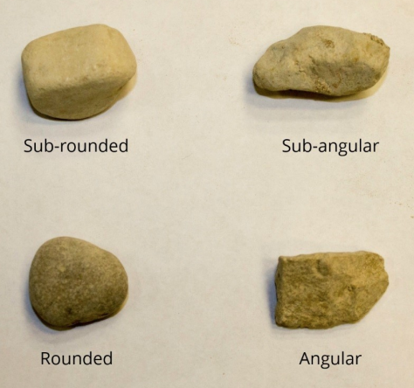
Figure 1: Types of Coarse-Grained particles^{[1]}
  - Describe shape of particles for gravels and larger particles
  - Describe color of soil
  - Describe moisture content
    - Dry- dusty
    - Damp- moist with no visible water
    - Wet- visible free water
  - Odor - heat a moist sample of soil in a spoon using lighter
    - Note if odor is organic or unusual (unusual may indicate presence of chemicals)
  - Consistency test using either pocket penetrometer, torvane, or thumb
    - Classifications are as follows (Figure 2):

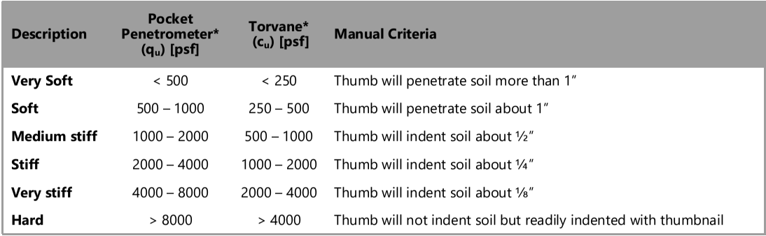
Figure 2: Consistency Classifications^{[1]}
  - Cementation
    - Weak- soil crumbles with handling
    - Moderate- soil crumbles with considerable finger pressure
    - Strong- soil will not crumble with finger pressure
  - Structure - categorize intact portions of soil according to the following chart (Figure 3):
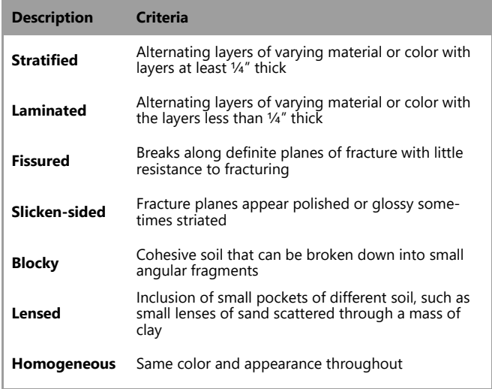
Figure 3: Soil Structure Classifications^{[1]}

- Perform one of two PARTICLE SIZE GRADATION TESTS
  - Jar test
    - Fill one liter bottle with 700-800 mL water
    - Fill rest of bottle with soil
    - Shake vigorously until no clumped soil remains, leave bottle to settle without shaking
    - Mark volume levels for soil settled after
      - One minute - sand and bigger particles
      - One hour - silt particles
      - One day - clay particles
    - Use volume readings to estimate percentage of sand, silt, and clay in soil
  - Sieve test
    - Take a representative dried sample of soil. If soil particles are lumped or conglomerated, crush the lumped particles.
    - Prepare a sieve stack with the lowest number sieve on the top and the highest number sieve on the bottom.
    - Place the pan under the bottom sieve to collect the fine material, the sample in the upper sieve, and the lid on top.
    - Shake the sieves for about 30 seconds to allow the particles to pass through the sieves.
    - Estimate the percentage of soil retained on each sieve and on the pan. Gravel is material that is retained on a No. 4 sieve, sand is material that is retained between a No. 4 and a No. 200 sieve, and fines are material that pass a No. 200 sieve.
    - Note, if a No. 10 and No. 40 sieve is used, an estimate of coarse, medium, and fine sand can be obtained.

- Perform IDENTIFICATION AND CLASSIFICATION TESTS
  - If soil is >50% fine grained (Fines = clay + silt)
    - Dry Strength test
      - Take soil sample smaller than No. 40 sieve, add water if necessary until soil has consistency of putty
      - Form 3 balls of soil roughly one inch in diameter
      - Air or sun dry samples until completely dry
      - Crush samples between fingers, classify as:
        - Slightly plastic silt- crumbles into powder
        - Medium plastic and medium compressible clay or highly compressible silt - breaks into pieces between finger and a hard surface
        - Highly plastic and highly compressive clay - will not break into pieces
    - Dilatancy
      - Take soil sample smaller than No. 40 sieve, mold into ball with ½ inch diameter
      - Add water if necessary until soil has soft but not sticky consistency
      - Smooth soil across palm of one hand
      - Shake horizontally by striking side of hands together several times, note any appearance of water
      - Squeeze soil by pinching between fingers, classify as:
        - None- no noticeable change in moisture
        - Slow- water appears slowly after shaking, does not disappear or disappears slowly after squeezing
        - Rapid- water appears rapidly during shaking, and disappears quickly after squeezing
    - Toughness
      - Shape the sample from the dilatancy test into an elongated pat and roll by hand on a cutting board or between the palms into a thread about 1/8” in diameter.
      - Fold the sample threads and re-roll repeatedly until the thread crumbles at a diameter of about 1/8”. The threads will crumble at 1/8” diameter when the soil is near its plastic limit.
      - Note the pressure required to roll the thread near the plastic limit as well as the thread strength.
      - After the thread crumbles, lump the pieces together and knead until the lump crumbles. Classify based on Figure 4.
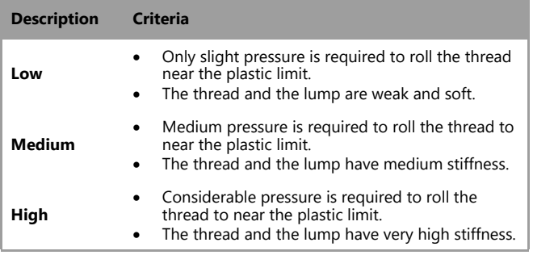
Figure 4: Toughness Classification^{[1]}
    - Plasticity - to be completed with toughness test
      - Classify plasticity based on Figure 5.
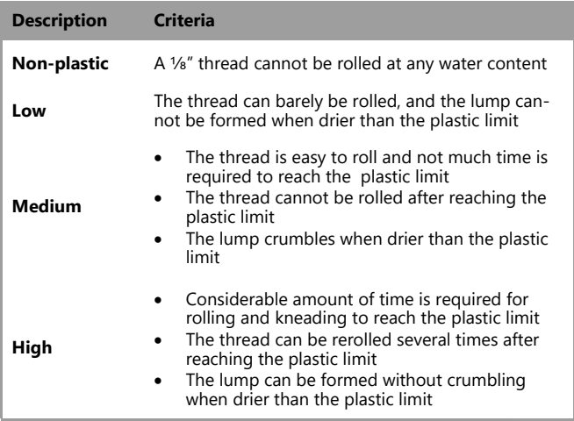
Figure 5: Plasticity Classification^{[1]}
    - Ribbon test
      - Select enough material smaller than a No. 40 sieve from the specimen to form a cigar-shaped cylinder of soil about 1⁄2” or 3⁄4” in diameter and about 3” to 5” long.
      - Flatten from one end to the other by pinching until a ribbon ¼ to ⅛” thick is obtained. Classify as:
        - Fat clay- 8 to 9” ribbon can be obtained
        - Lean clay- less than 8” ribbon obtained
        - Sand or silt- no ribbon obtained
    - Shine test
      - Draw fingernail or knife over slightly moist soil pat, classify as:
        - Fat clay- surface becomes shiny or lighter where scraped
        - Lean clay- surface remains dull where scraped
        - Sand or silt- surface very dull or granular
    - Feel test
      - Rub soil sample smaller than No. 40 sieve across skin of wrist, note harsh or smooth texture

    - Grit test
      - Place soil sample smaller than No. 40 sieve between teeth, bite, classify as:
        - Sand- harsh grating between teeth
        - Silt- does not feel very harsh between teeth
        - Clay- smooth and floury feeling between teeth
    - Review fine grained classification tests to identify inorganic content of soil based on Figure 6:
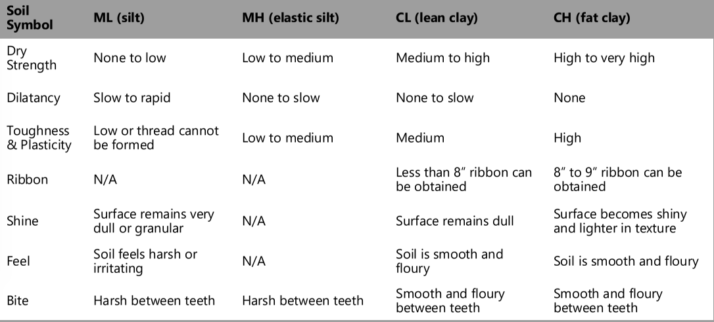
Figure 6: Inorganic Content^{[1]}
  - If soil is <50% fine grained
    - Clean test
      - Wet portion of soil sample in hand, classify as:
        - Dirty- fine grained particles stick to hand, percentage of fines likely greater than 5%
        - Clean- hand stays clean, percentage of fines likely less than 5%
      - Arrange coarse particles by size, classify based on Figure 7:
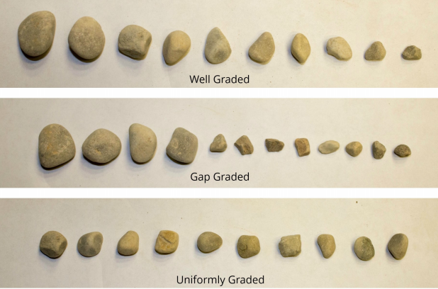
Figure 7: Grading of Coarse Particles^{[1]}

- Perform ROCK CLASSIFICATION TESTS
  - If rock is encountered, consult the rock type chart (Figure 8).
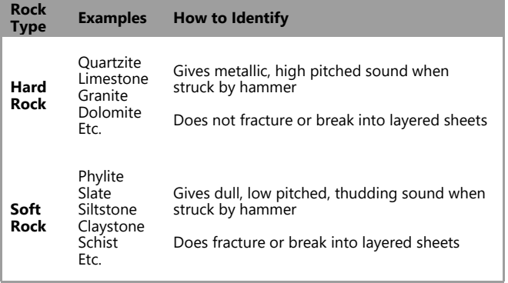
Figure 8: Rock Type Chart^{[1]}
    - Consult a geologist or geotechnical engineer for a more detailed analysis

Baseline Study and Needs Assessment
Approach
The assessment team will conduct a baseline study of El Cacao to 1) identify community needs related to water quality and access 2) establish a baseline condition for program monitoring and 3) identify contextual factors which may affect program success. The study will draw upon theories and methods of anthropology, public health, and international development to understand community context and its impact on program implementation, monitoring, and long-term success. The work will be conducted considering the EWB-USA Theory of Change, Planning, Monitoring, Evaluation, and Learning (PMEL) framework, and recommendations from the EWB-USA 2015 Nicaragua Closeout Impact Report.
Objectives
EWB-UMD will identify El Cacao’s immediate needs regarding water access and quality, establish a baseline condition, and study contextual factors related to program implementation and impact. The team seeks to understand the community holistically in an effort to understand need for water access within the community’s historical and present context. Contextual factors include community structure, economy and subsistence, environmental characteristics and impact, health perceptions and concerns, technological capacity, and water conditions and standards, among others.
By understanding the structural factors which contribute to the present situation related to lack of water access, EWB-UMD seeks to provide solutions which best address this critical community need. In addition, EWB-UMD will utilize the baseline study to create metrics for evaluating program success. Upon completion of the study EWB-UMD will:
1) Identify stakeholders for water supply infrastructure in El Cacao
2) Understand community need through surveys, participant observation, and in-depth interviews
3) Discern barriers to water access
4) Establish a baseline for public health, environmental health, and community capacity
5) Explore the community’s cultural, social, political, and economic context
Methods
The baseline study will utilize a qualitative approach to capture the diverse experiences and needs of stakeholders. All materials will be translated in English and Spanish prior to travel by bilingual engineering professionals and students. Fieldwork will be conducted by undergraduate students, an engineering professional, and a medical anthropologist with varying Spanish proficiencies. A Spanish-fluent individual familiar with the study will facilitate community interactions.
Participant observation
A travel team member will conduct participant observation at site of interest in the community. These sites may be related to water and sanitation, have social value, or be significant to daily life in the community. The observation will support assessment of water use behaviors as well as provide additional information regarding community context.
Community-wide meeting
EWB-UMD will conduct a community meeting facilitated by Comités de Agua Potable y Saneamiento (CAPS) and Asociación Tierra y Vida to introduce the program, describe the organization’s capacity, define the goals of the partnership, and create dialogue regarding community need. In addition, the meeting will be an opportunity to identify stakeholders and recruit participants for interviews.
Interviews
Semi-structured interviews will be conducted with key informants and individuals identified to provide a diverse set of experiences, perspectives, and interests. Participants will be selected to represent the full diversity of stakeholders in the community. Each interview will be conducted using an interview guide emphasizing community need and potential solutions.

Design Alternatives Considerations
Refer to 2.2 Water Sample Testing.

Schedule of Tasks
Appendix A shows the team’s schedule of tasks while in El Cacao. This plan outlines the schedule to collect water samples, meet with the community, source for materials, survey the community land and survey community health. The schedule will be adapted on the ground as needed to adapt to new information; the team will meet every day to evaluate the schedule, completed tasks and new information to plan remaining time accordingly.

Go/No Go Decision
The chapter’s involvement in the community will determine the outcome of this assessment trip. The community has identified multiple issues for the next phase of implementation and will use information gathered on this trip to determine a “go/no go” on deciding what implementation is necessary. The following criteria will be used to decide the feasibility of each proposed action in the project:
  - Community Health Survey
- Go: If the community health survey indicates water borne illness attached to drinking from the water distribution system, we will go forward with implementing point of use water treatment systems.
- No-go: If the community health survey indicates no water borne illness from the water distribution system, we will not go forward with implementing point of use water treatment systems.
  - 5% Community Contribution for El Cacao Water Project
- Go: If the majority of the community agrees on at least one water treatment solution as something they would use, benefit by and pay 5% to own, we will go forward with the water treatment solution.
- No-Go: If the majority of the community does not agree that any water treatment solution presented or suggested by them is something they would use, benefit and pay for, we will not go forward with the water treatment solution.
  - Community feedback of distribution expansion
- Go: If the majority of the community agrees on the location and benefit of an expansion of the distribution system we will go forward expanding it.
- No-Go: If the majority of the community does not agree on the location and benefit of an expansion of the distribution system we will not go forward expanding it.

List of Attachments
Currently no attachments have been added. If attachments need to be included this will be updated.

References
Harter, T. (2017). Water Well Design and Construction. [online] groundwater.ucdavis.edu. Available at: http://groundwater.ucdavis.edu/files/156563.pdf [Accessed 17 Oct. 2017].

“Hydrologic Soil Groups,” More Information - Hydrologic Soil Groups. [Online]. Available: https://engineering.purdue.edu/mapserve/LTHIA7/documentation/hsg.html. [Accessed: 16-Oct-2017].

^{[1]}Itzen, L., Davis, T. (2017). Field Guide to Soil Classification. Milwaukee, WI: Milwaukee School of Engineering

P. Williams, “How to Calculate Catchment for a Pond,” FoodProduction101 | Grow Your Own Food | Chicken Care, 13-Sep-2013. [Online]. Available: http://foodproduction101.com/how-to-calculate-catchment-for-a-pond/. [Accessed: 16-Oct-2017].

T. Klenck, “How It Works: Water Well Pump,” Popular Mechanics, 03-Feb-2015. [Online]. Available: http://www.popularmechanics.com/home/how-to/a152/1275136/. [Accessed: 23-Oct-2017].

Appendix A: Calendar

Task | Day 1 | Day 2 | Day 3 | Day 4 | Day 5 | Day 6 | Day 7
Travel from US to Managua
Travel to Embassy
Travel to El Cacao
Community Meeting (leaders)
Community Meeting (all members)
Community (people) Sampling
Water Sampling
Soil Sampling
Land Surveying
In-country fun
Travel from El Cacao to Managua
Travel from Managua to US

Appendix B: Response to Feedback

Are you taking into account waste water/grey water disposal after implementing a drinking water distribution system?
Based on the feedback we have received, we have researched options on managing greywater. There is the possibility of implementing either household or centralized technology that could turn greywater to non-potable water suitable for irrigation. Constructing a centralized water treatment is likely infeasible because the need for return pipes and water treatment tanks would double the required infrastructure. Alternatively, a lesson on greywater management that helps teach community members sanitary and healthy uses could maximize water usage without increasing costs for materials or need to build more systems. Both options will be evaluated against what the community would prefer, as well as potential integration to the primary water system implemented.

Appendix C: How to Survey using TopCon Equipment & How to use the GPS Tracks app

How to Use the TopCon Equipment
- Find level ground.
- Set up tripod, fully extending each leg.
- Adjust the tripod leg lengths until system is level as indicated by the circular bubble level
- Adjust the three black adjusters located on the bottom of the Top-Con to make sure the system is vertically level using cylindrical bubble level
- Attach the prism to the rod.
- Take a tape measure and measure from the ground to the center of the prism. Ensure that the indicated height of the rod matches the actual mid-point height of the prism
  - Adjust the rod by changing the height of the screw the prism screws onto
- Power on the Top-Con system and input your initial coordinates.
  - Press the [F4](↓) key from the coordinate measurement mode to get the function on page 2.
  - Press the [F3](OCC) key.
  - Enter N coordinate value. *1)
  - Enter E and Z coordinate values in the same manner.
- Before measuring check the initial screen and see if the message “X TILT OVER” or “YTILT OVER” this means that the TopCon is still not centered and needs to be corrected
- If manual leveling, a procedure to turn off automatic leveling may be needed
  - Press [F4] key to get the function page 2.
  - Press [F1](TILT) key.
  - Press [F3](OFF) key.
  - Press [ESC] key.
- Set the Coordinate value of the occupied point
  - Press the [F4](↓) key from the coordinate measurement mode to get the function on page 2.
  - Press the [F3](OCC) key
  - Enter N coordinate value.
  - Enter E and Z coordinate values in the same manner.
- Set Height of the Instrument
  - Press the [F4](↓) key from the coordinate measurement mode to get the function on page 2.
  - Press the [F2](INSHT) key. The current value is displayed.
  - Enter the instrument height.
- Set Height of the Prism
  - Press the [F4](↓) key from the coordinate measurement mode to get the function on page 2.
  - Press the [F1](R.HT) key. The current value is displayed.
  - Enter the prism height.
- Select a File for Data Collection
  - Press [F1](DATA COLLECT) key from menu 1/3.
  - If you want to make a new file press F1](INPUT) key and enter a filename.
  - If you want to use an existing file Press [F2](LIST) key to display the list of file.
  - Scroll file list by pressing [ ] or [ ] key and select a file to use.
  - Press [F4](ENTER) key.The file will be set and data collect 1/2 menu will be shown.
- Selecting a Coordinate File for Data Collection
  - Press the [F1](SELECT A FILE) key from DATA COLLECT menu2/2.
  - Press the [F2](COORD.DATA) key.
  - Select a coordinate file in the same manner as the previous step.
- Set the Occupied/Backsight Point
  - Press the [F1](OCC.PT# INPUT) key from the data collect menu 1/2.The previous data is shown.
  - Press the [F4] (OCNEZ) key.
  - Press the [F1](INPUT) key.
  - Enter PT#, press [F4](ENT) key.
  - Enter ID, INS.HT in the same way.
  - Press [F3](REC) key.
  - Press [F3](YES) key. The display returns to the data collect menu 1/2.
- Send a team member with the rod to the desired location.
  - Ensure that the team member does not drive the stake into the ground but just holds it.
  - Ensure that the team member is keeping the rod level, as indicated by the circular level on the rod
- Move the Top-Con so that the triangle (that can be seen through the small black viewer on top of the system) is above the team member’s head
- Angle the Top-Con so that you can see the prism through the main viewfinder
- Once you believe the TopCon is stable follow the procedure in step 20, and restabilize every time the person with the rod changes their position. Also hand write every point in case something goes wrong with storing data in the TopCon.
- Operation Procedure for Data Collection
  - Press the [F3](FS/SS) key from the data collect menu 1/2. The previous data is shown.
  - Press the [F1](INPUT) key and enter PT#. Press the [F4](ENT) key.
  - Enter PCODE, R.HT in the same way. There is a list of Codes in one of the Documents posted by Ivan that detail what each code stands for.
  - Press the [F3](MEAS) key.
  - Collimate the target point. [F3]
  - Press one of the [F1] to [F3] key. *4) Example: [F2](SD) key. Measuring starts. The measuring data is memorized and the display changes to the next point. PT# is automatically incremented.
  - Enter the next point data and collimate the next point
  - Press [F4](ALL) key.Measuring starts in the same measuring mode of the previous point.Data is recorded.Continue the measuring in the same way. To finish the mode , press [ESC] key.
- Looking over point data after it is taken to make sure your points are storing correct
  - While executing the DATA COLLECT mode, press [F2](SRCH) key. The using file name will appear on the top of the right side of the display.
  - Select one of three search methods by pressing [F1] to [F3] key. All data points however, should be stored under PT Data under F3.
If there is a point that needs to be taken at an offset follow the procedures below
- If there is a point that needs to be taken at an offset follow the procedures below
  - Press the [F3](MEAS) key.
  - Press the [F4](OFSET) key.
  - Press the [F2] key.
  - Press the [F1](INPUT) key and enter Right and Left direction offset value.*1)
  - Press the [F1](INPUT) key and enter Forward direction offset value. *1)
  - Collimate the prism.
  - Press the [F2] or [F3] key. Example:[F3](NEZ) key Measuring starts. The data is recorded and the next measuring point is displayed.
Using the GPS Tracks App
- Record a Track
  - To record a track simply press the "Start" button on the top menu bar. This will start drawing a blue line on the main map along your current route.
  - To pause, or end the current track, press the "Stop" button on the top menu. This will bring up a pop-up menu with the option to "Pause", "Stop and Save", and "Stop and Discard". The "Pause" option will stop recording your track and it will turn off the GPS on the device if you put the app to sleep or switch to another app. The "Stop and Save" option will save the current track to your phone and discard your waypoints. The "Stop and Discard" will end the current track and discard all of the current waypoints.
  - Waypoints can be added at anytime during a track, as well as an imported or save route from the Tracks tab.
- Creating and Ordering a List of Waypoints
  - To create a list of waypoints, you can either add new waypoints or select waypoints from the Waypoints tab. Once the waypoints are added to the map, you can view the ordered list of waypoints by selecting the Waypoints button at the top of the Map tab. The waypoint at the top is the current waypoint, the next waypoint is the one below it etc.
  - Each Waypoint will have four headings. They are as follows: waypoint name, total distance the user will travel to this waypoint along current path, distance between waypoint and currrent location (includes angle), waypoint coordinates
- GPS Tracks Pro - Paid Premium Subscription
  - If you need access to offline maps or if you need access to your private map tile server, GPS Tracks Pro subscription is perfect for you! GPS Tracks Pro is an auto-renewing yearly subscription
- GPS Data/Compass
  - The top view displays the next waypoint name, distance, bearing, and estimated time of arrival. You can tap this view to open the waypoint view page to edit, check-in, or remove it. When a waypoint is present a Check-In button will appear in the bottom right corner, you can tap this button to indicate that you are finished with the current waypoint and are ready to proceed to the next waypoint. The waypoint will be added to the Previous Waypoints list and the second waypoint will become the current waypoint. To view the list of Waypoints you can tap the Waypoints button at the top of the Map tab.
  - There are 11 statistics that cna be displayed about each waypoint, they are as follows:
Track Time - The total time for your current track.
Current Time - The current local time.
Track Distance - The total distance for your current track.
Altitude - The current altitude.
GPS Accuracy - The current GPS horizontal and vertical accuracy.
Speed/Pace - The current speed/pace.
.Glide Ratio - The ratio of distance / altitude.
Distance to End Point - This is the sum distance of all the remaining waypoints in order.
ETA to End Point - The estimated time of arrival to the last waypoint.
  - The compass can either display your current heading, which is the direction that the device is facing, or it can display your current course heading, which is the direction that you are currently traveling. To change to either the heading or course, just tap the compass, the current setting will be displayed at the bottom of the compass.
  - If there are waypoints on the map, the compass will display an orange arrow to point in the direction of the next waypoint on the map. To see the next waypoint on the map, tap on the waypoint list button in the toolbar at the top of the Map tab. The first waypoint in the list is the next waypoint, which the compass will indicate with the orange arrow.
5. Drop Waypoint Pin
- The drop waypoint pin function is used to drop a waypoint at your current location. This button is at the bottom right of the view and is denoted by the map pin icon.
6. View Current Location
- The current location can be viewed by pressing the button with the crosshairs icon. When done, simply swipe the view down to remove it from display.
7. Measurement Modes
- Two Types: Drop and Draw
- Drop - In this measurement mode you simply tap the map to create a measurement point. Each point is used to create a new measurement.
- Draw - in this mode, your finger is used to create new measurement points.
- Measurement Types: Area, Distance, and Route
- Area - this will measure the area enclosed in the polygon on the map.
- Distance - this will measure the total distance between all the measurement points on the map
- Route - This measurement type will first calculate a driving/walking route between the points and then calculate the distance along the route.
8. Adding Waypoints
- Manually Enter Coordinates
Select the "+" button from the top menu bar. This defaults to your current location.
- Tap Your Current Location Blue Dot
Tap the blue dot on the map and then select the blue round button on the right side of the pop-up.
- Drop a Pin on the Map
Select the Down Arrow from the top menu bar. This will drop a pin on the map. Use the orange arrow to help guide the placement of the pin. Then tap the pin and select the round blue button on the right side of the pop-up.
- Insert Saved Locations as Waypoints
Select the Waypoints tab from the tab bar. This gives you a list of folders or groups of locations. Select a folder to bring up a list of saved locations. Select a location to add it to the map as a waypoint. Select the menu button at the bottom tool bar and select the "Add all Waypoints to Map" to add all of the waypoints in the current folder to the map as waypoints.
- Open Files from Mail or Safari
If you open a KMZ, KML, or GPX file from your mail application or a KMZ, or KML file form Safari it will add any placemarks that are contained in the file as waypoints and add any route as a green track to the map. GPX files cannot be opened from Safari.

