Document 527
Continued Implementation Report
Chapter: University of Maryland, College Park Country: Ghana
Community: Suma Ahenkro
Project: Sumaman Senior High School Energy Project
Travel Dates: January 7 - January 16, 2019

Donald De Alwis, Renooka Karmarkar, Jonathan Garner, Megan Gertmenian, Nick Perkins, Hiroyuki Wakabayashi, Quinn Wandalowski, Nick Zahneis

7 November 2018

ENGINEERS WITHOUT BORDERS USA
www.ewb-usa.org

CONTINUED IMPLEMENTATION – PRE-TRIP PLAN

Executive Summary
Community: | Suma Ahenkro
Country: | Ghana
Chapter: | University of Maryland College Park Student Chapter
Submittal Date: | 5, November 2018
Authors: | Donald De Alwis, Renooka Karmarkar, Jonathan Garner, Megan  Gertmenian, Nick Perkins, Hiroyuki Wakabayashi, Quinn Wandalowski, Nick Zahneis
REIC and other  mentors: | Jungho Kim, Bryan Quinn, Peter Chang
Scope of Work for the project (50 words) ¹ | The project will provide sustainable and reliable electricity to Sumaman Senior High School through the use of solar power. The school previously relied on a national electrical grid that is prone to frequent outages. The system installed in August 2017 now provides electricity to parts of the school by a battery bank that is charged by PV panels and the electrical grid. This implementation expand the  current system to meet the needs of the school.
Scope of Work for the trip (100 words) ² | The school need more classroom space due to an increase in school population, as well as needs to reduce the load on the current system. The travel team aims to meet these needs by powering the 2-story building and by replacing all lights bulbs with LED bulbs to reduce the load on the current system. The current system will continue to power the Administration building and two smaller classroom blocks, but the larger block will be removed to reduce load. By adding another PV system for the 2-story building, more classrooms will be available to students to use at night to study.
Proposed Next Step (100 words) ³ | With the presumption that the whole system will be implemented in this trip, a load analysis will be conducted by the school to monitor the performance of the new PV systems to ensure it is being used in  an efficient manner to maximize the life of the system.
Describe Recent Contact with Community, NGO, and in country partners.  (100 words) ⁴ | Primary contact is through the NGO partner Changing Lives Together (CLT) and with the faculty and headmistress at Sumaman Senior High School.
Describe the Chapters current fundraising  goals and milestones. | The program is on track to fundraise for this implementation trip.

(100 words) ⁵
☒ 6 | IS THE PROGRAM STILL ON TRACK TO MEET THE EWB  PROJECT EXPECTATIONS?
Privacy: EWB-USA may release this report in its entirety to other EWB-USA chapters or interested parties. Once the report is approved any member in Volunteer Village will be able to find and view the plan. Please do not include personal or sensitive information.

Project Timeline ¹
Major Milestone | Previous Date ³ | Current Date ³ | Description
Program Adoption Date | 5/2/2014
Previous Project in Program Date Constructed ² | 1/20/2018 |  | Water distribution and storage system
Project Approval Date | 5/2/2014
Completed Assessment Trip | 8/4-12/2014 |  | Assessed Sumaman Senior High  School for an energy project.
Implementation Trip | 8/1-12/2015 |  | Implemented first phase of  project, including battery rack, mounting, roof ties
Implementation Trip | 1/7-18/2016 |  | Completed mounting of solar panels and electrical components in shed
Implementation Trip | 8/8-16/2017 |  | Completed wiring of solar panels and battery bank which completed the current system
Planned 2nd  Implementation Trip | Not Previously Planned | 12/7/2018 | Second implementation trip to expand the current PV system
Planned M&E Trip | 6/15/19 | 12/15/20 | Trip to monitor the system performance and conduct minor repairs.

Table of Contents

- Project Description 6
  - Project Background and History 6
  - Project Context 6
  - Project Goals and Objective 6
  - Scope of Work 8
  - Summary of Alternatives Analysis 8
  - Project Team 9
  - Community Partners 9
  - Reference Projects (Conducted by EWB-USA) 10
- Design 10
  - Description of Existing Infrastructure 10
  - Description of Proposed Facilities 13
2.2.1 Reason For Continued Implementation 19
  - Calculations 20
- Schedule 22
  - Schedule overview 22
  - Work Breakdown Structure 23
  - Detailed Task Description 23
  - Schedule Analysis 25
    - Advance Task Scheduling 25
    - Critical Path Analysis 25
    - Schedule Threats and Mitigations 25
- Construction Budget 26
  - Material Quantity and Cost Estimate Summary Bill of Materials per System 26
- Facilities Operations and Maintenance Plan 28
- Community Based Organization CBO 29
- Baseline Monitoring Data Collection 30
  - Baseline Data 30
  - Other Factors Contributing or Hindering Development 30
  - Beneficiary Analysis 31
- List of Attachments 32
Attachment A: Drawing Package 32
Attachment B: Schedule 44
Attachment C: Revised Construction Cost Estimate 46
Attachment D: Revised Design Calculations 47
Attachment E: Revised Operations and Maintenance Plan 53
Attachment F: Signed Implementation Agreement 58
Attachment G: Original Implementation Plan 63
Attachment H: Revised Trip Budget 64
Attachment I: Revised Construction Safety Plan 66

Project Description

Project Background and History
When the project was initially proposed, Sumaman Senior High School was suffering from blackouts and soaring utility rates due to an overtaxed electric grid. The EWB- UMD-Sumaman Senior High School partnership was approved in May 2014. In the summer of 2014, a four-person team conducted an initial assessment of the community to meet contacts, evaluate materials sources, check the structural stability of buildings, and gauge electrical load requirements. They also met with community leaders to discuss the project, assess any ideas or concerns, and build community support and trust. Through implementation trips in 2015 and 2016 a concrete shed to house the PV electronics and battery rack were constructed, 12 photovoltaic panels were mounted to the racks installed on the roof with hurricane strapping, and the electrical grid and photovoltaic cell wiring was routed into the shed. The system wiring was completed in August 2017 and has been in operation since then.
Ghana’s government has recently put in place a new law requiring free secondary education that will be implemented slowly over the next couple of years. This has caused the number of students attending Sumaman Senior High School to increase much more rapidly than was originally predicted, resulting in a need for more energy.

Project Context
Sumaman Senior High School is in the town of Suma Ahenkro, Brong Ahafo Region, in western Ghana (70 55’ 15” N and a longitude of 20 43’ 3” W); it a rural, spatially dispersed agricultural community of about 8000 people. Most of the community lives off of less than the equivalent of $1.50 a day. Many locals are skilled tradesman and it was noted in the 2015 Post-Implementation Report that some of the labor could have been outsourced to community businesses. The school currently pulls power from both the EWB installed photovoltaic system and the power grid.

Project Goals and Objective
EWB-UMD aims to return to Suma Ahenkro in Winter 2019 to add an additional photovoltaic system to Sumaman Senior High School buildings. The PV system will support the increased number of students and allow the school to rely less on electricity from the unreliable power grid. The goal is to provide electricity that allows students to study at night in buildings at the school. The photovoltaic system will power a two-story building at the high school that holds classrooms, labs, and offices. Furthermore, the total load of the school will be reduced by replacing all fluorescent bulbs with low power LED bulbs.
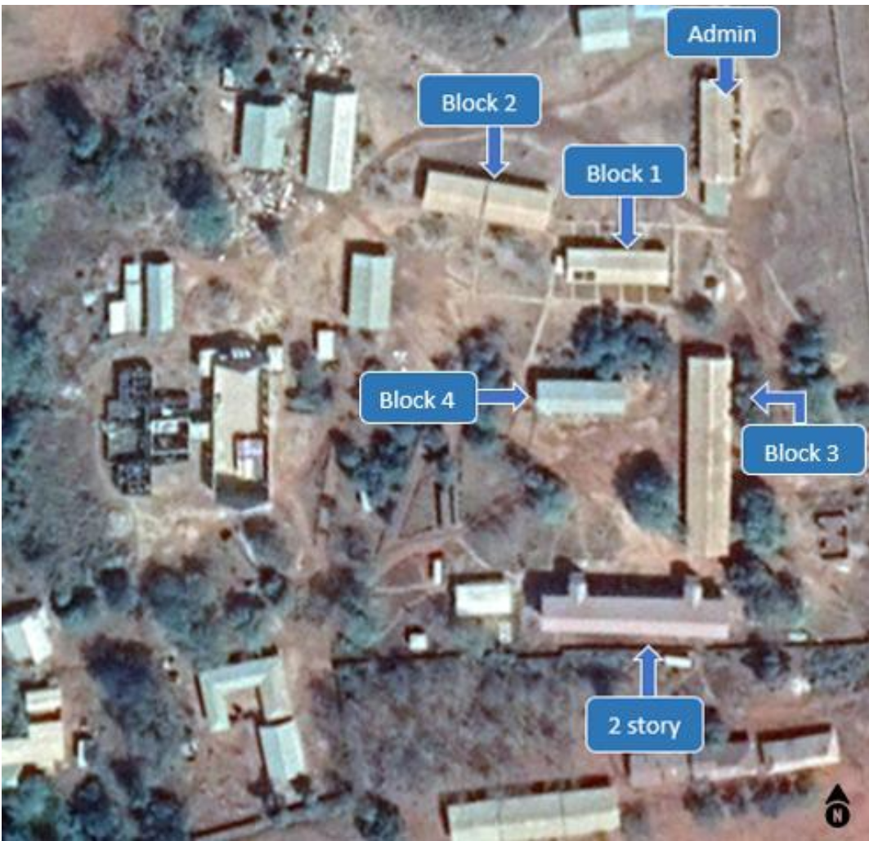
Figure 1. Campus Map
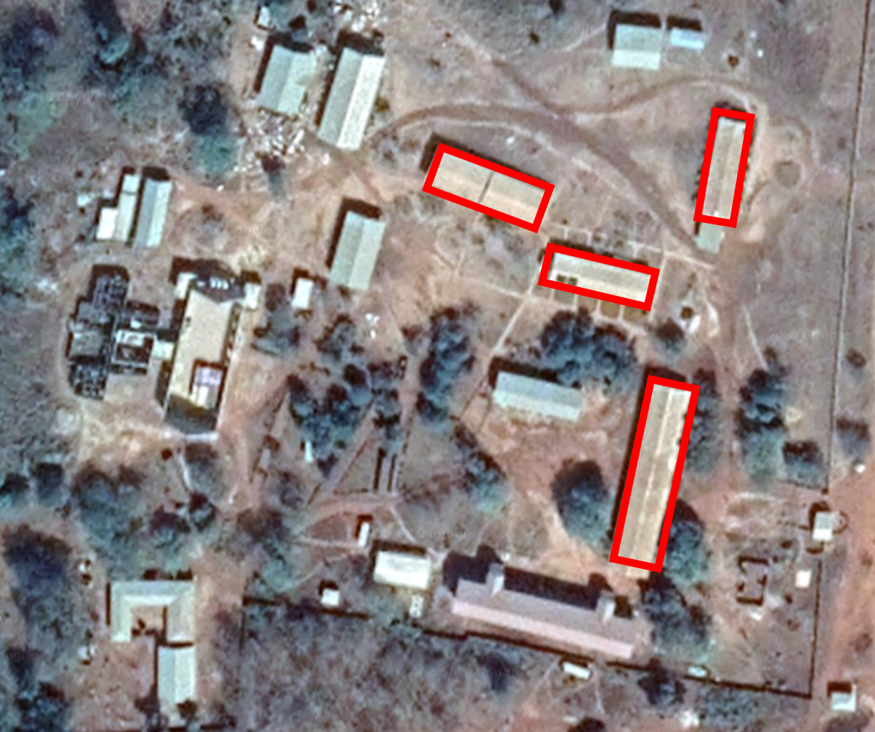
Figure 2. Current Layout Buildings (red) powered by the original PV system

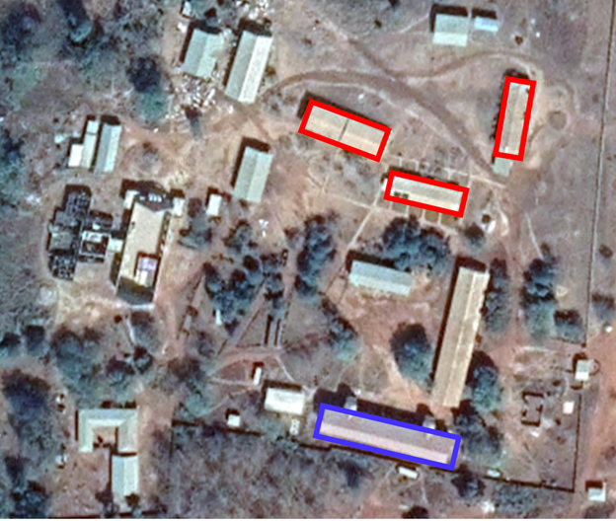
Figure 3. Proposed Layout. Buildings (red) powered by current PV system. Buildings (blue) powered by new PV system.

Scope of Work
The project team will be installing a photovoltaic system on the bathhouse adjacent to the two-story building. The photovoltaic system will supply power to the two-story building. This entails building the racking system as well as securing the solar panels with hurricane strapping to the roof of the bathhouse. The existing photovoltaic system will be rewired to work with the new solar panels, and shelving will be built for the battery packs that may be placed in the classrooms. These battery packs will be removed from the existing photovoltaic system and repurposed for the new system.

Summary of Alternatives Analysis
The current photovoltaic system in the community was constructed in order to handle the load for classroom blocks 1 and 2. The community now wishes to supply more reliable electricity to the two story building. Given that the existing photovoltaic system cannot handle the additional load of this building, the Ghana team has considered the following alternatives to solve this issue.

The first option was to expand the current photovoltaic system by increasing the number of panels, batteries and upgrading the circuitry. This would allow for the system to power the two story building and the Administration building. The second option was to
install a smaller system for the two story building. The size of the system is larger than the necessary load of each building. Additionally, the team has proposed to replace all the CFL bulbs (20W) with LED bulbs (7W) in order to further reduce the load. Other proposed alternatives were the use of a diesel generator, supplying power solely from the electric grid, reducing the load on the current system and constructing a PV system solely for the administrative building.

The Ghana electrical grid supplies 3-phase voltage to the shed which powers the community. If the first alternative was chosen, the community runs the risk of overloading one phase by increasing the load capability of the current system. There is limited amount of current for the single phase that would have to be split between buildings for this alternative that proposes added load to the current system. For this reason, the team has considered building a separate smaller system for the two story building, primarily for safety reasons and to prevent the system from tripping. In order to implement the a single PV system, one of the other phases can be used to balance the load.

Project Team
The design report and calculations completed by students will go under thorough review by our faculty mentors Professor Jungho Kim and Professor Peter Chang. Professor Kim has experience with energy systems and has assisted us in electrical calculations for the expanded system. A mentor, Bryan Quinn, worked on the first phase of the EWB-UMD solar implementation and has experience in installing the system, and helped us develop the electrical and structural designs for this project.

Community Partners
The three partners involved in this project are Sumaman Senior High School, the local NGO, Changing Lives Together (CLT), and EWB-UMD. The main point of contact at the school is the Headmistress, Ms. Agnes Barnie and the NGO’s point of contact is Mr. Lawrence Kumi. Mr. Kumi of CLT has an electrical engineering background and his colleague, Kwame Opoku, has a mechanical engineering background. Not only do these members provide logistical support, they also offer trustworthy sourcing. We have been in contact with both parties to discuss plans for expansion, operation, and maintenance. CLT is required to provide 2% of capital costs, equipment and materials requested by the travel team. They will also be used as a resource for in-country site visits. The EWB- UMD current president, Nipun Kottage, will also be on site for unrelated academic research in the weeks prior to EWB UMD’s arrival, and will be used to source parts from nearby locations to ease traveling and sourcing burdens when the travel team arrives to Ghana. In the past, EWB-UMD has partnered with students and faculty from Kwame Nkrumah University of Science and Technology (KNUST) for technical support. We hope to work with them on this implementation trip as well.

Reference Projects (Conducted by EWB-USA)
There are three similar projects conducted by EWB-USA that our team can learn from though none have been contacted directly. The first project was in Kianjavato, Madagascar where the University of Nebraska chapter of EWB-USA installed small solar powered systems in multiple classrooms to power lights and computers. Similar to Sumaman Senior High School, one purpose of the system was for student studying in the classrooms at night. The University of Nebraska students had to overcome the challenge of current electricity being generated by gas generators and being unable to provide enough power for all schools in the area. They prioritized first giving electricity to the main primary school where the most students would be benefited. Our team once in Ghana will make sure that the buildings being supplied with solar energy can be utilized by the most students.
Finally, EWB-UMD completed a solar project in Tangsabla, Burkina Faso located in West Africa. They implemented a solar powered lighting system for literacy centers created to raise the literacy rate among adults. The team had to handle little access to electricity and sourcing their materials. They were able to establish several local contacts with local solar technology businesses who could source material and help with repairs later on. Because of this, Ghana team will look first towards local vendors for materials and support.

Design

Description of Existing Infrastructure

The current PV system consists of a battery bank and electrical components housed in a concrete electrical shed, roof-mounted PV panels, and wiring from the PV panels and electrical grid to a battery bank. The concrete electrical shed and battery rack were constructed prior to the first implementation trip to Suma Ahenkro, in January 2016. During the first trip, all 12 PV panels were mounted to racks installed on the roof of the school using hurricane strapping (Figure 4) and were wired into the electrical shed. Two charge controllers and two breakers were mounted to a wooden board on the wall of the shed (Figure 6). Additionally, the battery rack was modified, in preparation for the new battery models, by adding wooden planks to serve as shelves for the batteries. The batteries arrived in Accra at the end of the trip and had been tested, but had yet to be installed. A grounding rod was buried in the front of the electrical shed.
The final wiring was completed in August 2017 (Figures 5 and 6). The batteries were transferred from Accra to Suma Ahenkro and installed in the battery racks. The solar panels and batteries were connected to the batteries and the system was turned on to provide power to Classroom Blocks 1 and 2. A knife switch was installed so that the school could switch back to grid power if needed.
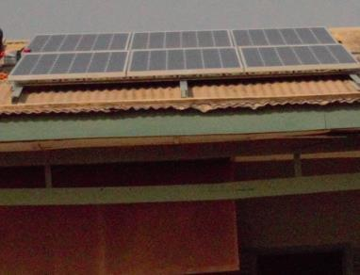
Figure 4. Installed solar panels
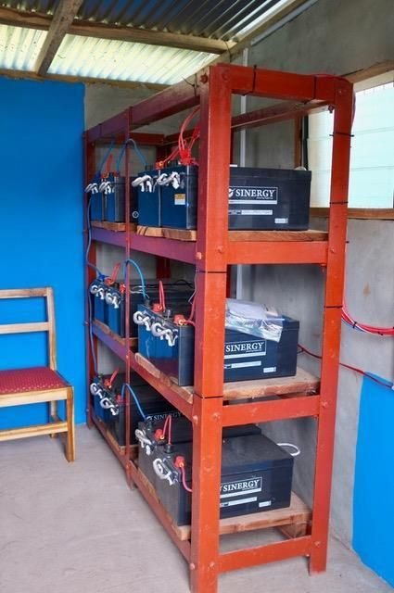

Figure 5. Shelving that holds the battery bank for the old system. Also shows some of the wiring in the system.

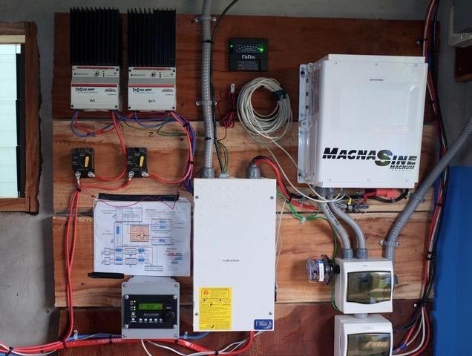
Figure 6. Electrical components mounted in the shed. The charge controllers are mounted to the top left and the inverter is mounted to the top right

Description of Proposed Facilities
During the continued implementation, planned for January 2019, the team will implement a single smaller system on the two-story building. The load for the two story building is significant at about 15 kWh. However, the panels will be supplying 7.5 kW, which is 50% of the total instantaneous load. The system will contain 6 total panels, a battery bank consisting of 4 batteries, and an inverter charger, as well as a mounting frame, battery rack, and hurricane straps to provide additional reinforcement to the roof in order to withstand wind loading. The panels and batteries will be the same models as the components used in the current system; they will be identical to the current system. An inverter charger will replace the inverter and charge controllers in the current system. It will control the flow of current into the batteries as well as convert the DC power generated by the solar panels into AC power for use by the school. We will need to build separate panel racking for the system.

Mounting Frame

The design plan divides the load of each solar panel onto the structural beams that support the roof. Since the panels cannot provide any support on their own due to the risk of damage from panel flexing, the panels will be fully supported by alternate methods. The six panels will be mounted side by side on the bathhouse. Each solar panel has dimensions of approximately 0.91 meters wide by 1.52 meters tall . Each truss support is 2.44 meters apart and each purlin is 1.22 meters apart. The panels will be placed so they span the length of two purlins. We will use the superstrut installation method, described in Section 3.3, in order to clamp each panel to the roof with a square washer at four points: left side upper purlin, right side upper purlin, left side bottom purlin and right side bottom purlin. An example of how the panels will be clamped down can be shown in Figure 7 below.
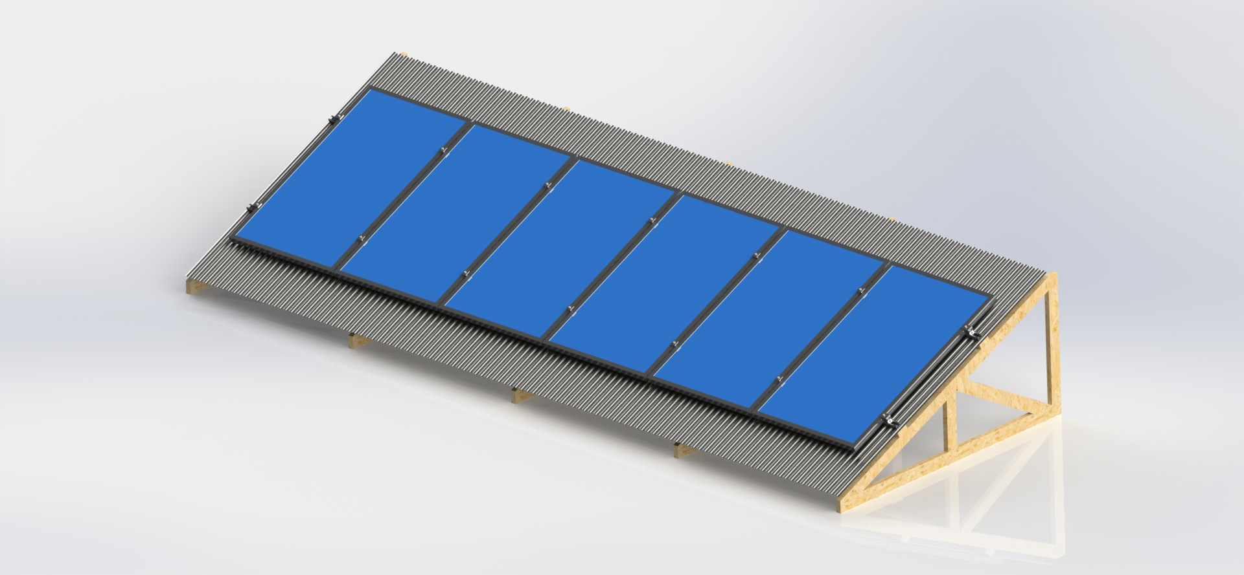
Figure 7: Example of how the panels will be installed side by side on the roof
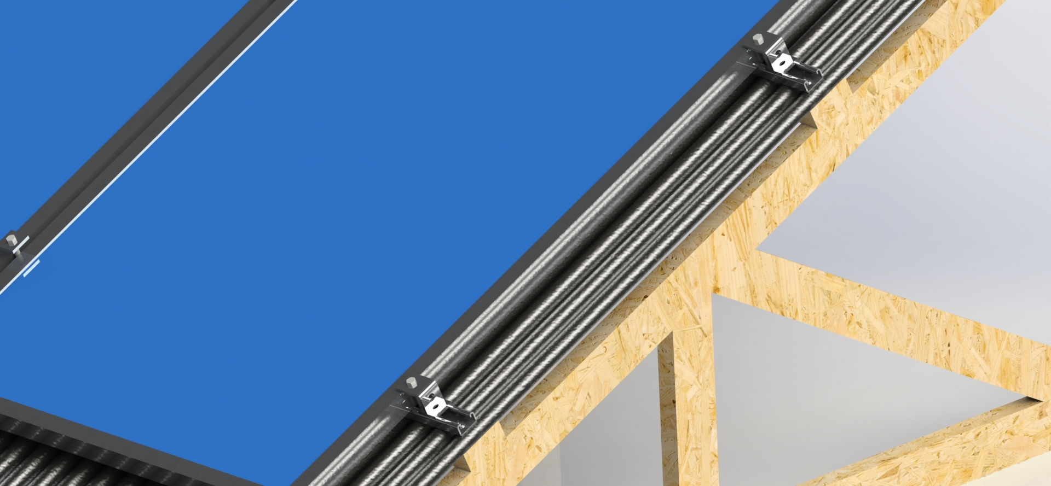
Figure 8: Example showing the clamps on the edge of the panels.
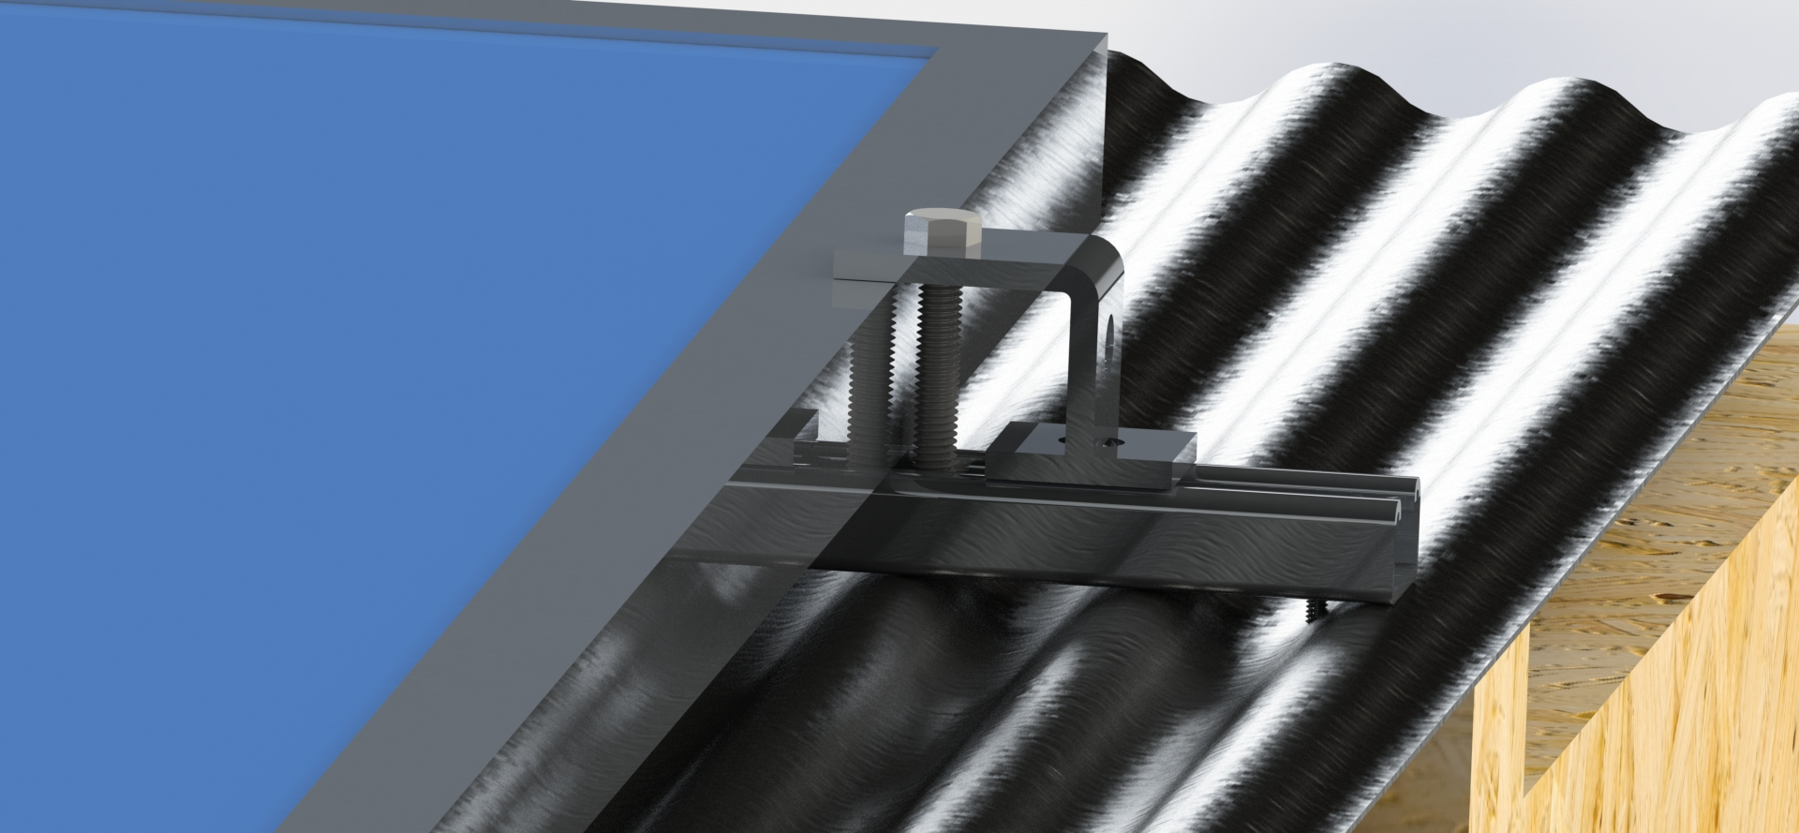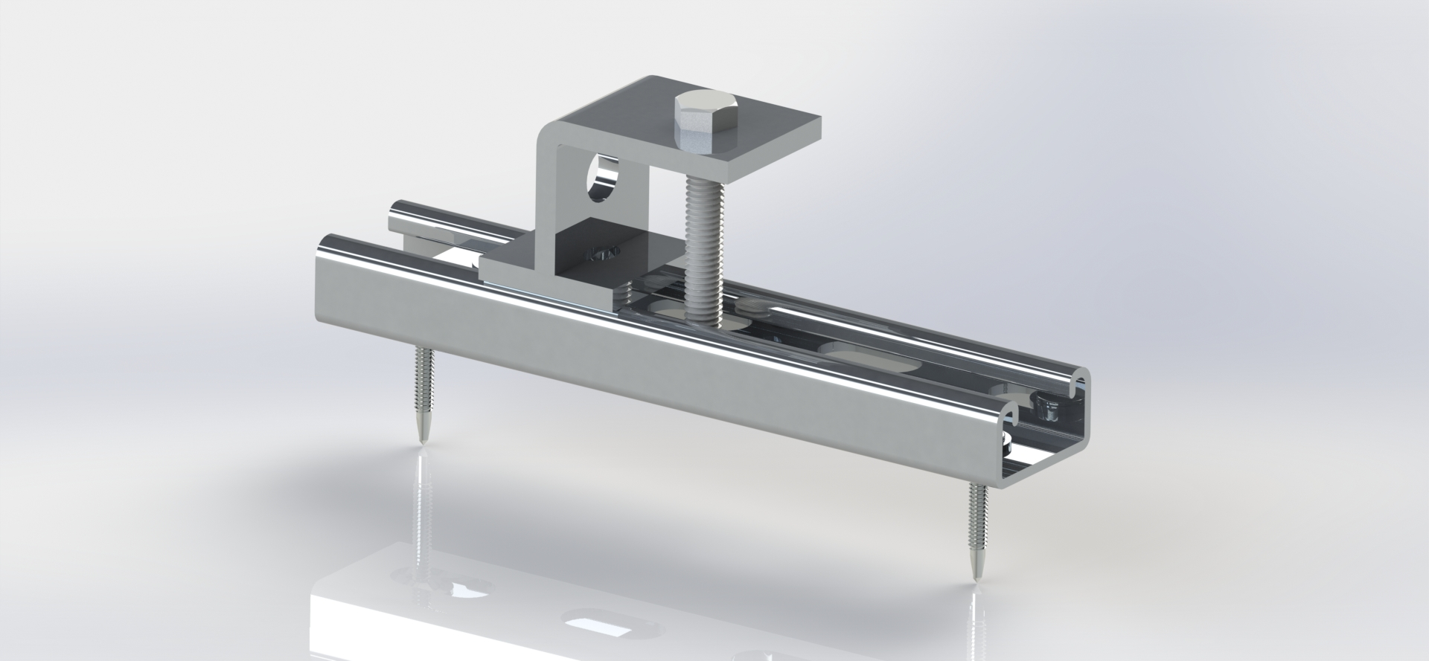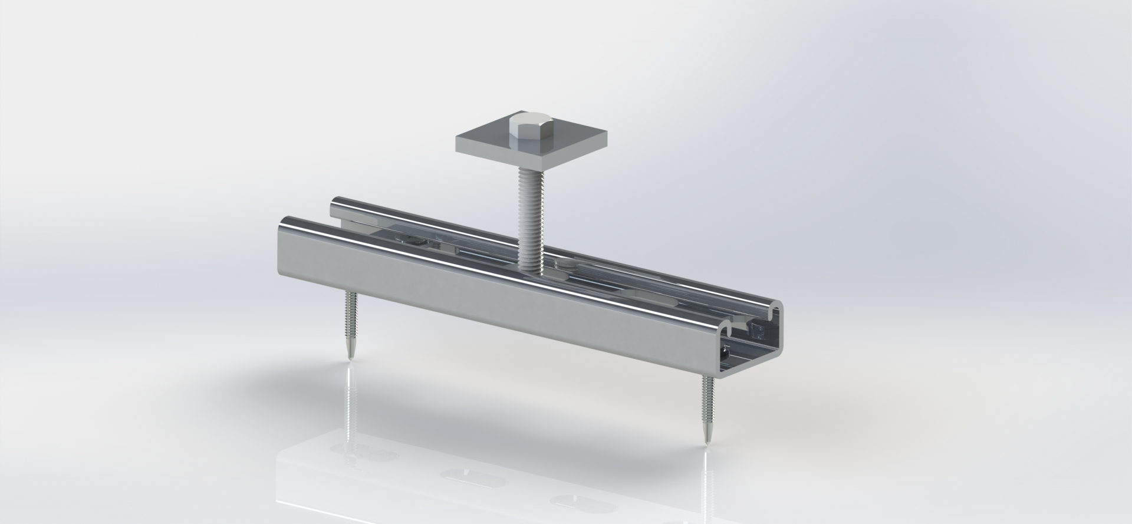

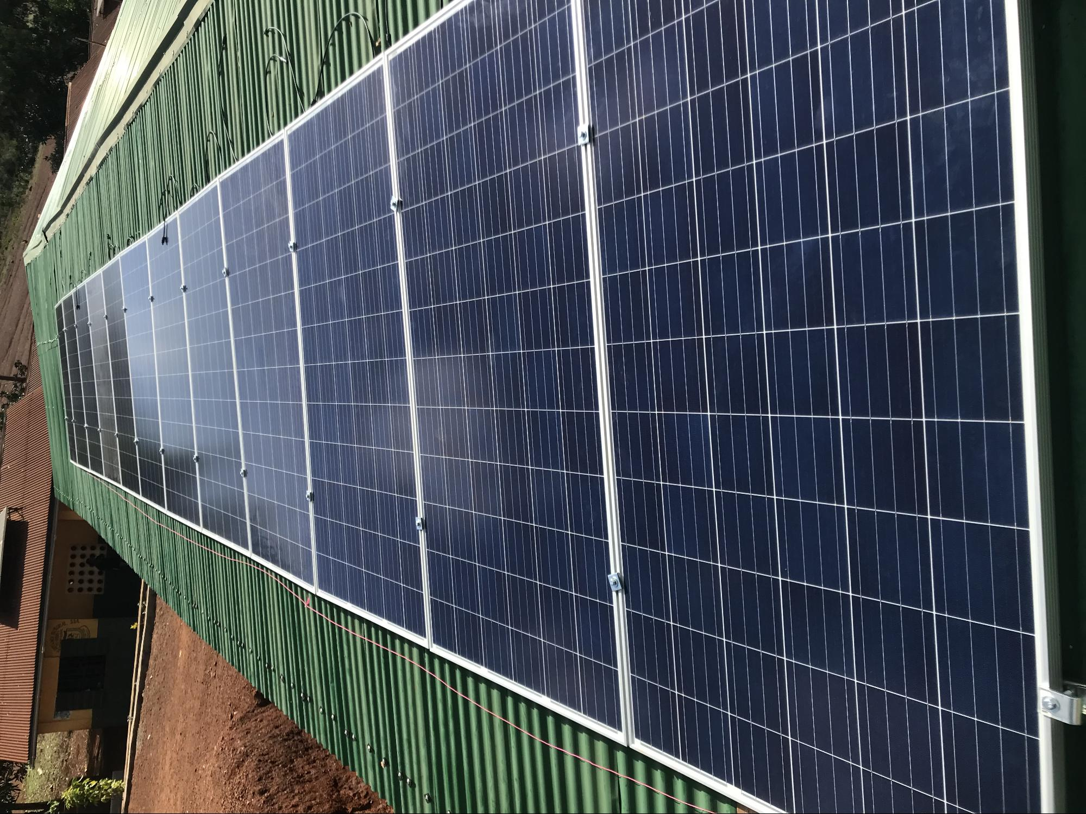
Figure 7. Example of how the panels will be installed side by side and clamped at four separate points.

Security Measures for the Frame

Taking into account the large investment into funding this project, the team will add security measures to ensure the longevity of the panels and their use. After talking to the on-site representatives, it was determined that there was not a high risk of theft due to the number of people remaining on campus overnight. However, in order to be safe, the team felt it necessary to implement extra efforts to secure the solar panels on the roofs. Therefore, a list of various ideas to keep the panels safe was generated. Options included, but were not limited to, security bolts, security cables or chains, barbed wire, fences, and electronic sensors to detect movement.

The four main security measures that are proposed to be implemented are one-way screws, epoxy, security wire, and rivets. A decision matrix, shown in Figure 9, was created with weighted categories of cost, performance, ease of installation, and changeability. It was determined that the best solution was to use epoxy (or another adhesive) to hold the bolts.
If one-way screws were used, the solar panels would screw into the roof with one-way screws which need a special screwdriver or drill bit to unscrew. These screws are secure and reliable, but a determined thief could eventually find the correct tool to remove them. They are relatively inexpensive, costing around $12 for fifty, and $20 for a drill bit.

Epoxy would simply be applied to the nut prior to installation. Normal screws would be secured with epoxy, Loctite, or other strong adhesives. The downside is that if a solar panel breaks and needs to be repaired or replaced, it would be difficult to remove. This is the most inexpensive method, since two ounces costs around $8.

The security wire method consists of looping a wire through all of the solar panels so that a thief would have to cut it to steal one. If the wire is cut, the remote monitoring board (called the RMS-200 by EtherTek) can be programmed to respond with a siren immediately alerting administrators and teachers. This option is expensive, however; the remote monitoring board (with a steel case) costs $655.

The advantages and disadvantages of tamper-proof rivets are similar to those for one-way screws. The rivets have smooth, flat heads so it would be difficult, but not impossible, for a thief to remove them. They cost around $9 for 10, which is more expensive than one-way screws.

 | Cost | Performance | Ease of Installation | Changeability | Total | Ranking
One-way Screws | 4 | 3 | 3 | 4 | 103 | 2
Epoxy | 5 | 5 | 5 | 1 | 130 | 1
Security Wire | 1 | 3 | 3 | 3 | 74 | 4
Rivets | 2 | 4 | 4 | 2 | 94 | 3
Weight of Category | 8 | 10 | 7 | 5 | -- | --
Figure 9. Security measure decision matrix.

Hurricane Straps

Steel hanger straps will be used to reinforce the purlin connection to the trusses and the truss connections to the walls. Currently the roof is connected to the walls with a tie beam and a triangular attachment nailed vertically to the tie beam and horizontally to the truss structure. With this setup, excessive winds could pull the roof vertically off of the walls because the vertical nail only creates protection against a horizontal gust of wind. Straps will be nailed horizontally into the tie beam on both sides of the truss structure. Nailing the straps horizontally will create a shear force to protect from vertical lift. Two straps per location, one on either side of the triangle attachment, will reinforce each truss attachment. These straps will be completed at the location of every triangle attachment, which are currently located along both long walls. In total, there will be 52 hurricane straps attached with 104 nails along the 13 trusses of the roof, in addition to the straps located on the purlin-truss connections.

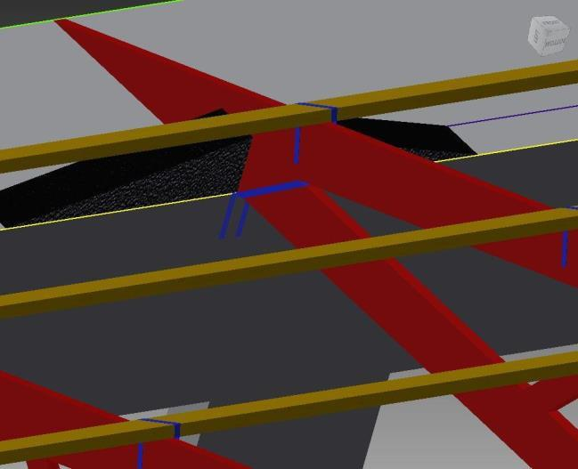

Figure 10. Hurricane straps (blue) attached to both the truss-purlin connection and the truss-wall connection.

Battery Rack Design and Installation

The photovoltaic system relies on batteries to contain the energy accumulated by the solar panels so that the power can be used anytime, even when the system is not generating additional power. These batteries will be stored in a either a closet within the 2-story building or shed where they can be kept safe from the elements, away from children, but also easily accessed for maintenance and replacement. Since this system is smaller, the installation only requires 4 batteries. Each battery weighs one hundred ten pounds, and is fifteen inches tall with a sixteen by seven inch base. In previous implementations, the larger systems required a battery rack, such as the one seen in Figure 5, to be built in order to accommodate for the size and weight of the batteries. However, since this system is smaller and only requires 4 batteries, we can place these batteries on the ground rather than building a seperate battery rack to house them.

2.2.1 Reason For Continued Implementation

After the most recent trip to Ghana, the EWB team was informed that the currently implemented system which was constructed to power Classroom Blocks 1 and 2, is currently being used to power Classroom Block 1, 2, 3 and the Administration Building. However due to the high load requirement of the Administration Building and classroom block 3, the implemented system is tripping and becoming unreliable. Along with this overloading problem, the Ghanaian government recently made public education free resulting in a large increase in school population. Due to this boom in enrollment, the school has requested that the 2-story building be a target area to increase the number of classrooms for students to use at night. In order to address these two issues, EWB-UMD and Sumaman High School have agreed to remove Classroom Block 3 from the original system to reduce the load. EWB-UMD will also implement a smaller PV system to supply 50% of the load of the 2-story building to help supply electricity when the grid is down. This additional system will provide increased reliability of electricity supplied to the building.

Calculations

The loads determined in the table below were calculated through an in-country load analysis completed in the Winter 2018 trip to Ghana. The load for each classroom block, the administration building and two story building was completed.

Classroom Block | Load (Watts) | Energy use (~6 hours per day) (Watt-Hours)
1 | 250 | 1500
2 | 445 | 2670
4 | 425 | 2550
Table: Loads for the Classroom Blocks

Voltage | 48V
Power | 250W
Table: Solar Panel Specifications (Tentative)

Photovoltaic System Voltage | 144V
Battery Bank Voltage | 48V
Maximum Current from Charge Controller | TBD
Inverter Rating | TBD
Table: System Specifications

For Breaker/Disconnect Sizing and Wire Sizing:
Power = Current * Voltage Current = Power/Voltage

Note: Instantaneous Currents can be much higher than the calculated current, but this calculation provides an idea of what the current should be in that section of the circuit.

Current out of Photovoltaic system | 10.41A
Current out of Inverter | 2.27A
Breaker Sizing

Construct Smaller System for Two - Story Building With LED Bulbs For Reduced Load LED Bulb: 7.5W (Models available in country)

Total Load for the 2 Story Building: 15 kWH (Derating Factor Accounted For)
Proposed system will supply 50% of total load: 7.5 kWH

$Number of panels=\frac{Load}{(Panel wattage)(Hours of full sun)}=\frac{7500 WH}{(250 W/panel)(5 H)}=6 panels$

𝑆𝑡𝑜𝑟𝑎𝑔𝑒 𝐷𝑒𝑝𝑡ℎ = (𝐷𝑎𝑦𝑠 𝑤𝑖𝑡ℎ𝑜𝑢𝑡 𝑝𝑜𝑤𝑒𝑟)(𝑃𝑜𝑤𝑒𝑟 𝑛𝑒𝑒𝑑𝑒𝑑)
𝑆𝑡𝑜𝑟𝑎𝑔𝑒 𝐷𝑒𝑝𝑡ℎ = (1.5 𝐷𝑎𝑦𝑠)(3.3 𝑘𝑊H) = 4.65 𝑘𝑊𝐻

Battery Power= (12V)(250AH) = 3 kWH
Necessary Output Voltage = 48 V $→$ 4 batteries in series

The photovoltaic array will include a total of 6 panels. There will be two sets of 3 panels, where each of the panels within each set are connected in series. Each set of 3 panels in series will have a voltage of 48*3 = 144V. The two sets of three panels will then be connected in parallel, yielding a photovoltaic system voltage of 144V. (See Figure A8 Section 8) This alternative requires 4 batteries. These 4 batteries will be set up as 2 sets in series to create a 48VDC output. A 3kW inverter will be used.

Structural and Wind Load Calculations
The calculations can be found in Attachment E

Schedule

Schedule overview
The project schedule consists of nine total day spanning from January 8 - 16, 2019. Reference the GANTT Chart in Attachment B for details. Prior to arriving at Suma Ahenkro, the travel team will locally source necessary materials and equipment. A list of our desired materials will be sent to an in-country contact to scope out local retailers in order to maximize the efficiency of our sourcing trip. Materials will be sourced in Accra and Sunyani prior to the drive to Suma Ahenkro. Once sourcing is completed, the team will travel to Sumaman Senior High School and establish a workspace environment to house equipment, materials and other construction belongings. All purchased materials will be inspected for safety, flaws, and other issues. Safety is especially important since some of the work is being done on rooftops. The community will then be updated on the daily plan and organized. A community meeting is optimal prior to the beginning of construction to allow the community to contribute to how the work is distributed and conducted.

Next, work tasks will be delegated so that the construction can be done in a timely manner. Task assignments will commence before work can begin. Teams can work in parallel according to task dependencies as seen on the GANTT Chart. In the first stage, one team will install the frames followed by mounting of the solar panels. In parallel, a second team will assemble the battery bank and a third team will set up auxiliary systems (wiring, conduit, etc.). The hurricane straps can be implemented during any stage as they are not contingent to other activities being completed. Safety check will be conducted for structural and electrical systems once each team completes their tasks. Each panel will be checked individually before integrating it into the system to minimize damage in case of failure.

Work Breakdown Structure

Construction Task | Responsible Party | Date of Construction
Shed | Sumaman High School | Prior to UMD arrival
Solar mounting frames | UMD team and local involvement | 12/10-13/2019
Wiring electrical components | UMD team and local involvement | 12/10-13/2019
Hurricane strapping | UMD team and local involvement | 12/10-13/2019
Table: Distribution of Responsibilities

Detailed Task Description Superstrut Installation and Securing Panels

- Before arriving in country, cut the Superstrut Channel from its standard length of either 10 ft or 20 ft into 6 inch segments. Insure that you have enough of these segments in order to install all of the solar panels. Our design of six solar panels requires 14 Superstrut Channels.
Securing SuperStrut Components to the Roof
- Lay plywood over the working area on the roof and secure the plywood to roof with roofing screws on both of the ends closest to the roof’s edge. The plywood will serve to distribute the weight of individuals working on the roof so as to not damage the corrugated roof while working.
- Determine the location and spacing of existing purlins by looking for existing screws on roof and decide which purlins will be used to support the panels.
- Once two purlins have been chosen to support the solar panels, measure along the purlins to determine where the Superstrut channels should placed in order to secure all six solar panels.
- Place channel horizontally over the purlin and mark where lag screws will be placed to secure channel to roof, as shown in Figure 12 indicated by green dots. If possible, screw the lag screws in the peaks of corrugated roof instead of in the valleys. This prevents against water damage that would occur if rainwater began to pool in the valleys.
- After all of the lag screw locations have been marked, drill pilot holes in each of these locations.
- Place the channel back where it should go and after adding a washer to the lag screw and applying sealant to the ends of it to prevent roof leakage, use the impact drill to drive the screw loosely into the predrilled hole from before. Do the same for the second lag screw and once both are correctly positioned so that it is horizontal with the purling beneath, tighten the rest of the way using a ratchet wrench. An image of an installed channel can be seen in Figure 13.
- Repeat the previous step in order to install the rest of the channels. Once all of the channels are installed, you are ready to mount the panels.
- After one line of purlins has channels secured to it, the same thing can be done for an adjacent purlin. To make sure that the channel on one purlin lines up with the channel on the next purlin over, use the peaks and valleys of the corrugated roof as guidance. Minor differences can be overlooked as the Unistrut allows for leeway as the spring nut can be moved around.
- Slide the spring nut into its approximate final position as shown in Figure 14. Place the Solar Panel on top of the channel. Then place the Hex-Head Bolt through the square washer, clamping the panel in between the A hex-head bolt with a square washer in between can also be loosely threaded into the spring nut for easier visualization when the panels are placed overtop. After this, the solar panels can be mounted.
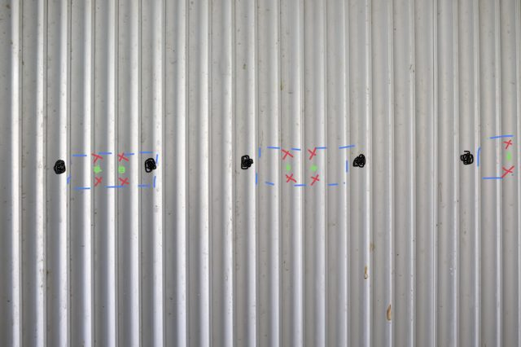
Figure #12: Diagram showing the placement of various components for the installation of the Unistrut to the corrugated roof.

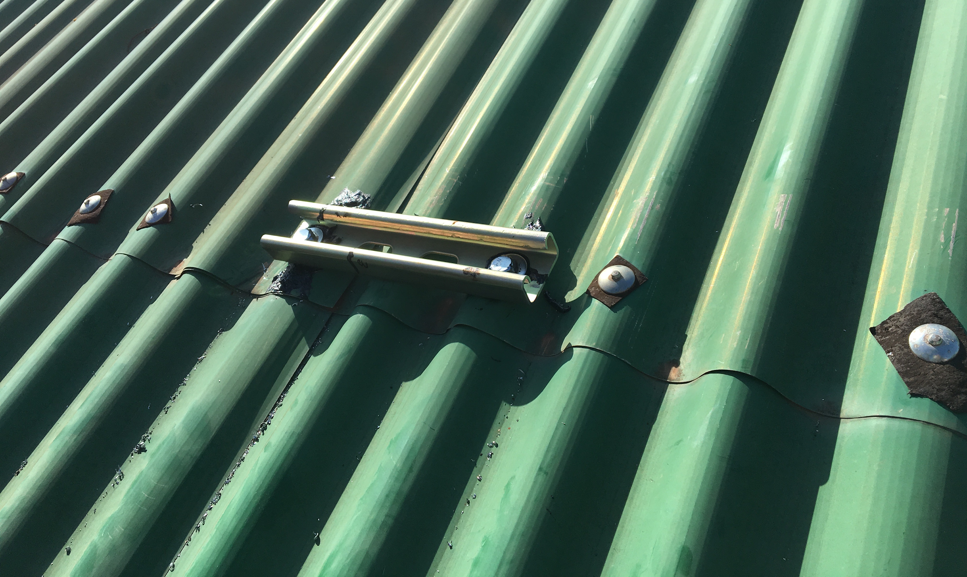
Figure #13: An installed Superstrut Channel
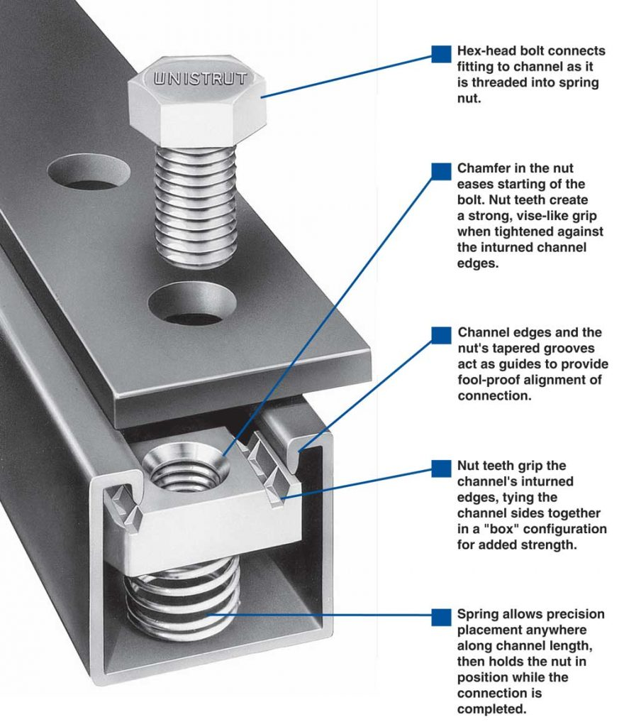
Figure 14: Diagram of how Channel, spring nut, square washer and Hex Head Bolt all fit together

Hurricane Strap Installation

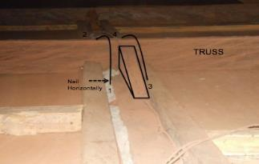
Figure 13. Installation of hurricane straps.

- Cut 156 2’ pieces of steel hanger strapping.
- Nail one end of one piece of steel strapping HORIZONTALLY to tie beam along wall (Point 1).
- Nail other end of piece of steel strapping HORIZONTALLY to tie beam on the opposite side of the truss (Point 2).
- Repeat steps 2-3 on opposite side of triangle attachment (Points 3 and 4).
- Repeat steps 2-4 along the long walls on every truss structure.
- Wrap a strap up and over the purlins, nailing it into the truss.
- Repeat step 6 for all 104 truss-purlin connections.

Electrical System Installation
- Connect battery bank positive lead to junction box and negative lead to common ground.
- Connect all positive leads of charge controllers to positive input of junction box.
- Repeat step 2 for the negative leads.
- Wire all the ground terminals of the charge controllers to common ground.
- Splice positive output of junction box to battery bank through fuse and switch, and to inverter through a separate fuse and switch.
- Repeat step 5 for negative output of junction box to negative lead of battery bank, and also wire negative lead to ground.
- Connect positive output of inverter to positive input of two story building circuit through the switch and fuse.
- Repeat for the neutral output of inverter.
- Connect AC and DC grounds of the inverter to common ground.
- Connect the ground terminals of each string to common ground.
- Repeat steps 9-10 for each string of 3 panels using one charge controller per string.

In October 2018, travel members attended a mock build of the solar racking. During this mock build, students gained a deep understanding on the process of assembling the racking. Using a corrugated metal practice roof, the same that will be seen in-country, students measured, drilled and assembled the mounting system. In the process, students were exposed to both manual and power tools such as a cordless power drill, circle saw and hand saw. This experience will assist them while they are constructing the mounting system in-country.

Schedule Analysis

    - Advance Task Scheduling
The tools needed for this implementation include: impact drivers, power drills, measuring tapes, wrenches, wire cutters, hammers a variety of screwdrivers, a hack saw and a circular saw. The EWB-UMD travel team will be in charge of bringing these basic construction materials to the site. The community will supply ladders and will assist in sourcing things like epoxy and angle iron needed for the racking. We will send Mr. Kumi a list of necessary materials prior to our travel so that he will be able to help in the sourcing process. All construction materials acquired before EWB-UMD arrival will be housed in the electrical shed.
    - Critical Path Analysis
For this project, many construction activities will need to be performed simultaneously in order to complete the project within our timeline. For the electrical component, there will be a mentor, a travel member, and a local electrician that will complete the process described above in section 3.3 Detailed Task Description. While they complete the wiring and installation of electrical equipment, a team of three to four people will work on installing the superstrut mounting on the roof and will subsequently mount the solar panels. This process will take a day to mount and another day to install the panels on the mounting frame. After the panels are in place and the wiring completed, the electrical team will be able to connect the system and test for any issues that may arise. We will also have a team responsible for installing the hurricane strapping. This construction activity is not dependent on other activities and can be performed at any point. If the steps are correctly followed in our above task description, we believe we can maximize our efficiency and complete this implementation in one trip.
    - Schedule Threats and Mitigations

This particular region in Ghana does not have access to the same resources available in America. The materials there have high variability. Although they are listed as available now, that does not ensure they will be an available and/or meeting our specifications. Therefore, there is a need to develop a contingency plan for the materials with the highest uncertainty. Among those potentially uncommon materials is the electrical metallic tubing that protects the wiring from the harsh climate. If it is not available, EWB-UMD will resort to PolyVinyl Chloride (PVC) tube or UV protected wires. In the case that there is no epoxy, Loctite, or other viable adhesive available, the team will first resort to one way screws and if these are not available they will use a loop of heavy cable that connects all the panels. This would make it extremely difficult to steal the panel, as all the panels would have to be removed and brought down at once. The team would have to decide between the more efficient design, the screws, or the stronger design, the steel cable, while in Ghana. EWB-UMDs objective is to order, purchase, or plan for the acquisition of as many materials as possible prior to arrival in Ghana. The partnering NGO will aid in this task.

Construction Budget

Material Quantity and Cost Estimate Summary Bill of Materials

Component | Cost per Unit (USD) | Quantity
Suntech STP-255 Panel | 416 | 6
12V 200 Ahr Sinergy Battery | 495 | 4
Inverter Charger (Part Number TBD) | 1000 | 1
AC breakers | 150 | 1
Wiring  (Gauges: 16, 12, 10, 6, 2) | 150 | 1
3-Way Switch | 10 | 1
Total | 5,786

Components to be replaced | Cost (USD) | Replacement Frequency
Batteries x4 | 495 | 5 to 7 years
Solar Panels x6 | 416 | 25 years
Inverter/Charger | 1000 | 10 years
Total | 5,476
Table: Lifecycle cost

Operation and Maintenance Costs

Component | Cost per Unit (USD) | Quantity | Lifetime (years) | Total cost per replacement
Suntech STP- 255 Panel | 416 | 6 | 25 | 2496
12V 200 Ahr  Sinergy Battery | 495 | 4 | 5 | 1980
Inverter-Charger | 1000 | 1 | 10 | 1000
Table: Individual Components

 | Cost (U.S. Dollars)
0 - 5 years (batteries) | 5,940
0 - 10 years (batteries+Inverter charger) | 12,880
0 - 15 years (batteries) | 18,820
0 - 20 years (batteries+Inverter charger) | 25,760
0 - 25 years (batteries+panels) | 39,188
Average cost per year | 1,568

Table: Cost Breakdown Over 25 Years

Frame and Mounting Materials

Component | Cost per part (USD) | Quantity
10' Superstrut - 14 gauge | 35.56 | 1
Spring Nuts (Pack of 5) | 4.66 | 3 packs
2-Side 90 Degree Angle Bracket | 1.97 | 4
Square Washers | 4.74 | 10
Hex Head Bolts (⅜ inch, 1-¼ long) | 3.67 | 20
Flat Circular Washers (⅜ inch, packs of 25) | 3.45 | 1 pack
Bob Smith 5-min Epoxy (From Amazon) | 13.19 | 1
Total | 194.86

Facilities Operations and Maintenance Plan
By far, the highest intermediate operations and maintenance (O&M) costs come from replacing the electrical equipment, particularly the batteries. The school will need to replace the batteries around every 5 years, and the inverters and charge controllers every 10 years. These components will have to be sourced from Accra. Members of the community or partnering NGO will travel to acquire new electrical equipment. This trip is made currently several times a month by faculty or the NGO. The cost savings generated from the system will total to $1,400 over 5 years which cover the $1,200 replacement cost for the batteries. EWB-UMD will encourage the school to save this money in case it needs to purchase hardware, hire an electrician, replace a solar panel if it breaks, or wishes to expand the system.

The electrical savings are lower than might be expected because in the school’s current situation, they simply don’t have access to electricity for large portions of the day and therefore aren’t paying for it at those times.

EWB-UMD will leave the community with an operations and maintenance manual. The O&M manual will describe the system in clear language that locals familiarized with the system during the construction process will be able to understand. EWB-UMD will update a manual used during their initial implementation trip. EWB-UMD will revise the manual for clarity, update the equipment to reflect items purchased in Ghana, and include a section on common problems and fixes. The team will update the manual as much as possible prior to the trip and finish it during the trip. EWB-UMD will use the campus printer to print out the updated manual. An electronic copy will also be sent.

Maintenance can be divided into two types: basic and advanced. The school’s electrician,
Kusi, will be primarily responsible for the basic maintenance of the system. He specifically will be trained during and after the construction process. He will be responsible for replacing the electrical equipment and solving minor issues should they arise. He will be paid his regular rate as groundskeeper. Additionally, the principal has indicated that many community members have shown interest in learning about the project. These people will also be trained during installation. EWB-UMD will train as many people as possible in the system’s operation. In the event that a problem arises that requires advanced maintenance, the school can call upon the University of Energy and Natural Resources in Sunyani to provide technical support. The college was founded specifically to educate students on energy projects. When in-country, EWB-UMD will continue to engage students through our partnership with Sumaman Senior High School.

Community Based Organization CBO

Political power structures specifically relevant to this program revolve around Sumaman Senior High School. The school is run by Headmistress Agnus Barnie, with help from the school leadership board. There is also an active Parent-Teacher Association at the school. This program aims to improve educational opportunities in the town. Residents appear to view education as a societal imperative, a boon to the community. By strengthening education through this program, the residents hope to improve the socioeconomic standing of the community; they believe the greater number of students they can send to tertiary institutions, the more the students will return to the community with sustainable solutions that alleviate poverty. The partnering NGO, Changing Lives Together, Inc. has previously undertaken efforts to improve the community. Its initiatives have involved constructing a three classroom block, conducting a 3-day eye clinic, and providing medical supplies to the local health clinic.

The school has a skilled electrician, Kusi, who has shown considerable knowledge on the operation and maintenance of the current system. Under his supervision, we believe the school is capable of repairing the system should a mishap occur, as well as replacing old parts to keep the system functioning. However, the new system involves an increase in cost budgeting, specifically for batteries. With the addition of four new batteries, the school is expected to pay for their replacement in five years. Our current cost estimates indicate that the replacement will cost around $2,000. The school has shown that it is capable of managing these costs in the past, but EWB-UMD has recently signed a community agreement contingent upon the request that the school make a maintenance fund. Sumaman Senior High School has agreed with this request and has begun the process for establishing the fund.

Baseline Monitoring Data Collection

Baseline Data
Indicator Questions:
- Number of days without electricity per year (Answer: In days/year)
- Cost of fuel consumed (Answer: $/month)
- Average number of hours/day the electrical system is available to users (Answer: Avg hours/day)

Other Factors Contributing or Hindering Development
Contributing factors to the project’s success include:
- Additional support from outside organization of funds or supplies and access to necessary materials

- Commitment from the school and community as a whole to communicate with the team about needs and problems that come up with time
- Diligent and careful maintenance of the system by a competent electrician employed at the school

Hindering factors to the project’s success include:
- A lack of cooperation at the school or community level with regards to the system created by the EWB team
- Theft or abuse of parts of the system after it is installed
- Drastic change in the health due to disease outbreaks or financial stability of the community
While these are possible concerns for the future success of the project, the school has demonstrated strong competence in managing the system and remaining in constant contact with EWB-UMD.

Beneficiary Analysis

The school currently supports approximately 1200 students and 50 staff members. These members will directly benefit from the expansion of the system when they are on campus. With an average family size of 7 people in this community, the system will indirectly benefit 8,400 people. EWB-UMD will continue to update this number as population grows due to a new government mandate resulting in free education.

- Attachments
Attachment A: Drawing Package
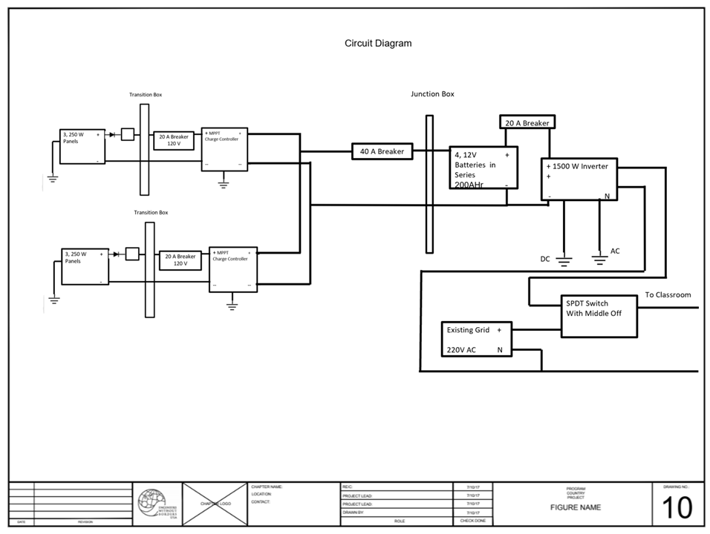Figure A5. - Circuit diagram of complete electrical system

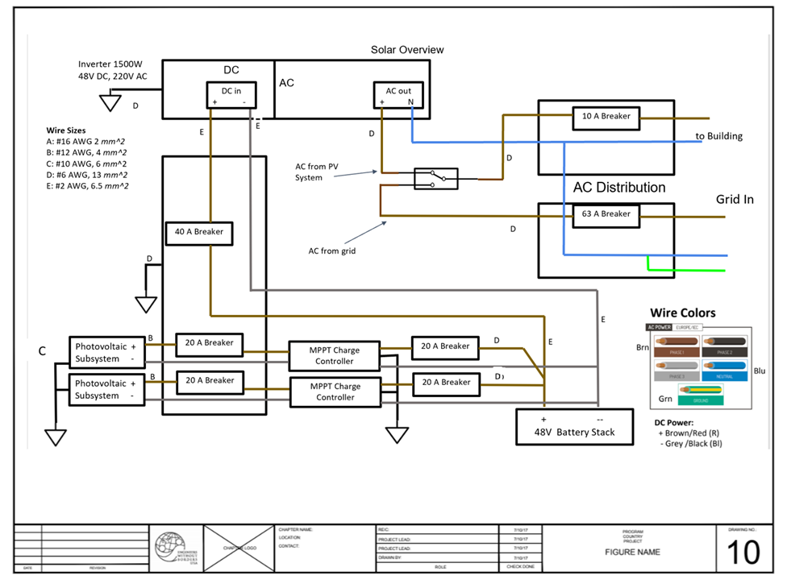

Figure A6. - Circuit diagram of complete electrical system

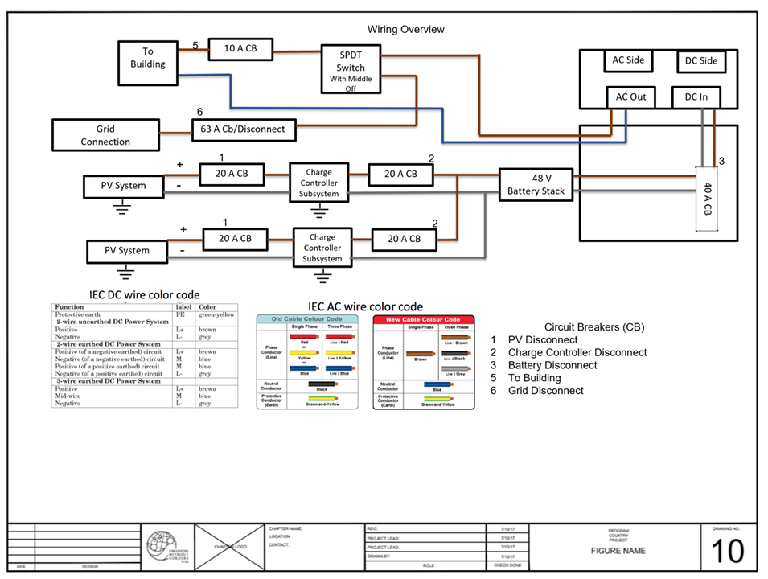

Figure A7 – Wiring Overview

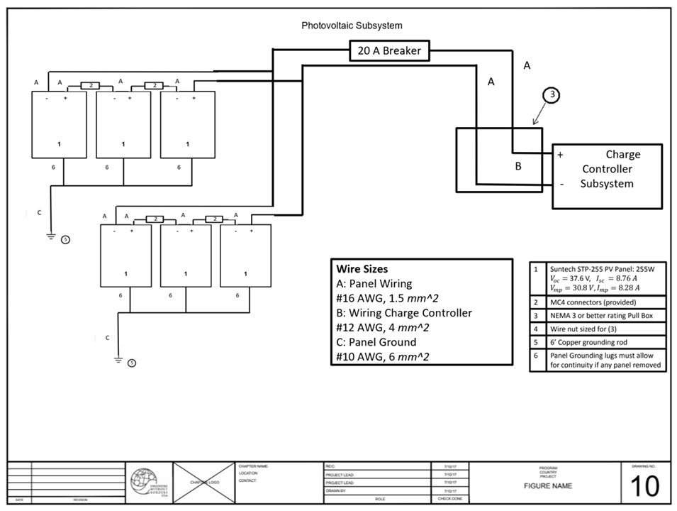
Figure A8 – Photovoltaic Subsystem

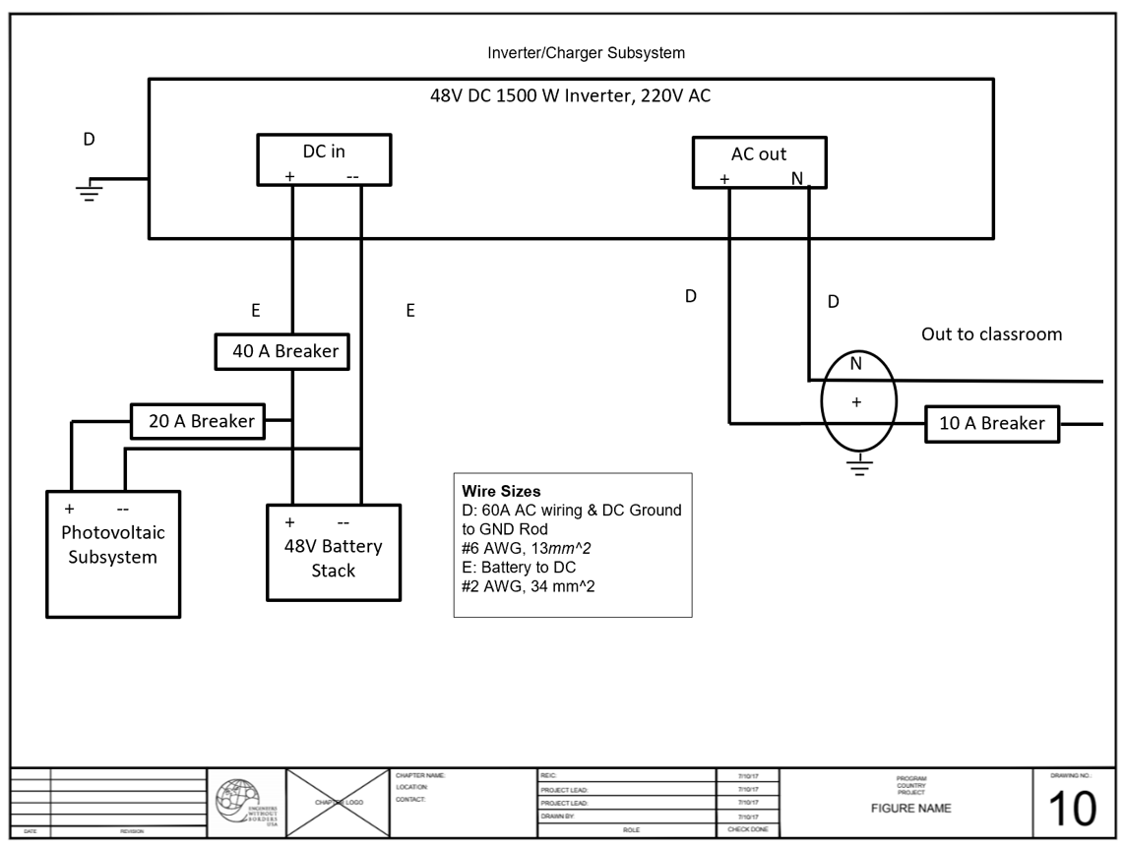

Figure A9 – Inverter/Charge Controller Subsystem

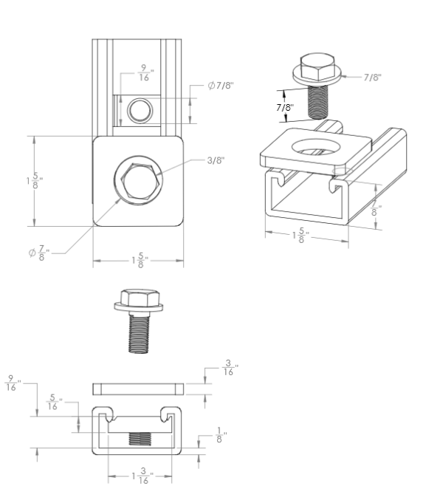
Figure A10- Unistrut Middle Assembly Drawing

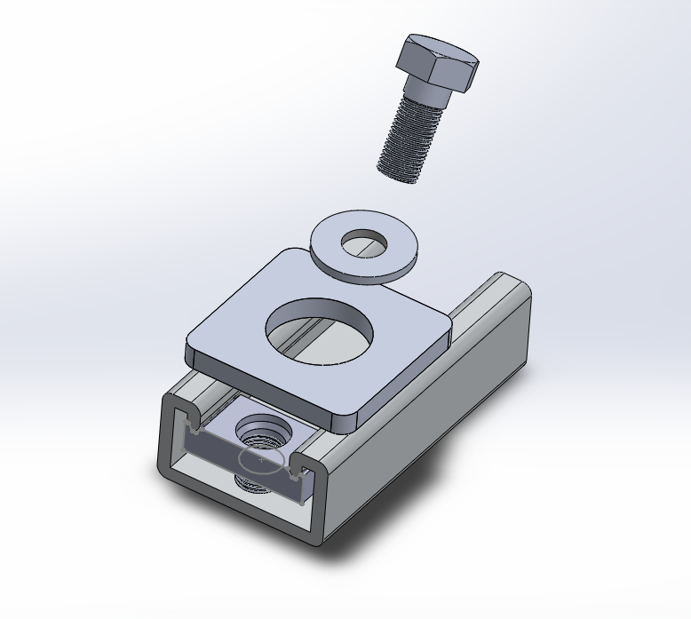

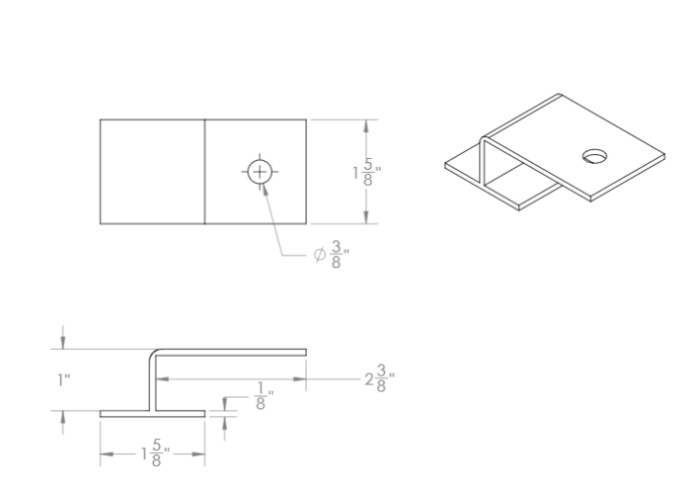
Figure A12-Unistrut End Piece Drawing

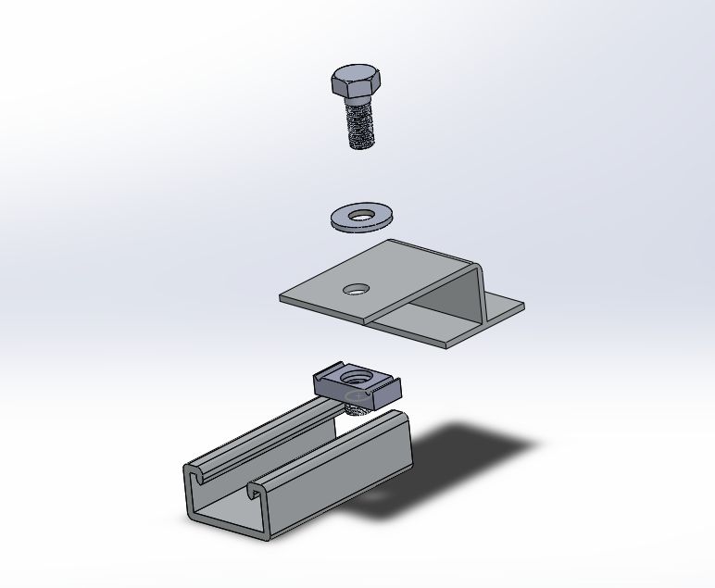
A13- Unistrut End Assembly 3D

Attachment B: Schedule
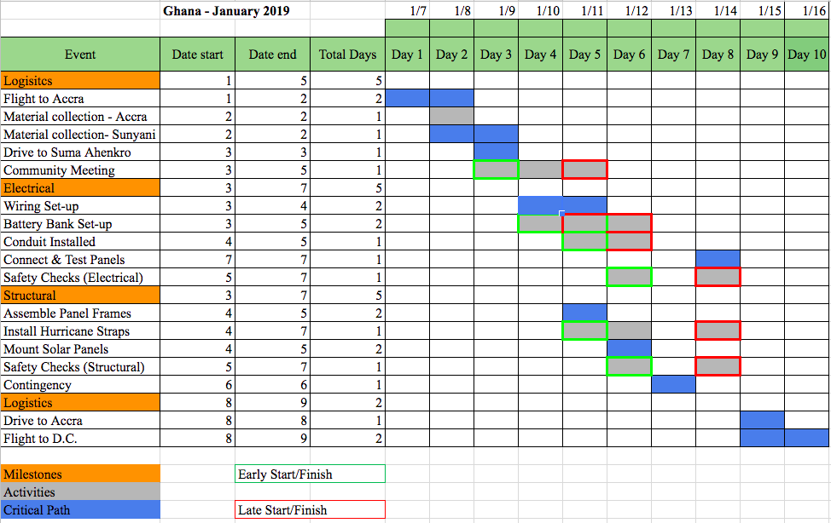

Attachment C: Revised Construction Cost Estimate

Component | Cost per Unit (USD) | Quantity
Suntech STP-255 Panel | 416 | 6
12V 200 Ahr Sinergy Battery | 495 | 4 (Does not count towards final cost - using existing batteries)
Inverter Charger (Part Number TBD) | 1000 | 1
AC breakers | 150 | 1
Wiring  (gauges: 16, 12, 10, 6, 2) | 150 | 1
3-Way Switch | 10 | 1
Philips LED Light Bulbs (Pack of 16) | 31.45 | 19
Total | 4404

Frame and Mounting Materials

Component | Cost per part (USD) | Quantity
10' Superstrut - 14 gauge | 35.56 | 1
Spring Nuts (Pack of 5) | 4.66 | 3 packs
2-Side 90 Degree Angle Bracket | 1.97 | 4
Square Washers | 4.74 | 10
Hex Head Bolts (⅜ inch, 1-¼ long) | 3.67 | 20
Flat Circular Washers (⅜ inch, packs of 25) | 3.45 | 1 pack
Bob Smith 5-min Epoxy (From Amazon) | 13.19 | 1
Total | 195

Attachment D: Revised Design Calculations Battery Rack Calculations
Vertical Yield and Buckling Calculations:

Yield Stress = F/A
Force = load of batteries = (15 batteries)*(110lb) = 1650 lb Cross-Sectional Area = 1.5”*3.5” = 5.25 in²
Yield Stress = (1650 lb) / (5.25 in²) = 315 psi Estimated compressive wood strength: 5,000 psi. Factor of Safety = (Material value) / (calculated value) Factor of Safety = 5,000 psi / 315 psi = 15.5

I = 1/12*b*h³
I = 1/12*1.5*3.5³ I = 5.36 in⁴
P_{cr} = (pi² * E * I)/(L_{e})²

Level 1: All weight, 4.5” off the ground P_{vert} = (15 batteries)*(110 lb) = 1650 lb
P_{cr} (Level 1) = (pi² * 1.5*10⁶ psi * 5.36 in⁴)/(4.5in)² = 3.92x10⁶ lb

Level 2: Weight of 2 shelves, 26.5” off the ground P_{vert} = (10 batteries)*(110 lb) = 1100 lb
P_{cr} (Level 2) = (pi² * 1.5*10⁶ psi * 5.36 in⁴)/(26.5 in)² = 113,000 lb

Level 3: Weight of 1 shelf, 48.5” off the ground P_{vert} = (5 batteries)*(110 lb) = 550 lb
P_{cr} (Level 3) = (pi² * 1.5*10⁶ psi * 1.244 in⁴)/(48.5in)² = 33,734 lb

Conclusion: In all cases, the critical buckling load is much greater than the loads being applied to the system. This makes sense when the geometry of the member is considered, and it is clear that the member will yield before it buckles. However, due to the very large safety factor, the design is very stable in this regard.

Shear Stress Calculations at Bolt Joints

V = Shear Force 10 bolts per level

V = 110lb/battery * 5 batteries V = 550lb
V_{jt} = 550lb/10 nails V_{jt} = 55 lb/nail

Shear strength of common 16d nail: 138 psi Safety factor: T_{n}/V_{jt}=2.5
Given a safety factor of 2.5, a typical nail obtained in Ghana will suffice.

Bending Moment in Horizontal Beams

*We only need to consider the moment in the 65” beams, since they will be subjected to a greater moment than the 18.5” beams.*

Let C be the point in the middle of the horizontal beam
Let L be the length of the beam from joint to joint (31.75 in.)

∑MC = Load * L/2
∑MC = 550lb * 31.75in.
∑MC = 17,462.5 lb*in.

Since the longer beams will experience more stress, due to the greater length, only they will be considered in the moment calculation. The shorter beams will be of the same material, but will experience less stress.

Since there is a vertical beam attached in the center of the long horizontal beams, the moment will be cut in half. This support halves the theoretical moment arm of each beam, thus halving the moment; however, this moment is still greater than the moment induced by the shorter horizontal beams.

M_{max} = M_{c}/2
M_{max} = 17,462.5/2
M_{max} = 8,731.25 lb*in.
Maximum moment the beam will experience is 8,731 lb*in. I = 1/12*b*h³
I = 1/12*19.6=5*1.5³
I = 5.51

SigmaMAX = cM/I
SigmaMAX =(0.75in.)(8,731lb*in.)/(5.51in.⁴) = 1,188 psi

The yield strength of Wood is assumed 5,000 psi.
Factor of Safety = (material yield strength) / (maximum stress)
Factor of Safety = (5,000 psi) / (1,188 psi) =4.2

ROOF WIND LOAD CALCULATIONS - Roof being ripped from walls

DEMAND
Wind Load
- 87 km/hr max sustained wind speed¹
- Wind Load Formula₂:
F=.00256v²(velocity in mi/h)r*roof area*drag coefficient (use 2 for flat planes)
F=.00256*(54mi/hr)²*(1766ft²)(2)
F= 26,430 lb

Dead Load (Weight of roof and solar panels)
- Weight of Roof
Roof material₃ = 18 gage metal deck (3 psf)
F=3*area F=3(1766ft²)=5290 lb

- Weight of Trusses
Wood = 2”X6” Cedar
Density of Cedar₄ = .0127 lb/in³
Volume of One Truss Structure -
V=(2”*6”(roof incline length + roof horizontal length)*(# of trusses)
¹ Weather2. "Kumasi Climate History." August Climate History for Kumasi. N.p., n.d. Web. 17 May 2015.
V=2”*6”*(209”+198”)*10 V=48841 in³
Weight of Trusses -
F=48841 in³*.0127lb/in³ F=602 lb
- Weight of Ceiling
Ceiling Material₅ = ⅝ in Plywood (.0133 psi)
Area of Ceiling = 240966 in²
Weight of Ceiling -
F=(.0133 psi)(240966 in²)
F=3212 lbs
- Weight of Solar Panels
Solar panels = 42 lbs Number of Solar Panels = 4
F=42*4= 168 lb
- TOTAL Dead Load
Dead Load = Roof + Solar Panel + Truss + Ceiling
Dead Load= 5290 lb +168 lb+ 602 lb+3212 lb = 9,272 lb

NET DEMAND = Wind Load - Dead Load
o Net Demand = 26,430 lb - 9272 lb = 17,158 lb

CAPACITY
Four hurricane straps will secure each of the 13 truss structures - a total of 52 hurricane straps, each secure with two nails.
  - Net Demand / # of hurricane straps = Demand on each strap
17158 lb / 52 = 330 lb
Each strap needs to hold over 330 lb

Two methods of failure were analyzed:
wood shear and hurricane strap tensile failure
Wood Failure in shear perpendicular to grain

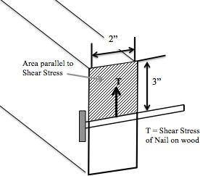
Shear strength Perpendicular to grain of cedar - 174 psi (1200 kPa)²

T = F / A
174 psi = F / (2”x3”) Fmax = 1044 lb 1044 lb > 330 lb
*wood will not fail under maximum loading

Steel hurricane strap failure in tension

Maximum load rating of 24-gage steel hanger strapping³ = 750 lb
Because 750 lb > 330 lb the hurricane strap will not fail under maximum loading
Using the smaller of the two maximum forces:
  - 750 lb * 52 straps = 39,000 lb (Total Capacity)

CAPACITY > DEMAND 39,000 lb > 17,158 lb

SOLAR PANEL WIND LOAD CALCULATIONS - Solar Panels being Ripped from Roof

² Green, David W., Jerrold E. Winandy, and David E. Kretschmann. "Mechanical Properties of Wood."
Wood Handbook—Wood as an Engineering Material (n.d.): n. pag. Web. 14 May 2015.
³ Sioux Chief Manufacturing Company. "Metal Hanger Strap." Sioux Chief. N.p., n.d. Web. 14 May 2015.

DEMAND

Wind Load
- 87 km/hr max sustained wind speed₁
- Wind Load Formula₂:
F=.00256v²(velocity in mi/h)r*solar panel area*drag coefficient*(# of panels) F=.00256*(54mi/hr)²*(17.5ft²)(2)(4)
F= 1045lb

1. Dead Load
o Weight of Solar Panels
Solar panels = 42 lbs Number of Solar Panels = 4 F=42*4= 168 lb
- NET DEMAND = Wind Load - Dead Load
o Net Demand = 3132 lb - 168lb = 2964 lb

CAPACITY
Number of hurricane straps = 52
Net Demand / # of hurricane straps = Demand on each strap 2964 lb / 52 = 57 lb
  - Each hurricane strap needs to withstand a maximum load of 61.75lb
  - The hurricane straps will fail in the same ways as listed above
  - 61.75 lb < 330 lb, therefore if the previous design can withstand the maximum demand, this design can withstand a smaller maximum demand

Attachment E: Revised Operations and Maintenance Plan
Suma Ahenkro, Solar Energy System Operational Manual

WARNINGS

BEFORE WORKING ON ANY PART OF THE SYSTEM, DISCONNECT AND TURN
OFF ALL EQUIPMENT/DEVICES (INVERTERS / BATTERIES / PANELS)

PLEASE SEE THE LAST PAGE FOR A LABELED DIAGRAM OF ELECTRONIC EQUIPMENT.

DO NOT PLUG IN LARGE (HEAVY WATTAGE) DEVICES INTO OUTLETS (SEE
CONSERVATION SECTION FOR FURTHER DETAILS)

DO NOT LEAVE DEVICES PLUGGED IN OVERNIGHT.

CHECK ON CHARGE CONTROLLER (TO DETERMINE BATTERY LEVEL), AND
INVERTERS BEFORE USING THE SYSTEM TO SEE THE CURRENT STATE OF THE SYSTEM.

FOR ANY INFORMATION NOT COVERED IN THIS MANUAL, PLEASE REFER TO
OPERATION MANUALS PROVIDED.

POWERING THE SYSTEM ON/OFF FOR MAINTENANCE
Powering On: Turn on the following switches in this order:
- Panel Breakers
- Battery Breakers
- Inverter Breakers
- Inverter Switches
Powering Off: Turn off the following switches in this order:
- Inverter Switches
- Inverter Breakers
- Battery Breakers
- Panel Breakers

CONSERVATION
It is important to conserve the energy from the solar panels, especially during a period of cloudy days. The charge controller light is a good indication of when it is very important to conserve energy. When the charge controller light is yellow, it is very important to begin to conserve energy. Do not overload the system at this time. Be aware of what devices you are plugging into the outlets in the school. If too many devices are plugged in at the same time then the batteries will drain very quickly. See the section on electrical outlets for specific information about devices that can be plugged into the outlets.

In general to conserve energy:
- Turn off the lights when no one is in the room
- Unplug devices that are not being used or charged
- If natural sunlight is sufficient, do not use lights
- Turn off all lights and unplug all devices when leaving for the night

SOLAR PANELS
Check the solar panels at the end of every school quarter. Signs that the solar panels must be cleaned:
- Dirt, debris, leaves, etc. on panel surface
- Panels do not appear as blue as normal
- Panels were not cleaned at the end of the last quarter
It is very important that the panels are cleaned at least once a year. To clean the panels, someone must climb onto the roof and gently wipe the panels down with water and a clean cloth.

The panels should last for 25 years. They need to be treated with a lot of care in order for the panels to last a long time. Any scratch or crack on the surface of the panel will cause the panel to not function properly. If a scratch or crack is seen on the panel surface, determine if the solar panel is still functioning enough to charge the batteries (See the Charge Controller Section). If the drop in power is noticeable, the panel needs to be replaced.

BATTERIES
Four batteries are used to store the energy produced by the solar panels. These batteries are 12 volt with 260 amp hours each. If one battery dies, then all of the batteries must be replaced, and the replacements must be 12 Volts. To maintain a similar size system the batteries should be at least 260 Amp Hours each. Using different batteries may have a negative impact on the health of the system.

INVERTER-CHARGE CONTROLLER
The inverter/charge controller is connected to a specific circuit that CANNOT exceed 300 Watt. If a circuit exceeds the 300 Watt limit, the inverter will beep, and shut down. The device that is causing the overload needs to be unplugged, and only then the inverter will turn back on to normal operation.

Connected to each inverter are 1 switch (white), and 1 breaker (black). The white switch will turn the inverter on or off, while the black switch is there to protect the inverter. In order, for the white switch to work, the breaker (black switch) must be in the upright position for the inverter to turn on. However, if the black switch is the downward position, the inverter will turn off.

Note: The white switch should be used to turn off the inverters, not the breaker.

The following table explains what each different combination of lights represents on the inverter/charger device.

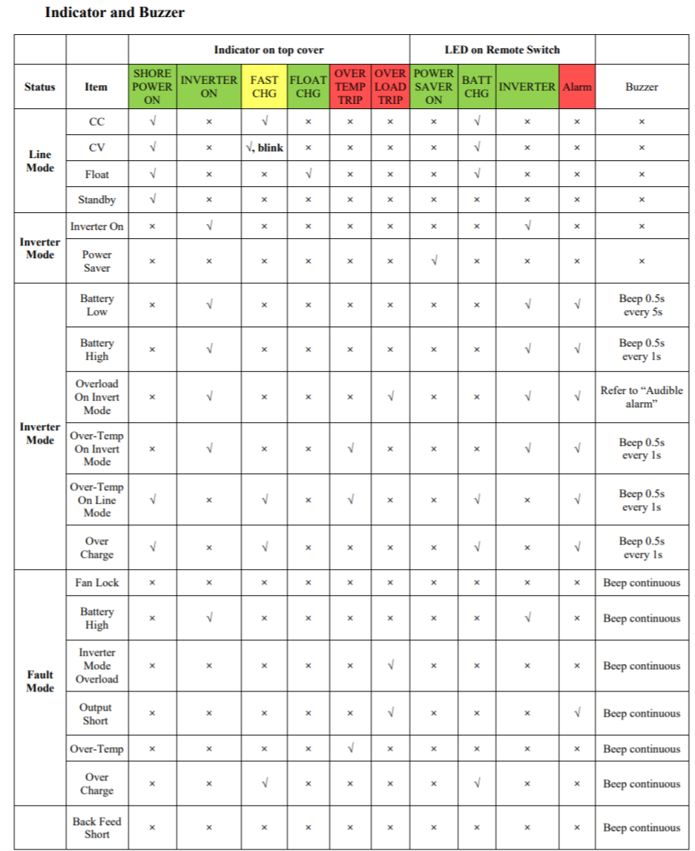

Note: At the start of the first quarter or each school year, make sure wire terminals are still tight.

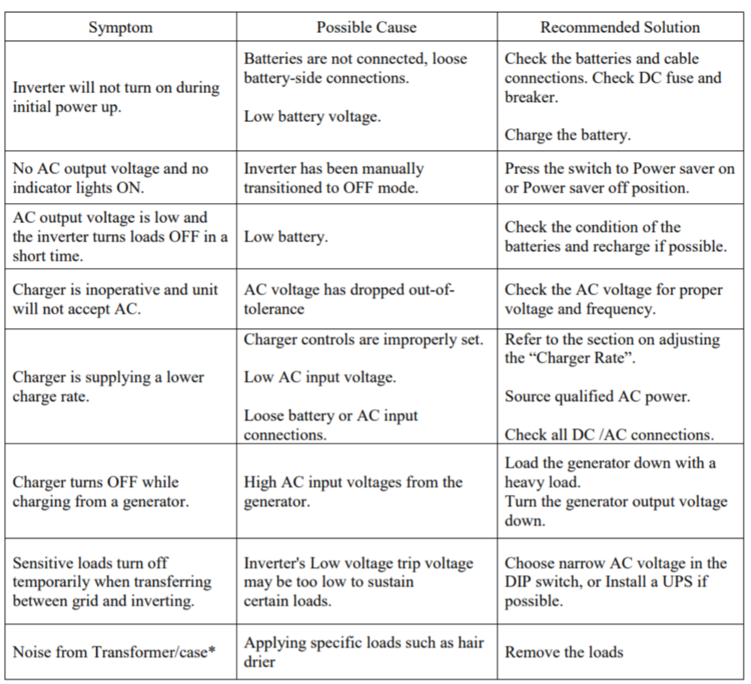

Note: For further information on regarding the inverters, please refer to the Installation and Operation Manual provided by the manufacturer

OUTLETS/LOADS
The electric outlets installed in the rooms have limitations. They are 220 volts and 50 Hz. The devices plugged into the outlets of each circuit cannot add up to more than 150 Watts. Information on the wattage of devices can be found on most devices.

If you don’t know how many watts the device requires, do not plug it in.

Things that can be plugged in | Things that cannot be plugged in
Cell phone chargers (5-10 watts) Laptop chargers (60-75 watts) Other similar chargers  Printer (60-75 watts) | Most speakers Refrigerator (600 watts)  Television (140-300 watts)

Operation and Maintenance Costs

Component | Cost per Unit (USD) | Quantity | Lifetime (years) | Total cost per replacement
Suntech STP- 255 Panel | 416 | 6 | 25 | 2496
12V 260 Ahr  Sinergy Battery | 495 | 4 | 5 | 1980
Inverter/Charger | 2000 | 1 | 10 | 2000

Table: Individual Components

 | Cost (U.S. Dollars)
0 - 5 years (batteries) | 5,940
0 - 10 years (batteries+Inverter charger) | 12,880
0 - 15 years (batteries) | 18,820
0 - 20 years (batteries+Inverter charger) | 25,760
0 - 25 years (batteries+panels) | 39,188
Average cost per year | 1,568

Table: Cost Breakdown Over 25 Years

Attachment F: Signed Implementation Agreement
Community Agreement – Project Partnership

EWB-USA projects are most successful when there is a three-way partnership between each of the entities listed below. Each partner has specific skills and expertise, which together, contribute to a more sustainable project over the long-term.
- Community – Sumaman Senior High School
- Local Partner Organization(s) – Changing Lives Together Inc.
- EWB-USA Chapter – EWB University of Maryland – College Park

This contract is between University of Maryland – College Park chapter of Engineers Without Borders, USA, Sumaman Senior High School, and Changing Lives Together Inc. for the purpose of setting guidelines for SSHS Solar Energy Project Phase 2. The roles and responsibilities listed below must be included in the standard EWB-USA Project Partnership Agreement. Additional roles and responsibilities identified by any party to the agreement may be added at the discretion of all parties to the agreement. This document must be signed by all parties in order to move on to the design development of SSHS Solar Energy Project Phase 2.

EWB-USA is a volunteer-based organization without a pre-approved budget. Implementation of all projects is contingent upon all parties meeting the commitments outlined below, funds being raised and a stable security situation which allows travel to the site by our members. This agreement is not legally binding, but is intended to clarify expectations, roles and responsibilities of all parties to the subject project.

The residents of Sumaman Senior High School agree to the following:
- To communicate directly with the University of Maryland chapter of EWB-USA on a regular basis, as determined by the needs of the project.
- To inform University of Maryland chapter of EWB-USA of any changes to the security/safety situation.
- To allow University of Maryland chapter of EWB-USA to communicate directly with all interested community groups in order to get all pertinent input to the development of Solar Energy Project Phase 2.
- To organize and involve community members in all aspects of the project.
- To identify community contacts to accompany the University of Maryland chapter of EWB-USA team during site visits.
- To ensure that Solar Energy Project Phase 2 represents community-wide priorities and that all community members will have the opportunity to benefit from the project per the terms of use established by the community.
- To contribute a minimum of 5% of the capital construction cost in cash before construction begins.
- To provide in-kind contributions to the project at no cost to University of Maryland chapter of EWB-USA (examples are skilled and unskilled labor, borrowed equipment, local materials, etc.).
- To identify a formal system of responsibility for the operations and maintenance of Solar Energy Project Phase 2.
- To establish and administer the funding mechanism required to continually operate and maintain Solar Energy Project Phase 2 after construction is complete.
- To be available to assist with additional technical data collection not completed by University of Maryland chapter of EWB-USA on site assessment trips.
- To allow photos or video taken by University of Maryland to be used in EWB-USA HQ’s marketing materials to share the story of the organization’s work with wider audiences.

Changing Lives Together Inc. agrees to the following:
- To inform University of Maryland chapter of EWB-USA of any changes to the security/safety situation.
- To visit Sumaman Senior High School often, and as needed, for project progress.
- To build the capacity of Sumaman Senior High School to establish continuing support of the system, as needed.
- To provide project-specific training for Sumaman Senior High School, as needed.
- To identify contributions that the Changing Lives Together Inc. can make to the project (examples include funding, resource procurement, heavy equipment, etc.)
- To assist in ongoing monitoring and evaluation of Solar Energy Project Phase 2.
- To be available to assist with additional technical data collection not completed by University of Maryland chapter of EWB-USA.
- To allow photos or video taken by University of Maryland to be used in EWB-USA HQ’s marketing materials to share the story of the organization’s work with wider audiences.

University of Maryland chapter of EWB-USA agrees to the following:
- To work in partnership with Sumaman Senior High School to design and develop the project, Solar Energy Project Phase 2.
- To seek input from community members during the design phase
- To communicate with Sumaman Senior High School and Changing Lives Together Inc. throughout project design phases to provide status updates on project design development.
- To identify contributions that the University of Maryland chapter of EWB-USA can make to the project construction expenses (examples include fundraising, assistance with community grant applications, etc.).
- To inform Sumaman Senior High School and Changing Lives Together Inc. of any changes to the agreed upon details of site visits (examples include a change of dates, number of travelers, etc.).
- To collect technical data required to complete the project design.
- To provide project-specific education and training, including operations and maintenance training in English.
- To provide a manual to instruct the community on operations and maintenance of Solar Energy Project Phase 2 in English.
- To provide as-built drawings to Sumaman Senior High School after project completion in English.
- To acquire explicit permission before photographing or videoing members of the Sumaman Senior High School and/or Changing Lives Together Inc., and explain that photos and videos may be used for marketing materials to share the EWB-USA story with wider audiences.
- To ensure photographs and videos present subjects in a dignified and respectful manner and that images are honest representations of the situations and the facts.

In addition to the responsibilities listed above, indicate the responsible party for each of the following:
- Coordination of transportation for travel team members of University of Maryland chapter of EWB-USA will be provided by Changing Lives Together Inc..
- Coordination of translation services for travel team members of University of Maryland chapter of EWB-USA will be provided by Changing Lives Together Inc..
- Transportation of materials will be coordinated by Changing Lives Together Inc..

On behalf of, and acting with the authority of the residents of Sumaman Senior High School, the NGO/local municipal partner Changing Lives Together Inc. and University of Maryland chapter of EWB-USA, the undersigned agree to abide by the above conditions.

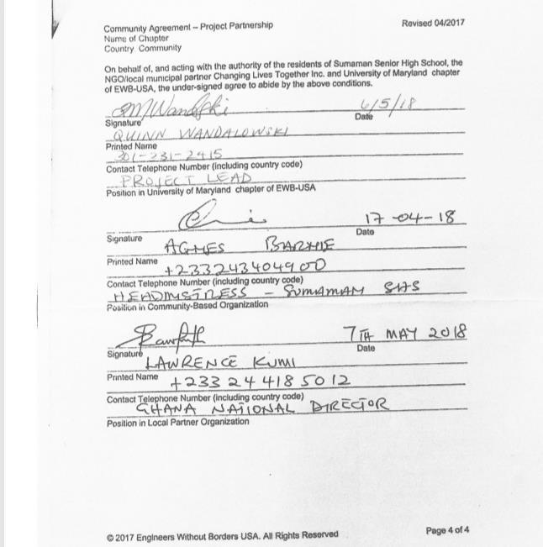

Attachment G: Original Implementation Plan
The current photovoltaic system in place is being used to power classroom blocks 1, 2 and the administration building. The current system contains 12 solar panels, a 48V battery stack, two charge controllers, an inverter, knife switch and the necessary circuit breakers. The proposed system contains three separate systems. These three systems will power classroom blocks 1, 2 and 4 respectively. Each of the systems will contain 4 panels, a 48V battery stack, 1 charge controller, an inverter and the necessary circuit breakers. The individual systems are significantly smaller than the current PV system in place, as they are being built to handle less load. The total estimated load for each system is 3.3 kWh. Similar to the both systems, the solar panels are each 250W. The panels, batteries and charge controllers will be the same model as those in the current system. The construction of the three separate systems will dissipate the excess load on the current system.
Buildings (red) powered by current system

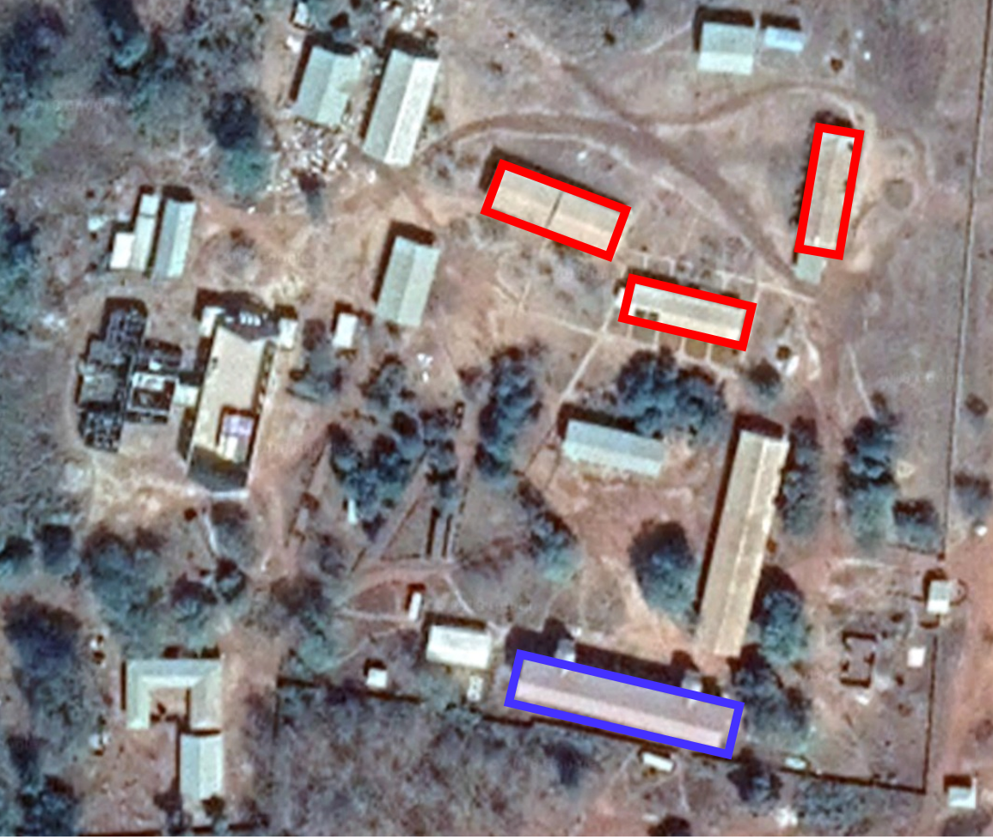
Buildings (red) powered by current system. Buildings (blue) powered by proposed system.

Attachment H: Revised Trip Budget
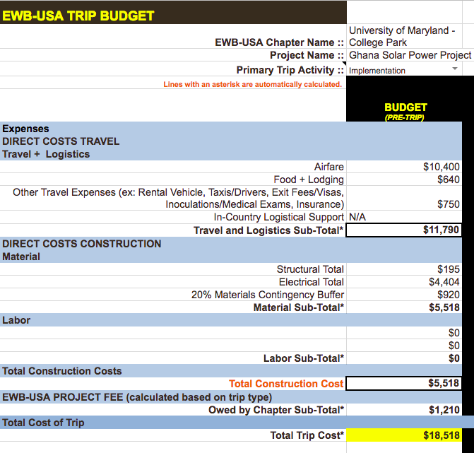

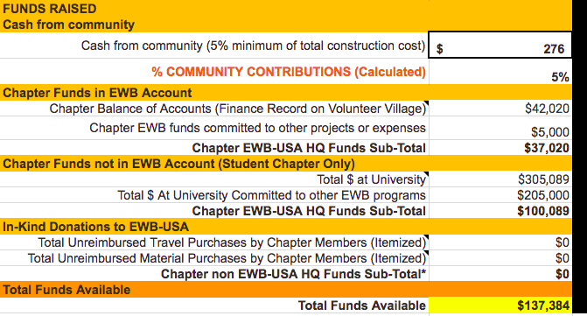

Revised Construction Safety Plan
Chapter: Engineers Without Borders-USA, University of Maryland, College Park Name: Quinn Wandalowski
Revised: 14, June 2018

Implementation – Pre-Trip Construction Safety Plan

Community: | Suma Ahenkro
Country: | Ghana
Chapter: | University of Maryland, College Park
Submittal Date: | 14, June 2018
Authors: | Quinn Wandalowski
Draft or Final: | Draft
Scope of Implementation (100 words): | This continued implementation will expand the number of classroom powered by solar at Sumaman Senior High School in Suma Ahenkro, Ghana. This implementation will include installing key electrical components, wiring the system, and mounting the PV panels.

Privacy: EWB-USA may release this report in its entirety to other EWB-USA chapters or interested parties.

Purpose: to organize and consolidate all construction safety information in a single plan that can be easily utilized throughout the entire duration of your project(s). The project team is responsible for reviewing and updating this document every time there is a new construction element.

1.0 Introduction
The current system in place at the school is overloaded due to an unexpected increase in school population. The travel team aims to meet the increased load by adding three additional smaller systems. The current PV system will continue to be used to power the Administration building and the largest classroom block. With the expansion of PV capacity, more classrooms will be available to students to use at night to study.

Construction Responsibilities
    - Please list all the people who have responsibility for construction and their role. This list includes team members and contractors.
    - If the entity is a contractor, include a description of its Safety Procedures as Appendix A, if appropriate.
    - HSOs must be able to focus on the construction safety and therefore should not be serving any other major roles during this trip.

Individual or Contractor | Role
Travel team | Racking batteries
REIC and local electrician | Wire battery bank
REIC and local electrician | Install inverter
REIC and local electrician | Install charge controller
REIC and local electrician | System wiring
REIC | System commissioning
Travel Team | PV frame installation
Travel Team | Install PV panels

3.0 Construction Schedule

Task | Resource | Day 1 | Day 2 | Day 3 | Day 4 | Day 5
General health & safety considerations | EWB | X | X | X | X | X
Preparation/assembly of equipment | EWB | X
Install components/system wiring | EWB | X | X | X | X
Install PV frame | EWB | X | X | X
System commissioning and testing | EWB |  |  |  |  | X

  - Construction Task Safety Risk Analysis
    - Using the tasks stated in Section 3.0, complete the following tables in the order of the tasks in Section 3.0 from the team’s perspective, rather than referral to a technique listed from another source. These descriptions should fully describe the task, discuss the construction techniques, as they have been adapted to local conditions, and identify the hazards, steps to mitigate those hazards, as well as identify the tools and personal protective equipment needed for each task.
    - All construction techniques must demonstrate an understanding of local conditions and references to resources (such as construction manuals) will not be accepted.
    - Task #1 shall always include a general description of health and safety considerations that will be used for the entire duration of the trip. The team will focus on accident prevention throughout the trip to prevent injuries.

Task #1 – General Health and Safety Considerations
 | Hazard(s) | Step(s) to Mitigate Hazard
Chemical
Biological | Biological agents, insects | Updated vaccinations including tetanus, typhoid, and yellow fever; malaria medication; insect repellant; avoid contact with untreated water and raw foods
Physical | Electrical safety, heat stress, manual lifting, foot care | Controls including all work done by qualified electricians, properly grounded circuitry, no work done until verification of disconnection; hydration,  frequent breaks; appropriately sized objects, proper technique
Tools Needed
Personal Protective Equipment (PPE) Needed | Closed toed shoes, work gloves, safety glasses

Task #2 – Preparation/assembly of equipment
 | Hazard(s) | Step(s) to Mitigate Hazard
Chemical
Biological
Physical | Manual lifting, heat stress | Appropriately sized objects, proper technique, frequent breaks, hydration
Tools Needed
Personal Protective Equipment (PPE) Needed | Closed toed shoes, work gloves

Task #3 – Install components/system wiring
 | Hazard(s) | Step(s) to Mitigate Hazard
Chemical
Biological
Physical | Electrical safety | Controls including all work done by qualified electricians, properly grounded circuitry, no work done until verification of disconnection
Tools Needed
Personal Protective Equipment (PPE) Needed | Safety goggles, closed toed shoes

Task #4 – Install PV frame
 | Hazard(s) | Step(s) to Mitigate Hazard
Chemical
Biological
Physical | Manual lifting, heat stress, power tools, roof work | Appropriately sized objects, proper technique, frequent breaks, hydration, familiarity with power tools, understand protocol when working on roofs
Tools Needed | Power drill, saw, hammer
Personal Protective Equipment (PPE) Needed | Safety goggles, closed toed shoes, work gloves, harnesses

Task #5 – System commissioning and wiring
 | Hazard(s) | Step(s) to Mitigate Hazard
Chemical
Biological
Physical | Electrical safety | Controls including all work done by qualified electricians, properly grounded circuitry, no work done until verification of disconnection
Personal Protective Equipment (PPE) Needed | Safety goggles, closed toed shoes

Construction Task Hazards Summary
Based on the identification of hazards in the previous section, the HSO should take the following actions.
    - The task hazards listed in this section are the same hazards that are described in the tables in Sections 3.0 and 4.0.
    - Select the applicable task hazards from EWB-USA’s Task Hazards documents
    - Summarize their inclusion in table below and insert them in Appendix B.
    - Review them for necessary modifications. If modifications are made to the Task Hazard, those modifications shall be made in BOLD and ITALIC on the task hazard sheet and noted here. All modified Task Hazards should be submitted for approval.

Task Hazard # | Reason for Modification

Checklist of Tasks and Associated Hazards
 |  |  | Tasks (from Section 4.0)
 |  |  | 1 | 2 | 3 | 4 | 5 | - | -
Type | Chemical*
 | Biological |  | X
 | Physical |  | X | X | X | X | X
Anticipated Task Hazards | TH 01 | Noise and Hearing
 | TH 02 | Inclement Weather
 | TH 03 | Heat Stress | X | X |  | X
 | TH 04 | Cold Stress
 | TH 05 | Foot Care | X
 | TH 06 | Confined Spaces
 | TH 07 | Hot Work
 | TH 08 | Manual Lifting | X | X |  | X
 | TH 09 | Rough Terrain
 | TH 10 | Housekeeping
 | TH 11 | Structural Hazards
 | TH 12 | Remote Areas
 | TH 13 | Working Over/Near Water
 | TH 14 | Traffic and Vehicles
 | TH 15 | Heavy Equipment
 | TH 16 | Fall Protection |  |  |  | X
 | TH 17 | Ladders
 | TH 18 | Shoring and Trenching
 | TH 19 | Hazardous Material Storage
 | TH 20 | Demolition
 | TH 21 | Utilities and Landmines
 | TH 22 | Electrical Safety | X |  | X |  | X
 | TH 23 | Hand and Power Tools |  |  |  | X
 | TH 24 | Hand and Emergency Signals
 | TH 25 | Lock Out Tag Out
 | TH 26 | Biological Hazards | X
 | TH 27 | Hazardous Materials
 | TH 28 | Clear, Grubbing, and Logging
 | TH 29 | Falling Objects
 | TH 30 | Silica
*Provide the Material Safety Data Sheets (MSDS) for any chemical hazards for example cements, non- standard cleaners, calcium hydrochlorite (chlorine tablets), oils/grease, etc. in Appendix C.

Safety Meetings
The Health and Safety Officers will hold daily safety meetings at the project site prior to the commencement of daily activities. Community members involved with the constructions tasks must be included in the daily safety meetings. All relevant hazards potentially encountered over the course of the day will be identified and management strategies will be discussed.
Notes of daily safety meetings should be kept by the HSO and should include the following information:
    - Names of those who are present, including community members
    - Items of work discussed
    - Conclusions
These notes should be kept in the project documentation of the chapter.

APPENDIX A: Contractor Safety Procedures
    - If a contractor is involved, include a description of its Safety Procedures, if appropriate.

APPENDIX B: Task Hazards TH 03 HEAT STRESS
General Information
Personnel performing tasks in high temperature environments including during hot weather, near radiant heat sources, in high humidity, in contact with hot objects, while wearing protective clothing or equipment or tasks requiring strenuous activity have a high potential for inducing heat stress.
Heat stress is a factor for while working in tropical climates, working in full sun or in closed spaces. Examples of physical reactions to excessive heat may be mild such as fatigue, irritability, anxiety and decreased concentration or dexterity or they could be as severe as brain damage or fatality.

Procedure
In the planning stages of a project, the potential for heat stress must be considered as a physical hazard in the site-specific Health and Safety Plan.
The HSO must inform the team members with regards to the symptoms and hazards of heat stress. All site team members must be aware of the symptoms in both themselves and their fellow team mates.
Susceptibility to Heat stress is affected by several interacting factors including, but not limited to, age, obesity, physical condition, substance abuse, personal protective equipment worn, and environmental conditions (temperature, shade, and humidity). The site personnel must be aware of the signs and symptoms of heat stress and take adequate rest breaks and proper aid as necessary.
The best approach is preventive heat stress management. Team members drink about 16 ounces of water before beginning work, and continue to hydrate throughout the day and after the work day is over. One-half to one quart of liquid per hour in high heat conditions is advised. The body’s normal thirst mechanism is not sensitive enough to ensure body fluid replacement; therefore, pre- and post- work fluid intake is necessary. Under heavy work and heat conditions, the body may lose up to 2 gallons of fluids per day. In order to prevent heat stress symptoms, the individual must ensure replacement of this moisture.
Bottled or otherwise safe drinking water should be stored in a cool location known to team members. Provide a shaded area for rest breaks. Discourage the intake of caffeinated drinks during work hours. Monitor for signs of heat stress.
Team members should maintain a balanced diet including lightly salted foods to maintain electrolyte balance. If utilizing commercial electrolyte mixes, double the amount of water called for in the package directions. Indications are that “full-strength” preparations taken under high heat stress conditions may actually decrease the body’s electrolytes.
Acclimate team members to site work conditions by slowly increasing workloads, i.e., do not begin work activities with extremely demanding tasks. In extremely hot weather, conduct field activities in the early morning and evening.
Adequate shelter should be made available to protect personnel against heat and direct sunlight, which can decrease physical efficiency and increase the probability of heat stress.
Good hygienic standards must be maintained by frequent showering and changes of clothing. Clothing should be permitted to dry during rest periods. Persons who notice skin problems should immediately consult medical personnel.

Common Heat Stress Disorders and Treatment
Heat Rash, also known as prickly heat may occur in hot, humid environments where sweat is not easily removed from skin surfaces by evaporation. It is aggravated by chafing clothes. It can be severe enough to impede a team member’s ability to perform work tasks or to tolerate heat and can be extremely uncomfortable making sleep difficult. It can also be complicated by infection.
Symptoms include mild red rash, especially in areas of the body that come into contact with clothing or protective gear.
Treatment consists of providing body powder to help absorb moisture and decrease chafing. Heat rash can be prevented by resting in a cool place allowing skin to dry.
Heat Cramps are caused by inadequate electrolyte intake or when large amounts of water are consumed without replacing the body’s salt loss causing the blood to thin to the point where it seeps into active muscle tissue.
Symptoms include acute painful spasms of voluntary muscles, particularly in the abdomen and extremities or in tired muscles, those being used for working. Cramps may occur during or after working hours.
Treatment consists of taking liquids by mouth or saline solution intravenously for quicker relief if medically determined to be required. Move the victim to a cool area and loosen clothing. Lightly salted water or sports drinks diluted with water are best.
Heat Exhaustion results from loss of fluid through sweating, not drinking enough fluids or not taking in enough salt. It is less dangerous than heat stroke but must be treated.
Symptoms include profuse sweating and extreme weakness, fatigue, giddiness, nausea or headache. The skin is pale or flushed, clammy and moist and body temperature is normal or slightly elevated. The victim’s pulse is weak and rapid and breathing is shallow. A headache, vomiting and dizziness may also occur.
Treatment consists of moving the victim to a cool place, air conditioned if possible, and give an electrolyte solution or water, 1 to 2 cups immediately and again every 20 minutes. They should rest with head lower than the feet to prevent shock and consult a physician, especially in severe cases.
Heat Stroke is the most serious reaction to heat stress and is caused by a failure of the body’s core temperature regulation mechanism. Sweating stops and the body can no longer rid itself of excess heat. The body’s temperature rises so high that brain damage or death can result if the person is not cooled quickly.
Symptoms include red, mottled or bluish, hot, dry skin, nausea, dizziness, confusion, extremely high body temperature (106°F or higher), rapid breathing, rapid pulse, convulsions, unconsciousness or coma. A decreased interest in drinking fluids may occur.
Treatment – Remove the victim from the source of heat and cool quickly. Soak the victim in cool (not cold) water, soak his or her clothing or sponge the body with cool water to bring body temperature below 102°F, fan vigorously. Do not give the victim coffee, tea or alcoholic beverages. Prompt first aid cooling can prevent permanent injury to the brain and other vital organs. Obtain immediate medical help.

TH 05 FOOT CARE

General
Safety-toe footwear will be required when conducting construction activities. For site assessments and other work where the risk of injury to the foot is low, sturdy hiking boots are required. The HSO will be responsible for communicating the footwear requirement to the project team.
Under both hot and cold stress conditions, feet that become wet and are allowed to remain wet can lead to serious problems. Wet feet can create an environment for the growth of microorganisms, which may produce infections such as athlete’s foot or yellow, crumbly, thick toenails (toenail fungus). Symptoms include swelling, tingling, itching, and severe pain. These may be followed by more severe symptoms including blistering, death of skin tissue, and ulceration.

Procedure
Recognition and Risk Assessment
The potential for wet feet must be considered as a physical hazard during the planning stages of the project. Risk assessment can be accomplished in part in the development stages of a project by listing in the Health and Safety Plan (HASP), the most likely task where wet feet may occur. These tasks could include wading in streams, or working during rainy conditions. The HSO must make decisions on the proper safety procedures and recommend them during the tailgate safety meetings. The HSO should also remind his or her team members to bring appropriate footwear with them on the trip.
Prevention and Protection Program
Prevention methods are required when work is performed in wet conditions or when conditions result in sweating, causing the feet to become and remain wet.
- Keep your feet clean and dry.
- Use foot talc or powders and sprays specifically designed for wet feet problems.
- Change your shoes and socks often to help get rid of wet feet problems.
- Rotate your shoes (especially athletic or walking shoes) on a regular basis to help you treat wet feet.
- Change removable insoles frequently so they can dry out.
- If it is warm, wear sandals during leisure time to let your feet dry out.
- Do not wear 100% cotton socks. Wear socks that specifically provide cool comfort – such as socks
made with synthetic or silk fibers – to keep feet ventilated and help treat wet feet.

TH 08 MANUAL LIFTING AND HANDLING OF HEAVY OBJECTS

General Information
Improper lifting can result in cuts, pinches, crushing, and serious injury to back, abdomen, arm and leg muscles, and joints. Even relatively light objects, lifted improperly, can contribute to injury.
Splinters, slivers, and sharp edges on objects to be lifted can result in cuts. Heavy objects can pinch or crush fingers, toes, arms, and legs between the object and nearby objects (e.g., walls, tables, counters, or railings).
Muscle and joint injuries occur when objects to be lifted are too heavy or awkward, are lifted improperly, or in areas where access is restricted.
Nerve and Joint damage can result from lifting tasks which are awkward and repetitive, even if involving only light objects.

Procedure
The need for manual lifting must be identified as a physical hazard when project tasks specifically require manual handling or use of heavy equipment, and the following safe lifting techniques must be instituted.
Before lifting or carrying a heavy object, consider the following:
- Weight of object. Unless involved in weight training, recommended safe lifting weights for an average man or woman are 50 and 35 pounds, respectively. Test the weight by lifting one of the corners. If it is too heavy or an awkward shape, stop and get help.
- Contact hazards. Check each object before lifting for presence of splinters, slivers, sharp edges or parts, cracks and loose joints, and signs of biological hazards such as spiders and scorpions.
- Area in which lifting is to be done. Check for pinch points such as other objects close by and ensure there is room for safe lifting.
- Size and shape of object. Large and oddly shaped objects are more difficult to lift, even within safe weight limits, due to imbalanced center of gravity. Lifting a large object may result in the object blocking your view
- Distance you will have to carry the load
- Route to be travelled. Check walking and working surfaces for slip and trip hazards, note ramps, changes in level of elevation, and ladders or stairways that need to be negotiated.
- Breaking the load down into smaller parts
- Wearing gloves to get a better grip and protect your hands
- Avoid contact with, or cover cracks or loose joints to reduce hazards of pinching.
- Avoid reaching as you lift.
- Keep objects close to the body.
- Know your lifting limitations, and get help if uncertain that you can lift safely. To lift square or rectangular objects:
- Set feet firmly, placing one foot alongside the load and the other slightly behind the load.

- Bend your knees. Bending your knees is the single most important thing you can do when you lift moderate to heavy objects. Squat down like a weightlifter, bend your knees, keep your back in its natural arch, and let your legs do the lifting. Your leg muscles are much more powerful than the smaller muscles in your back.
- Tighten your stomach muscles. Tight abdominal muscles increase intra-abdominal pressure and help to support the back.
- Grasp one of the top corners away from the body and the opposite bottom corner closest to the body.
- Tilt the object slightly away from the body, tilt forward at the hips, keep the back straight and tuck in the chin.
- Straighten the legs, keeping the spine straight, pull the object into the body and stand up slowly and evenly without jerking or twisting. Keep your head up, and look straight ahead.
- If turning or change of direction is required, turn with feet without twisting the torso and step in the direction of travel
- To set an object down, reverse the sequence, and plan your release. Once the load is where you want it, release your grip. Never release your grip until the load is secure. Keep the load close.
For odd-shaped objects, the only modification needed should be hand-hold position. When two or more persons are lifting, have a plan and a set of signals so lifting occurs simultaneously.
Do not carry objects in a manner which obstructs vision in the line of travel.
Carrying the load:
- Your nose and your toes should always be pointing in the same direction. Any sudden twisting can result in taking out your back.
- Rest if you fatigue. Set the load down and rest for a few minutes. Using trolleys and lifting aids:
- Push rather than pull. It is easier and safer to push than to pull. You can use your body weight to assist when pushing.
- Keep close to the load and lock your arms. Try not to lean over, and keep your back in its natural arches.
- Use both hands. Carts are easier to push and control using both hands.
- Use tie-downs, if necessary, to secure the load.
Manual Handling of Heavy Objects
Manual maneuvering or handling of heavy objects without actually lifting is often required. Manual handling of heavy objects, even when not actually lifting, can pose the same hazards as lifting including cuts, pinches, bruises, crushing, muscle and joint strain, and contact with biological hazards.
Mechanical equipment or assistance such as dollies, carts, come-alongs or rollers are to be used whenever possible. Mechanical assistance must be of proper size, have wheels sized for the terrain, and be designed to prevent pinching or undue stress on wrists. Objects to be moved must be secured to prevent falling and properly balanced to prevent tipping.
The minimum protection for manual handling is heavy cotton or leather gloves, and reinforced-toe boots.
Properly trained personnel may roll heavy objects with a round. Rolling must be controlled by chutes, tag-lines, or other means of limiting acceleration. Use of the legs for pushing and tag-line control of rolled objects must be stressed.
Flat, square, or rectangular objects are most easily handled using make-shift rollers or skids to break the friction with the resting surface and pushing, using the legs.

TH 16 WORKING AT ELEVATION/FALL PROTECTION

General Information
Requirements listed in this procedure are general requirements for ensuring safe elevated work. Should use of these guidelines be impractical or create a greater hazard, then assess the task and conditions to select alternative hazard control measures. The HSO must approve alternative fall control measures prior to beginning work. Other Task Hazards that are related to Working at Elevation are Ladders,
This procedure does not apply to emergency response activities such as emergency rescue where compliance is not feasible or increases the overall hazard associated with the response.

Procedure
Work performed at elevation where there is a risk of injury due to falls, will be performed in accordance with the following general guidelines;
- Where appropriate, equipment required to safely work at elevation shall be procured prior to travel, and personnel will be trained in the use of the equipment.
- Permanent working platforms shall be mitigated by the installation of guardrails, walls or other barriers.
- Exposure to fall hazards shall be managed by reducing the number of workers exposed, relocating equipment/work area, and by choice of appropriate equipment such as hoisting, scaffolding, ladders, etc.
- Equipment (ladders, body harnesses, lanyards, etc.) shall be visually inspected by trained workers or the HSO prior to each use. Defective equipment shall be tagged and immediately removed from service. The Project Manager shall be notified so that replacement equipment can be procured where necessary.
Should the use of scaffolds or stationary work platforms be deemed necessary, a Health and Safety professional shall be contacted prior to travel.

The structural integrity of any roof where work is to be performed shall be inspected by a qualified person in concert with the HSO prior to allowing the workers to access the roof.

Workers performing inspection or investigation activities on low-pitched roofs with a ground- to-cave height greater than 6 feet shall be protected from falling at unprotected sides or edges by maintaining a minimum distance of 6 feet from the edge. Workers within 6 feet of an unprotected edge shall be protected by using a body belt and restraining line or a body harness with lanyard and/or lifeline.

NOTE: A body belt shall not be used as a fall arresting device. Body belts may be used in conjunction with a restraint line to prevent a worker from being exposed to a fall hazard.

Workers on a roof 6 feet or more from the ground to eaves and with a pitch of greater than three in twelve without a parapet (roof edge wall) shall be protected by the use of personal fall protection consisting of a body harness and lanyard or lifeline.

Workers accessing elevated structures (i.e., radio towers, meteorological towers, and water towers) shall be provided with and use fall protection equipment at all times while on these structures.
A safety harness with appropriate lanyard and/or lifeline shall be used where workers are subject to a fall of 4 feet or greater unless otherwise allowed (i.e., roof work and construction activities must be protected at 6 feet or above and work from incomplete scaffolds must be protected at 10 feet or above). A safety belt may be used as a fall restraint device (i.e., a safety belt with a restraint line may be used to prevent a worker from reaching the
edge of a platform or roof; a safety harness with lanyard and/or lifeline shall be used if the worker could fall over the edge).

Body belts (safety belts) may only be used in conjunction with a restraint line to prevent a worker from reaching the edge of a roof/elevated platform. Body belts shall not be used as part of a fall arrest system.
The harness, lanyard, and lifeline assembly shall be installed to prevent a worker from free falling for more than 6 feet or striking a lower surface or object before the fall is arrested. This is especially important when utilizing shock-absorbers which can elongate as much as 3-1/2 feet during the shock-absorption process.
Personal fall protection equipment (harnesses, lanyard, lifelines, etc.) subjected to an arresting fall or a shock load shall not be reused.

Fall arrest systems shall be tested as complete systems. Only components that are fully compatible with one another shall be used together.
Anchorage used for attachment of personal fall arrest equipment shall be capable of supporting at least 5,000 pounds per worker attached. Anchorage for suspended platforms (i.e. two point suspended scaffold) shall be independent of any anchorage being used to support or suspend the platform from which work is being performed. Anchorage points for positioning devices which automatically limit free fall distances to 2 feet or less shall be capable of supporting at least twice the potential impact load of a worker’s fall or 3000 pounds, whichever is greater.

TH 22 ELECTRICAL SAFETY

General Information
Exposure to electrical sources may pose a serious threat of burns, electrocution, etc. In most EWB settings where EWB projects are conducted, the likely electrical sources may be relatively low voltage (compared to high voltage distribution lines in the US). Likely exposure sources may include portable or permanent generators, batteries, photovoltaic panels, etc. The most likely reasons for being in proximity to electricity includes operation of hand and power tools, computers, communication equipment, daily living tasks, lighting, etc. Related work activities that may involve considerations for electrical safety include inclement weather, confined space entry, ladders, utilities, and hand and power hand tools.

Procedure
Work areas shall be checked for the presence of high voltage and other hazardous electrical sources. INFORM workers and community by:
  - Labelling areas in close proximity to high voltage and other hazardous electrical sources.
  - Overhead utilities shall be located and steps taken to ensure there will be no adverse contact with overhead utilities prior to positioning or moving any elevated work platform or rig superstructure.
CONTROL exposure to electrical hazards by:
    - Ensuring work areas are provided with shielding or located at sufficient distance from electrical sources to prevent contact or arcing to personnel or equipment.
    - When high-voltage electrical service is required for site or project activities, service shall be connected by qualified electricians in general accordance with applicable US electrical codes.
    - Ground fault circuit interrupters shall be used in the absence of properly grounded circuitry or when portable tools must be used around wet areas.
    - Electric lines, cables, and extension cords must be appropriately guarded and maintained in good condition.
    - No work will be done on electrical lines or electrically activated equipment until verification is made that service has been disconnected and/or the system has been locked and tagged out, and the individual doing the work has sole possession of a key to the lock on the lock-out hasp.

High Voltage
Whenever possible, electrical equipment and electrical conductive equipment will be guarded or de-energized as a means of engineering control. When it is necessary to work with or around energized power transmission equipment, and use of permanent guarding is infeasible, grounding and personnel protective equipment is required. Work must be done by personnel who have been specially trained to work around high voltage electricity.
Considering the highly specialized expertise required for this type of work, the risks, and the small likelihood of it being required on an EWB project, detailed requirements are not listed. High voltage work is prohibited on an EWB project unless approved in advance by the national EWB Health and Safety personnel. Any such expected requirements should be identified early in the project so that appropriate planning and dialog may occur.
RELATED TASK HAZARDS: Inclement Weather, Confined Spaces Entry, Ladders, Utilities, Hand and Power

TH 23 HAND AND POWER HAND TOOLS

General Information
Hand and sometimes power hand tools will be the most common implements used on EWB projects. Improper selection and/or use of tools can increase the likelihood of injury and damage to property. A general premise to follow is to select (and have available on site) the right tool for the job and then use it correctly. Related work activities to be considered include: noise protection, inclement weather, confined space entry, hot work, lifting and handling of heavy objects, housekeeping, heavy equipment operations, utilities, and electrical safety.

Procedure
DO:
- Obtain training and practice in working with the tools that will be utilized onsite.
- Keep all hand tools will be in good repair and use only for the purposes for which they were designed.
- Keep guards in place during operation on all power tools designed to accommodate them. This includes contractor supplied equipment. Guards and safety devices must remain in place on power tools unless removed according to manufacturer’s instruction for maintenance by a competent person and must be replaced before use. Belts, gears, shafts, drums, flywheels, chains or other rotating, reciprocating, or moving parts exposed to worker contact, or representing other hazards, must be guarded.
- Use proper PPE when operating power tools or hand tools that may produce projectiles, cuts or abrasions, dusts, fume, mists, or light, or which pose a risk of harm to arms, legs, or feet if dropped.
- Inspect and test power tools and determine that they are safe for operation prior to use. Continued periodic inspections will be made to ensure safe operating condition and proper maintenance.
- Ensure that electric powered tools shall be double-insulated or grounded in general accordance with 29 CFR 1926.404.
- Ensure that rotating or reciprocating portable power tools have a constant pressure switch that will shut off the power when the tool is released by the operator. A portable power tool may have a lock-on control provided turn-off can be accomplished by a single motion of the same finger or fingers that turned it on.
- Hydraulic fluid used in powered tools will retain its operating characteristics at the most extreme temperatures to which it will be exposed.
- Use nonconducting hoses having adequate strength for the normal operating pressures for all hydraulic or pneumatic tools that are used on or around energized lines or equipment should have.
- Ensure that extension cords:
- Should meet Underwriter’s Laboratory (UL) or other rating criteria according to OSHA.
- Use will be limited to essential tasks.
- Should be tested for continuity before each use and should be connected to grounded outlets, or ground fault current interrupters must be used.
- Must be inspected daily for loose insulation, broken or missing plugs, bared wires, or other hazards.
- Grounding of outlets used for portable tools should be confirmed before use.
- Must not be allowed to become tripping or slipping hazards.
- Must not be used for lifting or tying off, and shall be disconnected by pulling on the plug.
DO NOT:
- Issue or use unsafe hand tools. Wrenches with sprung jaws, where slippage could occur, shovels and hammers with loose handles, and wooden handled tools with cracks or splinters are examples of unsafe hand tools.
- Keep in service tools having defects that will impair their strength or render them unsafe.
- Throw or drop tools or materials from one location to another, or from one person to another.
- Use sparking tools in locations where sources of ignition may cause a fire or explosion.
- Exceed manufacturer’s safe operating pressures for hydraulic hoses, valves, pipes, filters, and other fittings.
- Wear loose and frayed clothing, dangling jewelry, rings, chains, and wrist watches while working with any power tool or machine. Long hair will be tied back or otherwise secured. Appropriate PPE must be worn, such as face and eye protection, head protection, hearing protection, protection from abrasion (such as gloves and long sleeved shirts/trousers), foot protection, etc.

TH 26 BIOLOGICAL HAZARDS

General Information
Team members may encounter biological hazards that include: animals, insects, molds and fungus, plants and etiological agents (infectious diseases).

Procedure
The HSO will be responsible for researching and relating to team members information regarding the biological hazards that are likely to be encountered in the region of travel. The HSO shall provide current information including any recent advisories posted by the Center For Disease Control (CDC). Current information can be found on the CDC’s travel website: http://wwwn.cdc.gov/travel/default.aspx
Some team members may be sensitive to certain hazards because of allergies or other reasons. Any known allergies should be reported to the HSO prior to travel and any appropriate and addition first aid supplies must be carried to the site, and be used by trained personnel.
The following is a list of commonly encountered biological hazards. In addition to this sheet, the HSO must attach the detailed hazard descriptions that can be found on the CDC’s website, for the location of travel, including any recent or emerging health risks. It is highly recommended that each team member visit a travel clinic before travelling.

Bloodborne Pathogens
During the administration of first aid, personnel can be exposed to blood or blood-containing fluids infected with Bloodborne Pathogens. Bloodborne pathogens are pathogenic microorganisms that may be present in human blood and may cause disease in humans. These pathogens include, but are not limited to, Hepatitis B Virus (HBV) and Human Immunodeficiency Virus (HIV).
Anyone administering first aid must take the “universal precaution” of assuming that any blood-containing fluid, person bleeding, or equipment contaminated with blood are infected with both viruses. Protection involves use of personal protection such as gloves, gowns, eye shields, surgical masks, one- way valve rescue breather devices. It also involves training, disinfectants, and decontamination.

Endemic Biological Hazards
An important part of health and safety planning and protection includes identifying and understanding local flora and fauna. Animals, insects, molds and fungus, and poisonous plants vary from site to site, and their likelihood of causing harm also varies. Risk assessment and protection protocol determinations include knowing the how, where and what of hazardous types of plants, animals, insects, or molds and fungus.
Biological Agents: A source of biological hazard for EWB workers is poor sanitation. Waterborne and foodborne diseases can be a problem if adequate precautions are not taken. Examples of waterborne diseases are cholera, typhoid fever, viral hepatitis, salmonellosis, bacillary dysentery, and amoebic dysentery. In some locations, it may be necessary to transport water and food to the site. The food and water must be handled properly and come from an uncontaminated source.
The response team must also avoid creating any sanitation problems by making sure that properly designed lavatory facilities are available at the work site
Tetanus is another form of biological hazard encountered on hazardous materials sites. Workers must be careful to avoid puncture hazards, wear appropriate protective clothing, and have current tetanus inoculations.
Animals represent hazards because of their poisons or venoms, size and aggressiveness, diseases transmitted, or the insects they may carry.
Poisonous snakes are common around the world. The major variables are the likelihood of encounter and the type of snake likely to be encountered. Encounters with snakes may be caused reaching into holes, or just walking through high grass and other dense vegetation, swampy areas, or on rocks.
Key factors to working safely include being alert, using care when reaching into, around, or moving objects, and being familiar with the habits and habitats of snakes in the vicinity of a work site.

A snake bite warrants medical attention after administration of proper first aid procedures.
Many villages where EWB works will have several dogs that are kept hanging around the village. They are usually semi-domesticated, but they should not be mistaken as the sort of pets that are typically encountered in the US. They can become pack oriented, aggressive, and represent serious risk of harm to unprotected workers.
Rabies varies from area to area as do the animals most likely to be rabid. Rabies is a viral infection most often transmitted by bites of animals infected with the virus. Skunks, raccoons, foxes, and bats are wild animals most frequently found to be infected with rabies; however, any warm blooded animal can be infected. Squirrels, groundhogs, horses, cattle, and rabbits have been tested positive for rabies. Dogs and cats are frequently rabies-infected if not immunized.
Rabies infection is not always apparent. Signs to look for in wild animals are over aggressiveness or passivity. Spotting animals which are normally nocturnal (active at night) during the day and being able to approach them would be an example of unusual behavior. Finding a bat alive and on the ground is abnormal. The best precaution, however, is to observe wild animals from a safe distance, even if they are injured. Avoid dogs and cats that you do not know.
If bitten by an animal you suspect is infected with rabies, immediately wash the bite area with soap and water, then disinfect with 70% alcohol and seek medical attention for follow- up.
Contact the local authorities as soon as possible. If feasible, try to keep the animal under surveillance so that the local authorities will be able to capture it. Avoid being bitten again or contacting the mouth or any saliva of the animal.
Rabies is preventable, even after being bitten if treatment is begun soon enough. Getting prompt medical attention and confirming the rabies infection of an animal are very important. Rabies is not curable once symptoms or signs of rabies appear.
Hantavirus is associated with rodents, especially the deer mouse (Peromyscus maniculanis) as a primary reservoir host. Hantavirus has resulted in numerous deaths in the southwestern U.S. The CDC is concerned that the virus may have been distributed over a larger geographic area than originally suspected. The Hantavirus can be transmitted by infected rodents through their saliva, urine, and feces. Human infection may occur when infected wastes are inhaled as a result of aerosols produced directly from the animals. They also may come from dried
© 2016 Engineers Without Borders USA. All Rights Reserved Page 1 of 23

Implementation – Pre-Trip Construction Safety Plan Revised 08/2016 Name of Chapter
Country, Community

materials introduced into broken skin or onto mucous membranes. Infections in humans occur most in adults and are associated with activities that provide contact with infected rodents in rural/semirural areas.
Hantavirus symptoms begin with one or more flu-like symptoms (i.e., fever, muscle aches, headache, and/or cough) and progresses rapidly to severe lung disease. Early diagnosis and treatment are vital. Personnel involved in work areas where rodents and the presence of the Hantavirus are known or suspected will need to take personal protective measures and to develop an expanded site safety plan.
For workers and facilities in rural/semirural areas the following risk-reduction strategies are appropriate:
  - Eliminate rodents and reduce availability of food sources and nesting sites used by rodents.
  - Store trash/garbage in rodent-proof metal or thick plastic containers with tight lids.
  - Cut all grass/underbrush in proximity to buildings.
  - Prevent rodents from entering buildings (e.g., use steel wool, screen, etc., to eliminate openings).
Insects spread many diseases including those borne by ticks: Rocky Mountain Spotted Fever, Lyme Disease;
fleas: Plague; and mosquitoes: Malaria, Yellow Fever, Dengue West Nile Virus and Arboviral Encephalitides.
It is important to note that animals may be hosts for insects which may spread diseases. Ticks carrying Lyme disease and Rocky Mountain spotted fever are found on grass, but may be carried on animals. Bubonic plague, which has emerged in parts of Colorado, New Mexico, and Arizona, is associated with fleas found on prairie dogs.
A sensitivity reaction is one of the more dangerous and acute effects of insect bites or stings. It is the most common cause of fatalities from bites, particularly from bees, wasps, and spiders. Anaphylactic shock due to stings can lead to severe reactions in the circulatory, respiratory, and central nervous system. This can also result in death.
Team members travelling to the work site must be questioned regarding their known allergic reaction to insect bites. Anyone knowingly allergic should be required to know how to use and carry two response kits. First aid providers must be instructed on how to use the kit also. The kit must be inspected to ensure it is current.
Implementation – Pre-Trip Construction Safety Plan Revised 08/2016 Name of Chapter
Country, Community

Benadryl or similar antihistamine should be brought to the site along with the medical supplies. Benadryl can slow allergic reactions, and keep any resulting swelling manageable until more sophisticated remedies can be accessed.
Administer first aid and observe persons reporting stings for signs of allergic reaction, such as unusual swelling, nausea, dizziness, and shock. At the first sign of these symptoms, take the individual to a medical facility for attention.
Lyme Disease is a bacterial infection transmitted by the bite of a deer tick. It is prevalent across the U.S. and other countries. Not all ticks transmit Lyme Disease. Ticks must be attached for several hours before Lyme Disease can be transmitted. Being bitten by a tick does not mean you will get Lyme Disease.
To protect against Lyme disease wear light-colored, tight-knit clothing. Wear long-sleeved shirts and long pants with pant legs into shoes or boots. Wear a hat and use insect repellent containing DEET (follow manufacturer’s instructions for use). Check yourself daily for ticks after being in grassy, wooded areas.
If bitten remove the tick immediately with fine-tipped tweezers. Grasp the tick as close to the skin as possible. Pull gently but firmly without twisting or crushing the tick. Wash your hands and dab the bite with an antiseptic. Save the tick in a jar in some alcohol. Label the jar with the date of the bite, the area where you picked up the tick, and the spot on your body where you were bitten. Monitor the bite for any signs of infection or rash. If the victim becomes ill while still in country on the project, and must go to a medical facility, bring the tick along. If the victim does not become ill before leaving the country, destroy the tick, but complete an notice of incident form and document the information on the form.
Early Signs are expanding skin rash, flu-like symptoms during summer or early fall that include chills, fever, headache, swollen lymph nodes, stiff neck, aching joints, and muscles, fatigue. Later signs include nervous system problems, heart problems, arthritis, especially in knees.
Plague continues to be a risk in many areas around the world. Plague is transmitted by fleas, and is commonly found in fleas living on rodents. Antibiotics can be used to treat the Plague, and without these the infected person can become ill and die. Symptoms include swollen and painful lymph glands as well as flue like symptoms and the history of exposure to rodents and/or fleas. Risk of exposure is reduced by avoiding rodents and keeping the work and living spaces rodent free.

Implementation – Pre-Trip Construction Safety Plan Revised 08/2016 Name of Chapter
Country, Community

Malaria can only be avoided by not being bitten by mosquitoes. Preventative measures are the most important line of defence. Use of insecticide containing DEET and mosquito nets are highly recommended. Anti-Malarial medications will prevent the continued development of malaria parasites in the blood. Medications shall be procured and the course started before entering the region, according to a doctor’s instruction. Different strains of malaria are prevalent in different parts of the world and it is imperative to procure the appropriate medication for the region of travel.
Yellow Fever is a virus transmitted by mosquitoes. Preventative measures are the most important line of defence. Use of insecticide containing DEET and mosquito nets are highly recommended. Vaccination is highly recommended for persons travelling to areas where Yellow Fever is a concern.
Dengue Fever is a virus transmitted by mosquitoes. Preventative measures are the most important line of defence. Use of insecticide containing DEET and mosquito nets are highly recommended. There is no vaccine for dengue fever.
Plants: Toxic effects from plants are generally caused by ingestion of nuts, fruits, or leaves. Personnel should also be concerned with plants like poison ivy, poison oak, and poison sumac, which produce adverse effects from direct contact. The usual effect is dermatitis or inflammation of the skin. The protective clothing and decontamination procedures used for chemicals also reduce the exposure risk from the plant toxins. Risk can be reduced by cleaning the skin thoroughly with soap and water after contact.Hepatitis B Virus: The term hepatitis simply means an inflammation of the liver. This condition can be caused by a wide variety of agents including medications, alcohol, toxic or poisonous substances, and infectious agents such as viruses. Hepatitis B, formerly known as “serum” hepatitis, is the only form of viral hepatitis that poses a significant occupational threat in the health care environment.
Symptoms: HBV is a disease that causes liver damage, the severity of which can range from mild or even unapparent to severe or fatal. Of the infected individuals, 6-10% will become HBV carriers. Carriers are at risk of developing chronic liver disease, including active hepatitis, cirrhosis and primary liver cancer. Carriers are also infectious to others (USHHS and NIOSH, 1989).
Sources of Infection: The Hepatitis B virus has been isolated from various body fluids including blood, semen, vaginal secretions, breast milk, saliva, and serous fluid. Within the health care setting, however, Hepatitis B is thought to be transmitted primarily by

Implementation – Pre-Trip Construction Safety Plan Revised 08/2016 Name of Chapter
Country, Community

percutaneous or permucosal blood through needle sticks or the splashing of blood or blood- tinged body fluids into the eyes or mouth.
Risk: There is a direct relationship between the likelihood of occupational Hepatitis B infection and the frequency of blood contact. Health care professionals (surgeons, operating room-staff; pathologists, and emergency room personnel) exhibit a high incidence of exposure to Hepatitis B infection. The frequency of blood contact determines the level of risk.
Protective measures against Hepatitis B infection include good hand washing practices, caution, and proper technique in the handling of the following potentially contaminated items: needles, sharps, supplies, and instruments. Excellent protective treatment for, or prevention of, this disease is afforded by both Hepatitis B immune globulin (HBIG) and by Hepatitis B vaccine. Either or both of these should be given as soon as possible after any documented exposure to blood (Johnson and Johnson, 1992).
Acquired Immunodeficiency Virus: Acquired Immunodeficiency Syndrome or AIDS is a severe viral disease. AIDS severely affects the immune system and is characterized by a multitude of opportunistic infections. The AIDS virus is typical of most viruses. It cannot survive for any appreciable amount of time outside its human host. Its presence in the general environment is extremely unlikely and is limited to body secretions, primarily blood and semen. HIV is very susceptible to a large number of common household disinfectants since it is an unstable virus.
Risk - There is a common misconception that health care workers are at high risk for acquiring HIV infection through occupational exposure. Studies confirm the fact that this supposed risk is less than one percent. Of the thousands of health care workers in the U.S. and other parts of the world who have been exposed to HIV through patient contact, very few have developed subsequent infection. AIDS is a concern of immense proportion to the health care community. However, from an occupational health point of view there is little reason for undue concern regarding this virus.
Simple use of good personal hygiene, common sense, and the barrier techniques which are discussed in this operating practice will help to prevent health care workers from contracting HIV infection or any other serious illness in the workplace (Johnson and Johnson, 199)

Implementation – Pre-Trip Construction Safety Plan Revised 08/2016 Name of Chapter
Country, Community

