Assessment – Post-Trip Report

Community: | Suma Ahenkro
Country: | Ghana
Chapter: | University of Maryland, College Park
Submittal Date:
Dates Traveled: | January 6 – January 17th
Authors: | Joshua Cocker
Scope of Assessment (100 words) | EWB-UMD performed a load analysis to recognize the overloading of the previously installed solar energy system and record all classroom loads not currently supported by said system.

Privacy: EWB-USA may release this report in its entirety to other EWB-USA chapters or interested parties.

Purpose: To archived, presented, and summarized the information gathered during the assessment for review. This includes notes, photographs, sketches, survey information, interview notes, measurements and any other pertinent data.

Instructions:
When completing this report, the chapter should
- Provide all the technical information about the project that was gathered during the assessment.
- Modify the outline of the report if necessary to present the information more clearly. It is your chapter’s responsibility to clearly and thoroughly present your project and the results of your completed assessment trip.
- Include additional information relevant to the specific project.
- Provide pertinent figures, tables, and photographs with figure numbers, table numbers and photograph numbers in the section where discussed. Full drawing sets, complete lab reports, and any information larger than 2 pages should be included at the end of the report as an appendix.
Section 1.0:
- Provide a concise description of the assessment sufficient for anyone who had not participated on the trip to understand what happened.
Section 2.0:
- Provide a review and go/no go decision based on the criteria established in the Assessment – Pre-Trip Plan. The chapter may decide that the originally proposed project is inappropriate but that another project is feasible. The chapter may also decide that there are no feasible projects in the community.
Section 3.0:
- Please provide a coherent, brief summary of the information that you collected while at the site. Many times it is useful to display this information in a drawing or in tabular form. You should include all the useful information collected at the site in one or more appendices. Please be sure that the data are annotated for clarity and presented in a coherent fashion.
- Establish subsections for data collection to help organize your report. Please provide maps, tables and photographs where most relevant to the understanding of the report.
Section 4.0:
- Label each photo with a photo number and give a full description.
- Provide a few photos of relevant parts of the project along with a photo number and description. Photos are not limited to this section, please include photos where appropriate. Additional photos taken during the project along with a photo log can be included in an appendix.
List of Attachments:
List all attachments included as separate files, including:
- Signed Final Project Partnership Agreement

Table of Contents

1.0 Assessment Description 3
2.0 Go/No Go Decision 4
3.0 Data Collection and Analysis 5
3.1 Site Mapping 5
3.2 Technical Data Collection 6
4.0 Photo Documentation 9
5.0 List of Locally Available Material Costs 10
List of Attachments 14

Assessment Description

From January 6th to January 17th 2018, the University of Maryland - College Park (EWB-UMD) chapter of EWB-USA traveled to Ghana on an implementation trip for the Sumaman Senior High School (SSHS) Water Supply project (#). An auxiliary goal of this assessment trip was to work with the school’s leadership to determine the third and final project of the partnership between EWB-UMD and SSHS. This trip was the 6th trip in EWB-UMD’s Suma Ahenkro program.
In August of 2017, EWB-UMD completed a solar energy project for SSHS providing a ____W array, and ____W-hrs of energy storage capacity. This system has been a catalyst for increased academic performance, and the students of SSHS have been using the classrooms powered by the solar array to allow for more hours to spend studying or socializing each night. The system powers two classroom blocks, which hold four classrooms each. However, these 8 classrooms become increasingly crowded, as most nights they are the only rooms on campus with available electricity for lighting and outlets.
Furthermore, since the start of the 2018-2019 academic year the government of Ghana has mandated that all secondary education be offered at no-cost to the student. The role out of this initiative is over 4 academic years, with free education being phased up through the 4 class levels in secondary school. This is the first year of the initiative, and currently only the first year students receive free education. The population of the first year students at SSHS has increased dramatically though. The enrollment at the start of the academic year was almost twice what the school had predicted and is almost three times the enrollment of first years from the previous years.
The unexpected government decision has outpaced what EWB-UMD and SSHS had previously predicted would be the growth of the school, and as a result the previously installed solar energy system is showing signs of failing to meet the energy demands of the school. After consulting with the leadership at SSHS, EWB-UMD determined that revisiting the previously implemented solar energy project would help ensure the lifespan of the implemented equipment and could also provide additional campus facilities with reliable electricity, resulting in additional cost savings and de-crowding the classrooms.
The travel team from EWB-UMD performed a load analysis of the previously installed solar energy system, and of all classroom loads not currently supported by the solar energy system. The current loading on the installed solar energy system exceeds what the system is capable of handling, and to preserve the life of the system, adjustments need to be made. The travel team also verified the roofing structures that would be used for mounting any additional panels are still sound.
This assessment was performed in response to the school’s suggestions during the implementation trip for future EWB-UMD involvement and was not determined prior to travelling to Ghana. As a result there exists no pre-assessment plan for this report.

Go/No Go Decision

No initial pre-trip assessment plan was performed for this trip, so no formal feasibility criteria were outlined. The primary purpose for this trip was an implementation of the water supply project. However, since EWB-UMD has been involved with Sumaman Senior HS the feasibility of future projects can be evaluated based on the same criteria used in the past projects.
Financially the school is capable of supporting a second energy project. Using the cost savings the water supply and solar energy projects have provided the school, they plan to set up an operations and maintenance account to assist in stockpiling a suitable maintenance fund. However, to ensure the school is taking the appropriate measures to prepare for the lifetime costs of their system, EWB-UMD is making the implementation of the project contingent on proof that the operation and maintenance account exists, and is receiving money.
The school has an onsite electrician who has proven to be technical capable of maintaining and repairing the current solar energy system. Because of the increased load on the system, the electrician has had to engage in extensive monitoring and preventative maintenance. He has shown himself to be adept at locating and addressing faults in the system. Over the past 4 months, the inverter has cut out frequently requiring a manual restart due to the overloading of the system. The electrician has been able to identify sources of the overload and remove them from the PV system. The outages continue to occur however, as individuals not as fluent in the capabilities of the PV system (students, teachers, staff, etc.) will add new loads to the already strained system.
The infrastructure available during the first solar implement is also still available. Vendors that EWB-UMD sourced from are still open and supplying the necessary items. The structure of the roof trusses that hold the current array of solar panels are still structural sound, and capable of supporting another array.
The crux of the Go/No Go decision rests on SSHS administration showing proof of the creation of an operations and maintenance account. And proof that they are beginning to regularly allocating money to it. The technical capacity of the school’s staff is strong enough to support EWB-UMD’s energy implements, it is only the financial capacity that needs some minor organization. EWB-UMD is still waiting on a response from the school with this information.

Data Collection and Analysis

Site Mapping
EWB-UMD generated site maps detailing which academic buildings are and are not supported by the solar array and mapped how the electrical loads were distributed around campus.

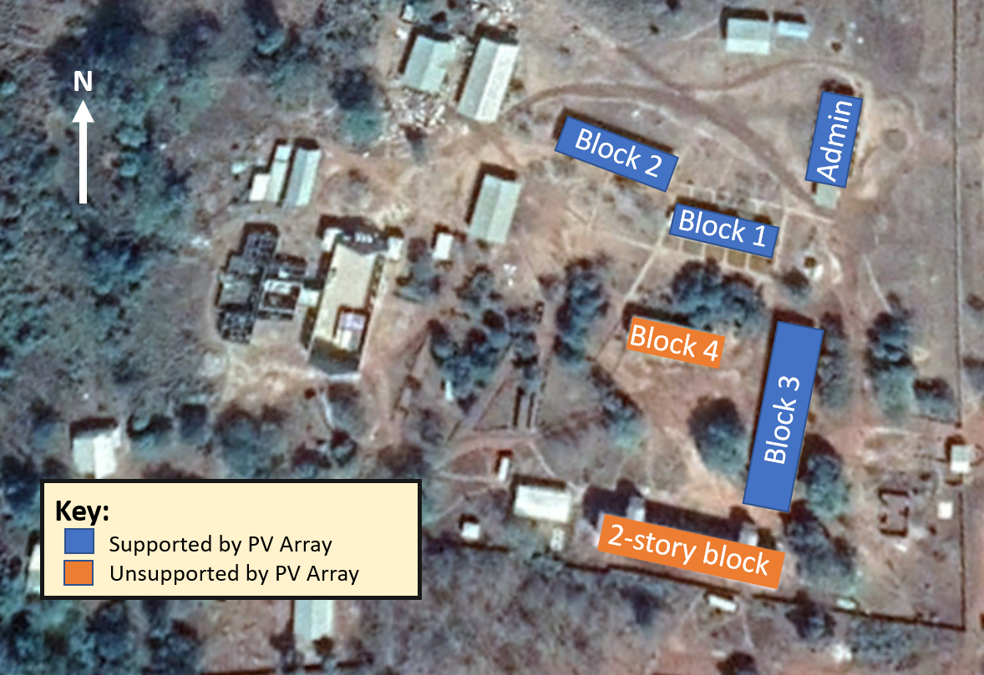
Figure 1: Solar Loading Map (Only academic buildings were considered)

Technical Data Collection
EWB-UMD performed a load analysis of all loads on the previously installed solar energy system, and all remaining classroom loads. The results of the load analysis are presented below:
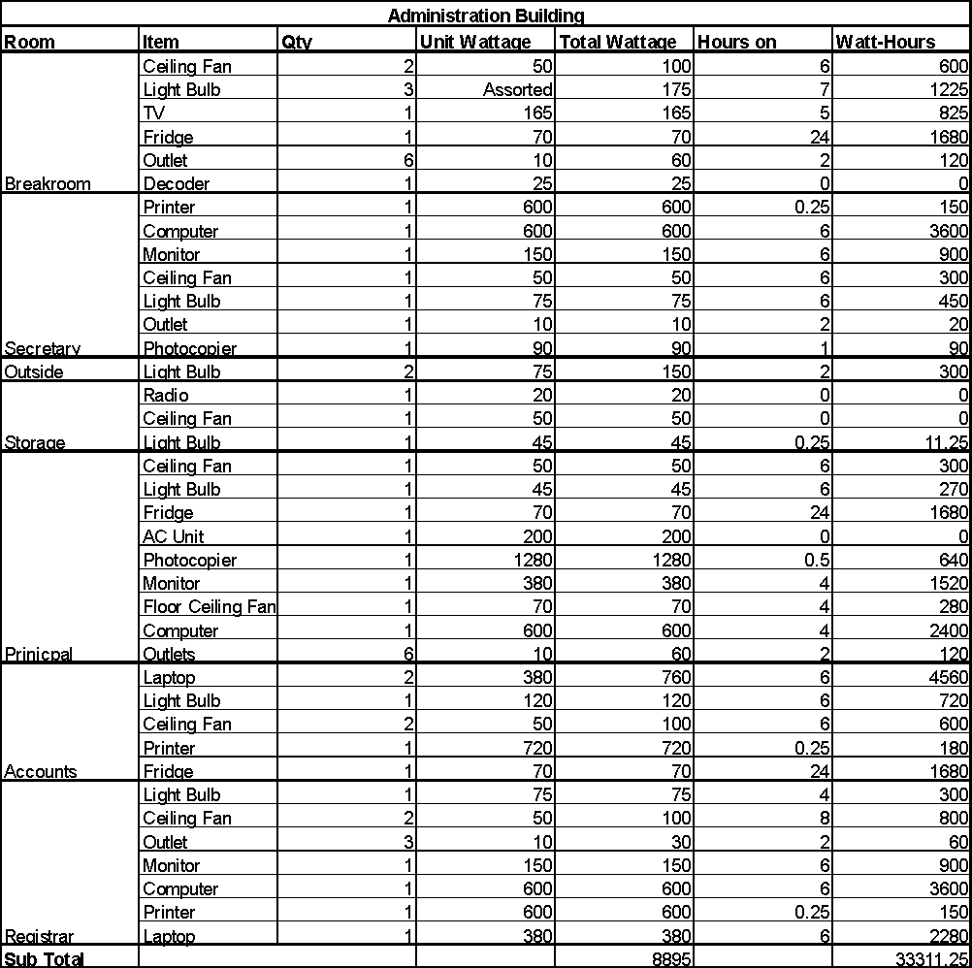

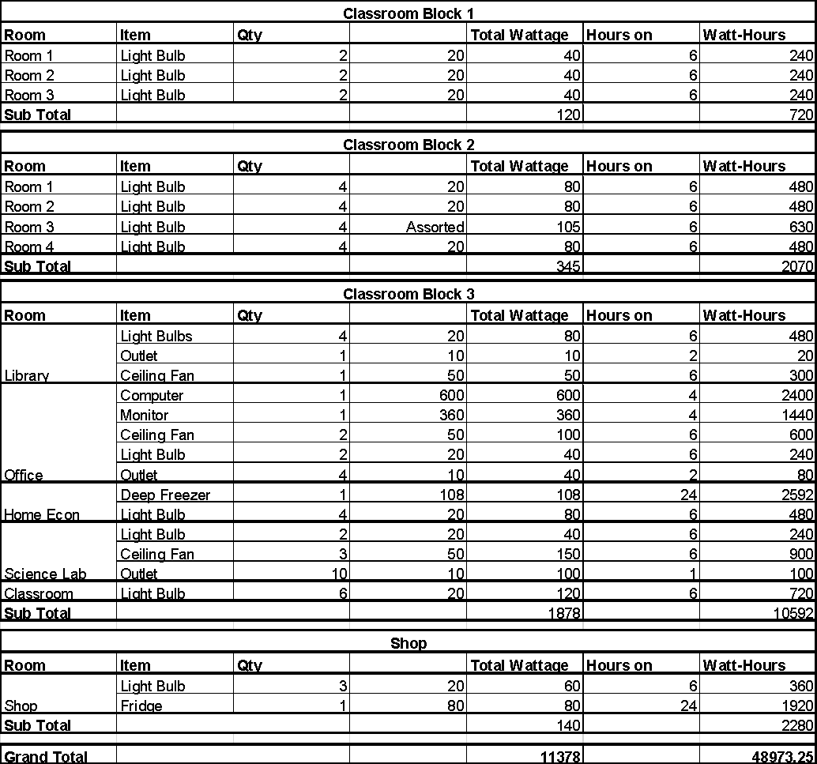
Figure 2: Current PV System Loading Breakdown

The max power consumption (assuming all items on at once) of the current system loading is 10,978 Watts. At a 220V output from the inverter, this results in an current of around 50A, which would cause the inverter to shut down as a result of it’s overload protocols (which it has several times between November 2017 and February 2018). The energy draw is 46,832 Watt-hours which exceeds to storage capacity of the current battery bank. A majority of the energy usage is in the administration building, which needs to be monitored for wasteful usage.

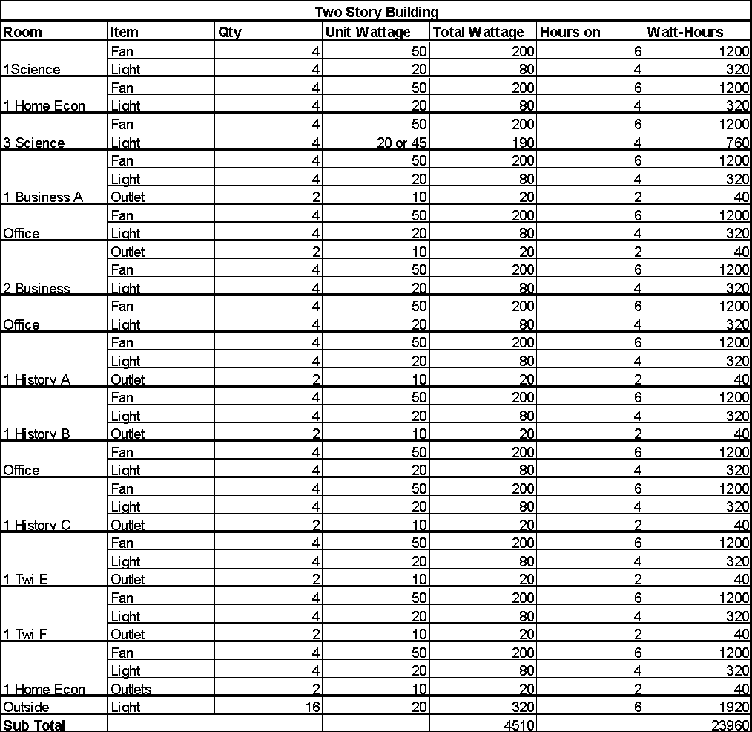

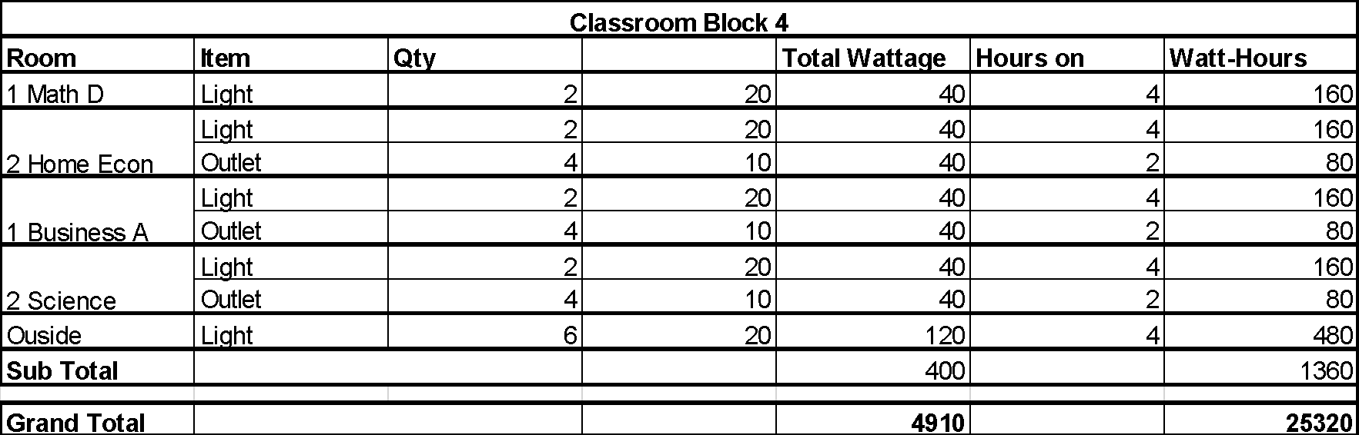
Figure 3: Remaining Unsupported Classroom and Academic Loads

The remaining loads feature a max power draw of 4,910 Watts, and a daily energy use of 25,320, almost half the amount of the loading on the current PV system. A second energy system could potentially relieve some of the burden on the current system by distributing the loads more equally between the two.

Photo Documentation

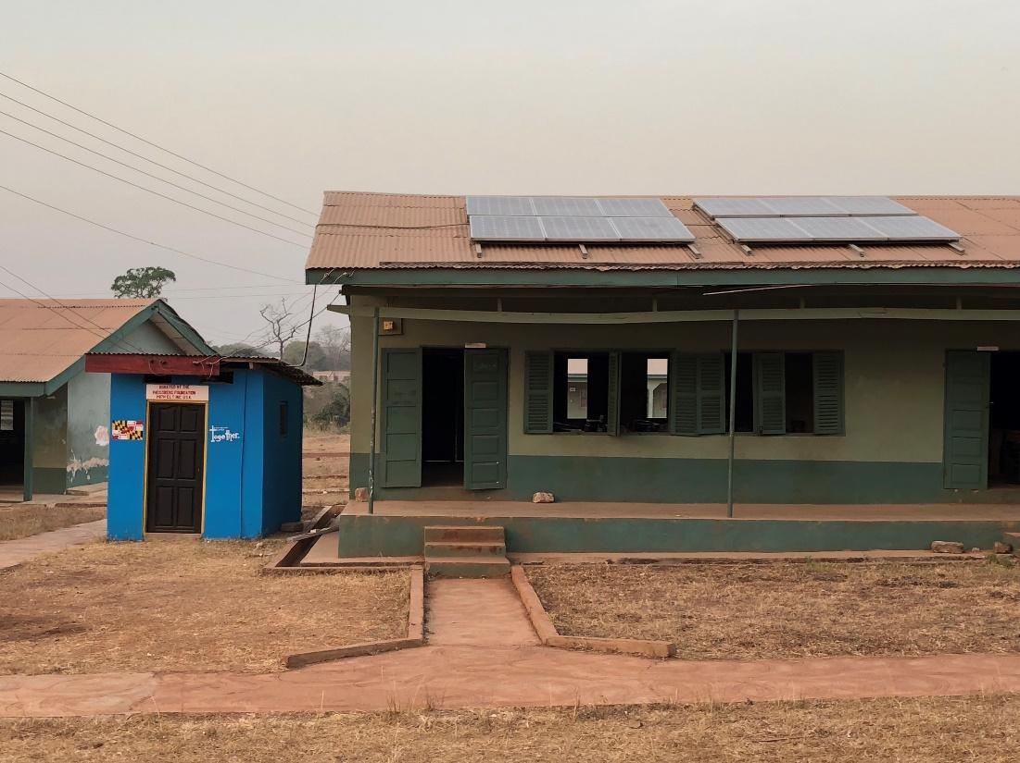
Photo 1: Current PV System Located on Classroom Block 1
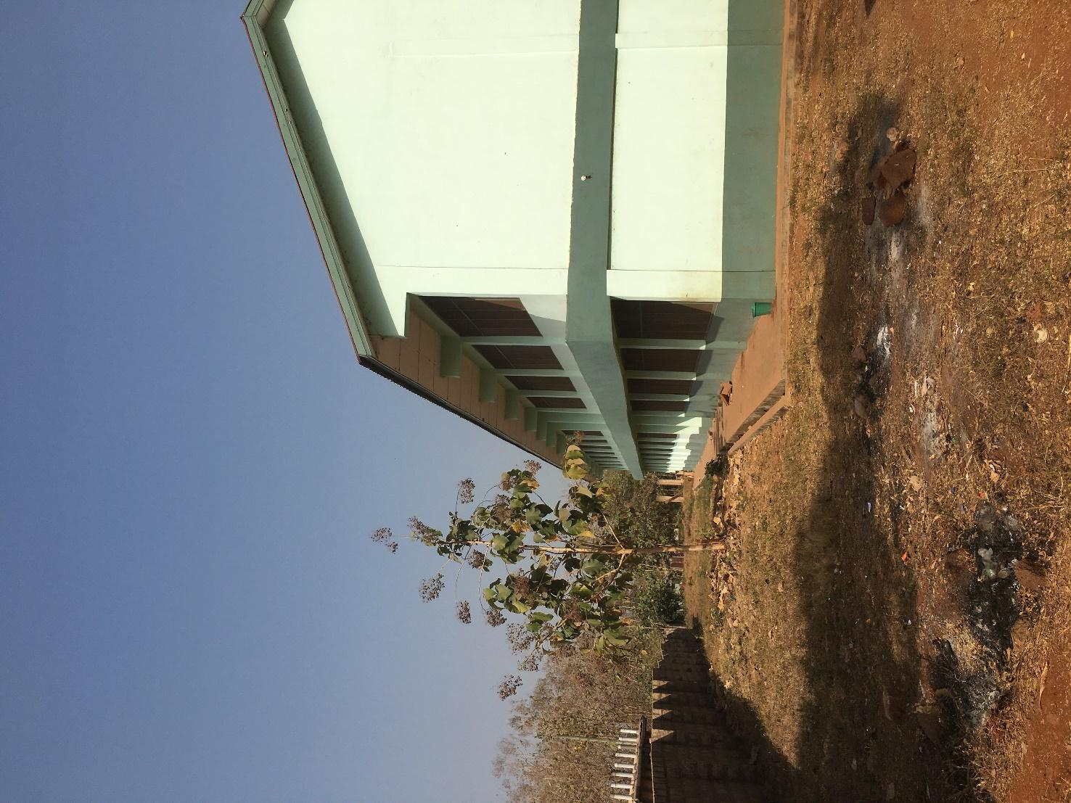
Photo 2: Side view of Two Story Classroom Block

List of Locally Available Material Costs

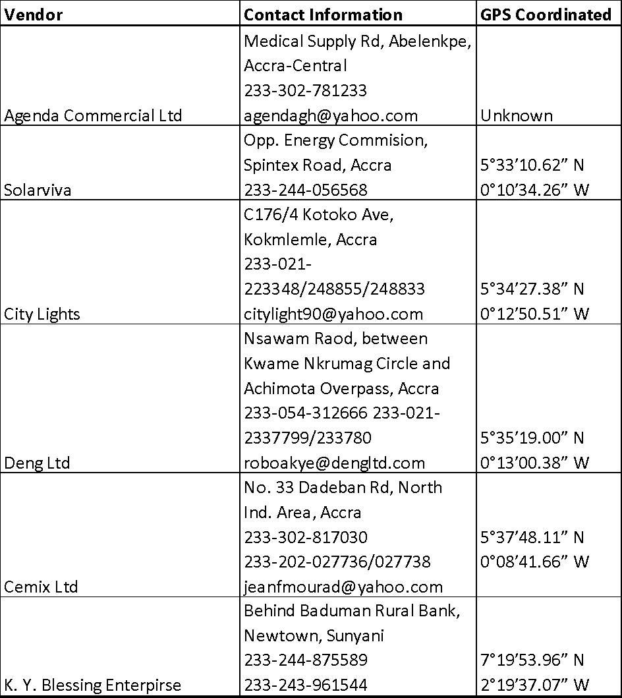
Figure 4: Vendor Locations and Contact Information

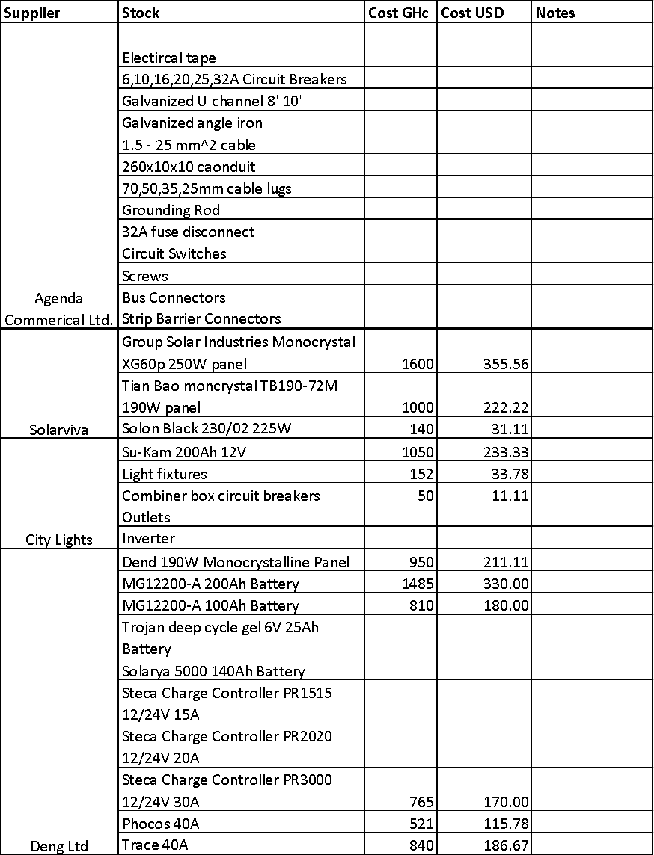
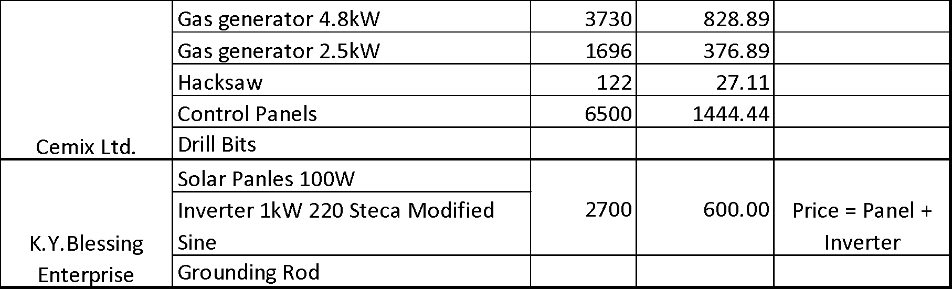
Figure 5: Vendor Products Availability
(This list does not detail all products available at specific vendors. Instead it shows products the travel team considered relevant during the assessment trip)

List of Attachments

